About this Lesson
Buskerfest is a tradition celebrated in many cities across Canada. This lesson provides an opportunity for students to explore some non-traditional ways by which musical artists earn money. It also gives students a chance to explore non-traditional performance environments and audiences.

Grade Level | Course(s)/subject(s) | Learning Goal(s) | Suggested  Timing
9 | AMU1O – Music  (adaptable to other arts areas) | At the end of this lesson, students will:  - describe traditional and non-traditional ways to earn income  - reflect on the responsibilities of individuals and organizations to act ethically and in socially responsible ways | 1 period

Curriculum Links
The Arts, grades 9 and 10 (2010)
Music (AMU1O)
The critical analysis process
B1.4 Conduct research to gather reliable information relating to specific music, musicians and the musical opinions of others, and describe the impact this information has had on their own opinions or assessments.

B2.3 Identify and describe ways in which art music reflects the society in which it was created and how it has affected that culture or community.

B4.1 Identify and describe a variety of work or career possibilities related to music study (e.g., explore job websites; interview a freelance musician).

B4.3 Identify opportunities for and explain the benefits of participating in co-curricular music activities and other arts activities in the school.

C2.1 Demonstrate an understanding of the origins and development of some musical forms.

C3.3 Identify ethical and legal responsibilities associated with music.

Inquiry Question
What role does music play in our society, particularly focusing on street musicians using non-traditional instruments?

Materials List
- Student copies of Busking Location Comparison Chart (Appendix A)
- Permission from principal to perform in high-traffic areas of the school at a particular time of day
- Pictures/video of street musicians
- Student copies of school map
- Busking licences (Appendix B)

Timing  (Mins.) | Lesson Sequence | Assessment for and as Learning Opportunities (self/peer/teacher)
MINDS ON
 | Display images or videos of a variety of street musicians performing. Ask students if they have had the opportunity to hear any street performers. Find out where they listened to these performers, what instruments they were playing, what equipment they had, and the quality of the music that the artist was playing.
Context for Learning
Bill Fold is a character who is constantly getting himself into financial scrapes. Use the scenario below to provide students with a context for learning.
Bill Fold is short on cash and is trying to think of ways to generate some funds. He gets an idea – he’ll get out his old dusty guitar and play in public for money. Unfortunately, with little formal training or knowledge about this kind of performing, he has limited success. He performs in a part of town where few people walk by and, to top off his day, receives a fine for busking without a licence. How can we help Bill improve his profit margin, avoid fines and earn money through street entertaining?

Timing  (Mins.) | Lesson Sequence | Assessment for and as Learning Opportunities (self/peer/teacher)
ACTION
 | In small groups, have students discuss different perceptions about street performers:  - Who are they?  - What kind of background or interest might they have in their art form? Would they have received any formal or informal training?  - Why might they choose to perform in public spaces?  - What kinds of performances are suited to public spaces?  - What type of person is likely to be in the audience?  - How would an audience member decide whether or not to give money to the performer?  - How do street performers collect and protect their income?  - How much money do they earn in a day?  Hand out a copy of the school map and the Busking Location Comparison Chart (Appendix A).  Explain that students in the music class will be responsible for putting on a one-period Buskerfest. (This activity could be used as a fundraising activity or to raise awareness about an issue.) Students will perform in small groups.  Generate a conversation about what makes an appropriate location for street performers to set up in order to make money or raise awareness about an issue. Have students fill out the chart with their ideas as to what makes an ideal/poor busking location and explain ways that money should be collected and counted after the event.  Referencing the school map, have students discuss potential “hot spots” for busking within the school and explain what makes these locations appealing for a street performance (e.g., high traffic, good acoustics)?  If possible, travel as a class to the suggested locations to fill out the comparison chart and to evaluate traffic flow, acoustics and other factors. | Collect: Busking Location Comparison Chart (Appendix A)

Timing  (Mins.) | Lesson Sequence | Assessment for and as Learning Opportunities (self/peer/teacher)
CONSOLIDATION/DEBRIEF
Ask if students are aware of any government regulations related to busking. Can it be done anywhere? Is it legal? To whom would you turn to find out?
Gather information from the municipal authority concerning licences. Share the process of obtaining a busker’s licence with students and include the following information:
- where to obtain a licence
- how much it would cost
- in what areas the licence permits musicians to perform
- age requirements to obtain the licence
Create Busking Permits (Appendix B) and have them signed by the principal/vice-principal. Note: if money is raised through this activity it should be donated to the school cause or event.
Generate a whole group discussion using the following questions:
- What is the process for planning a street performance?
- What are the challenges and benefits for performers, audiences and communities during a busking performance?
- What are our individual and collective responsibilities when it comes to using our talents to raise awareness or raise money in our community and in society?

Busking Location Comparison Chart
What makes an ideal location for a street performance? |  | What makes a poor location for a street performance?
 | Location 1  ___________________________ |  | Location 2  ___________________________
Description of location
Materials/gear needed for location
Quality of acoustics
Traffic flow
What makes this location appealing?
What would make this location ideal?
How should money be collected to ensure it is kept safe?
Who will count any coins and where will the money be stored?

APPENDIX A
Busking Permits
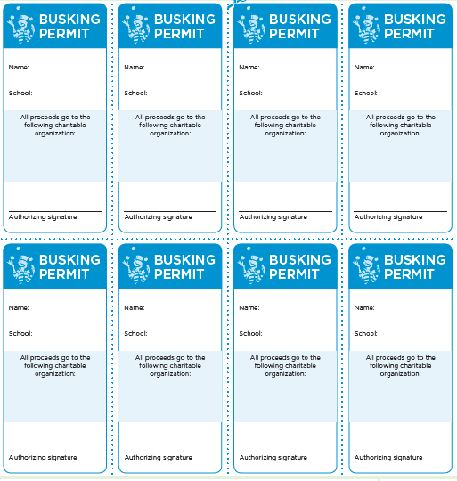
APPENDIX B

