About this Lesson
In this lesson, students will create a duct tape wallet that they can use to hold or store currency and other financial items, personalizing their wallets to reflect their own personality.

Grade Level | Course(s)/subject(s) | Learning Goal(s) | Suggested  Timing
4 | Visual Arts | At the end of this lesson, students will:  - develop vocabulary related to money (e.g., bills, currency, coins)  - understand the need to organize their finances | 40–50 minutes

Curriculum Links
The Arts, grades 1 to 8 (2009)
Visual Arts
D1. Creating and Presenting: apply the creative process (see pages 19–22) to produce a variety of two- and three-dimensional art works, using elements, principles and techniques of visual arts to communicate feelings, ideas, and understandings.

D3. Exploring Forms and Cultural Contexts: demonstrate an understanding of a variety of art forms, styles and techniques from the past and present, and their social and/or community contexts.

Inquiry Question
What methods do we use to store money for day-to-day transactions?

Materials List
- Examples of various wallet designs from across cultures
- Different colours of duct tape (black, white, red, silver, etc.)
- Scissors
- Ruler
- Wallet-Making Instructions (Appendix A)
- Duct Tape Wallet Rubric (Appendix B)
- Step-by-step video (optional):
  - http://www.youtube.com/watch?v=bn5Narcc2mk (Approximately 10 minutes) or
  - https://www.youtube.com/watch?v=JZ4CiLez5x8 (Approximately 8 minutes)

Timing  (Mins.) | Lesson Sequence | Assessment for and as Learning Opportunities (self/peer/teacher)
MINDS ON
5-10 minutes | WHOLE CLASS  Show a variety of sample wallets to the class (show on screen if you do not have access to samples, by searching “wallet images.” Encourage students who have wallets to describe what their own wallet looks like.
 | Ask the following questions to prompt student discussion:  - Based on your personal experience and observation, what sorts of things do people put in their wallets? (Use this prompt as an opportunity to explore words like bills, coins, currency, etc.)  - What elements of a wallet’s design make one more useful than another?  - What elements of a wallet’s design make one more desirable than another?  - Why do you think it might be important to have a place to organize your money?  - Wallets serve a function, but as the examples show, they also have design elements.  - How important is the artistic design of a functional item such as a wallet? | Assessment FOR Learning (Teacher Observation)

Timing  (Mins.) | Lesson Sequence | Assessment for and as Learning Opportunities (self/peer/teacher)
MINDS ON (cont’d.)
Context for Learning
Students should be familiar with the concept of saving money and how to buy and sell using cash.
ACTION
20–30 minutes | SMALL GROUPS  Activity: Making a duct tape wallet  Explain that students will be applying various elements of design to make their own wallets using duct tape as the primary material.
 | Provide table groups with sample duct tape wallets to look at, or display photos of various wallet designs to the class.  Take students through each of the steps of creating the wallet (Appendix A) or, if possible, show a variety of YouTube clips that demonstrate how to make various duct tape wallets and their design.  Provide students with stickers and/or templates to decorate their wallets. | Assessment AS Learning (Self)
CONSOLIDATION/DEBRIEF
10–15 minutes | WHOLE CLASS  Create a gallery in the classroom to showcase students’ wallets. Take pictures of the wallets and post them online, if appropriate. | Assessment AS Learning (Peer)
 | Encourage students to offer feedback on the balance between function and design as observed in their own and their peers’ work. | Assessment AS Learning (Self)

Timing  (Mins.) | Lesson Sequence | Assessment for and as Learning Opportunities (self/peer/teacher)
CONSOLIDATION/DEBRIEF (cont’d.)
 | Have students respond to and discuss the following questions/prompts when reflecting on their final product:  - What criteria can you use to judge your work?  - How do your design choices reflect your personality?  - Given the opportunity to make another wallet, what would you do differently?  - What were the biggest challenges in making the wallet? What advice would you give others to overcome them?  - Although this was an art activity, you had to apply your mathematical skills. Discuss the relationship between math and art as you experienced it here.  - Discuss how artists have to learn to balance creativity and practical elements when creating works of art. | Rubric (Appendix B)
EXTENSION
After making the wallet, have students participate in using the wallet. See: Duct Tape Wallet – Math Edition lesson
https://www.inspirefinanciallearning.ca/index.php/teachers/teaching/by-grades/grade-4/duct-tape-wallet-math-edition/

Instructions for making a duct tape wallet
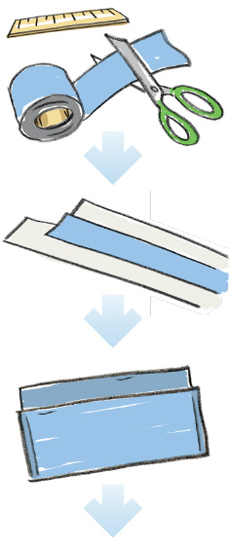
STEP 1
- Cut 10 strips of duct tape 18 cm long. You may wish to cut them a little longer in case of mistakes, and you can trim them back in Step 3.
- Cut 3 pieces of duct tape 15 cm long. Again, you may wish to cut them a little longer in case of mistakes.

STEP 2
Make 2 sheets of duct tape fabric by alternating strips side up/side down so that:
- The first larger sheet is made of ten 18 cm (or longer) strips.
  - Place the first strip on a flat surface, sticky side up. Then, place a second piece sticky side down, halfway covering the first piece. Keep alternating until you have a piece of fabric.
  - When you get to the end, fold the remaining sticky sides over to make a clean edge.
- The second smaller sheet is made of three 15 cm strips.
  - Follow the instructions above to alternate the pieces and create the smaller piece of fabric.

STEP 3
Create the main pocket:
- Trim the larger piece of duct tape fabric to 22 cm by 18 cm.
- Fold the sheet over, leaving the top edge higher than the bottom edge as shown in the picture, so that it measures 18 cm wide and 12 cm high.
- Tape the two outer sides securely with duct tape.
APPENDIX A
Instructions for making a duct tape wallet (cont’d.)
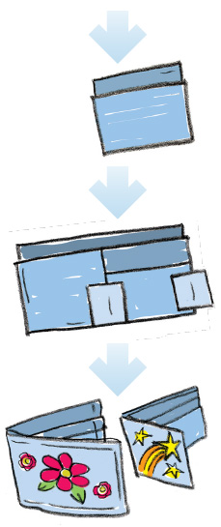
STEP 4
Create and attach the smaller credit and identification card pocket:
- Trim the smaller piece of duct tape fabric to 15 cm (high) by 8 cm (wide).
- Fold it over leaving the top edge higher than the bottom so that the top edge is 8 cm high, which will allow for two pockets when it is attached to the larger pocket.

STEP 5
Assemble the wallet:
- Use 2 pieces of duct tape to carefully attach the smaller pocket to the right side of the larger pocket.
- Add a third piece of tape to the bottom of the small pocket to secure it.

STEP 6
Decorate the wallet:
- Use stickers, different coloured duct tape cut into shapes, or anything else you can think of to personalize the wallet.
APPENDIX A
Rubric
Criteria | Level 1 | Level 2 | Level 3 | Level 4
Knowledge and understanding
The student uses terminology and instructions accurately | Demonstrates limited accuracy. | Demonstrates some accuracy. | Demonstrates considerable accuracy. | Demonstrates outstanding accuracy.
Thinking
The student creates a 3D work of art that expresses feelings and ideas inspired by their interests and experiences. | Demonstrates limited ability to express feelings and ideas in a 3D work of art. | Demonstrates some ability to express feelings and ideas in a 3D work of art. | Demonstrates considerable ability to express feelings and  ideas in a 3D work of art. | Demonstrates a high degree of ability to express feelings and  ideas in a 3D work of art.
Communication
The student demonstrates awareness of the meaning of signs, symbols and styles in works of art. | Demonstrates limited awareness of the meaning of signs, symbols and styles in works of art. | Demonstrates some awareness of the meaning of signs, symbols and styles in works of art. | Demonstrates considerable awareness of the meaning of signs, symbols and styles in works of art. | Demonstrates a high degree of awareness of the meaning of signs, symbols and styles in works of art.
Application
The student uses  a variety of materials, tools and techniques  to determine solutions to  design challenges. | Uses limited materials, tools and techniques to determine solutions to design challenges. | Uses some materials, tools and techniques to determine solutions to design challenges. | Uses a reasonable variety of materials, tools and techniques  to determine solutions to  design challenges. | Uses a wide variety of materials, tools and techniques  to determine solutions to  design challenges.

Comments:
________________________________________________________________________________
________________________________________________________________________________
Mark: __________________ Parent initials: __________________
APPENDIX B

