About this Lesson
In this lesson, students review the functions and responsibilities of Canada’s three levels of government by participating in a role play to learn how public funds are spent at the municipal provincial and federal level.

Grade Level | Course(s)/subject(s) | Learning Goal(s) | Suggested  Timing
10 | CHV2O – Civics | At the end of this lesson, students will:  - understand the different levels of government and their roles | One period

Curriculum Links
Canadian and World Studies, grades 9 and 10 (2013)
Civics (CHV2O)
Civic Awareness
B2.2 Explain, with reference to issues of civic importance, the roles and responsibilities of different levels of government in Canada (e.g., federal, provincial, territorial, municipal, Aboriginal governments) and of key figures at each level (e.g., members of Parliament [MPs], senators, members of provincial Parliament [MPPs], premiers, mayors, municipal councillors, chief, band councillors, Métis senators).

Materials List
- Data projector or SMART Board
- Maps
- Hat or bag for draw
- The Three Levels of Government in Canada (Appendix A)
- Name Tags (Appendix B)
- Government “Money” (Appendix C)
- Or interactively use the CLIPS Money Tool from: http://mathies.ca/learningTools.php
- Government “Money” Scenarios (Appendix D) – cut in strips by topic
- Exit Cards (Appendix E)

 | Timing  (Mins.) | Lesson Sequence | Assessment for and as Learning Opportunities (self/peer/teacher)
 | MINDS ON
Instructions
Review the levels of government: federal, provincial and municipal, and a map of Canada (if possible, use an online map to zoom in on the geographic areas for which each level of government is responsible).
Point to various locations on the map and ask questions that check for prior learning (e.g., point to Toronto and ask, “Who is the mayor of Toronto?”; point to Ottawa and ask, “In what building in Ottawa does the prime minister conduct civic business?”; “How many provinces and territories does the federal government oversee?”).
Context for Learning
Bill Fold is a character who is constantly getting himself into financial scrapes. Use the scenario below to provide students with a context for learning.
Bill Fold wants to get involved in politics, but he’s unsure as to what position would best suit him. He decides to job shadow a local politician to find out more about the key functions of different levels of government.
ACTION
 |  | Activity: Role play  Distribute the handout The Three Levels of Government in Canada (Appendix A). Review the roles and responsibilities of each level of government in greater detail by explaining the services listed under each level of government. Invite students to fill in the information about the heads of government and their positions and take up answers together.  Choose three students to come to the front of the class. Assign each volunteer a role: prime minister, premier or mayor. Give each volunteer the appropriate name tag to wear around their neck (Appendix B) and explain that the student is the representative for their assigned level of government. Provide each leader with play money (Appendix C) or use items in the class to represent the money. | Collect:  Exit Cards (Appendix E)
ACTION (cont’d.)
Place strips of various funding scenarios (Appendix D) in a hat. Select two additional students to come to the front of the room and pick out a funding scenario from the hat (example scenarios include “build an arena”). After a quick consultation, this pair attempts to request money from the correct level of government.
If the students ask for money from the correct branch(es) of government, they receive play money from the representative at the front of the room. If the funding comes from more than one level of government, the pair of students should know to make a second request.
If the students are incorrect in their request, intervene with the class and review the roles and responsibilities chart as it applies to the scenario (Appendix A).
Repeat the activity with other volunteers until all of the funding scenarios have been addressed.
CONSOLIDATION/DEBRIEF
Challenge students to offer opinions about government funding and the functions of government by asking the following questions:
- Why do you think we have three levels of government in Canada?
- How can a citizen influence spending decisions at each level of government?
- Do you believe education should be paid for at the provincial or federal level? Why?
- What are the advantages of municipalities being able to fund and control spending on services like public libraries, arts and recreation centres?
- What is the origin of the money that governments spend?
Exit Card (Appendix E)
Have students write exit cards (Appendix E) (or journal entries) highlighting three things they learned in today’s class as to how money is spent by the different levels of government.

The Three Levels of Government in Canada
Federal | Provincial | Municipal
Who is the head of the  federal government?  What is their position? | Who is the head of the  provincial government?  What is their position? | Who is the head of your  municipal government?  What is their position?
Responsibilities of the  federal government:  International trade  Canada-wide communications  Canada-wide transportation  Banking  Currency  Finance  Foreign affairs  Military/defense  Jails  Immigration  Weights/measures  First Nations  Old age pensions  Agriculture | Responsibilities of the  provincial government:  Immigration  Old age pensions  Agriculture  Finance  Hospitals  Education  Transportation within the  province  Natural resources | Responsibilities of the  municipal government:  Water  Sewage  Waste collection  Public transit  Libraries and recreation  Emergency services  Animal control

APPENDIX A
Name Tags
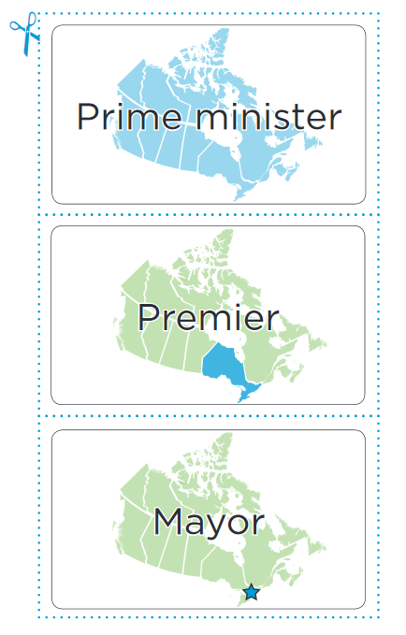
APPENDIX B
Government Money
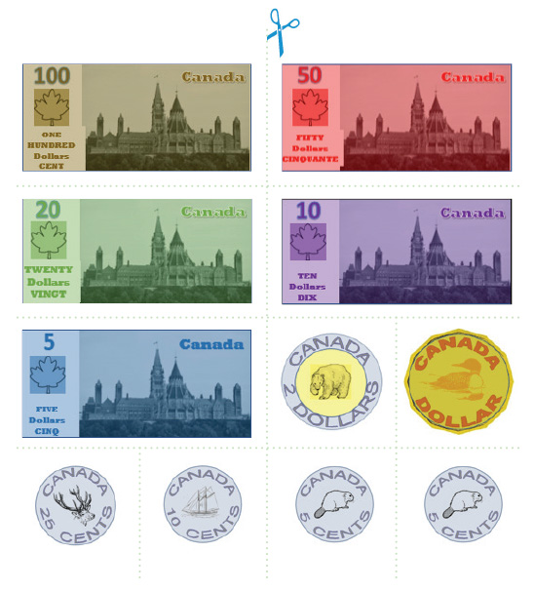
APPENDIX C
Government “Money” Scenarios
Topic: | Trade with Japan
Scenario: | You are the minister of International Trade and you are working on a trade deal with Japan. You need money to host Japanese politicians who are coming to Canada.
Topic: | All-hockey TV channel
Scenario: | You are the head of the CBC (Canadian Broadcasting Corporation) and need government funding to start a new channel dedicated entirely to hockey. This channel would be broadcast all over Canada.
Topic: | Trans-Canada Highway repairs
Scenario: | You are a truck driver who is upset about all the potholes on the Trans-Canada Highway (a highway that crosses much of Canada). You have a petition with 100,000 signatures to fix the highway.
Topic: | New $1,000 bill
Scenario | You are the governor of the Bank of Canada and need money for the design of a new $1,000 bill.
Topic: | New arena
Scenario: | You are the coach of a peewee hockey team. There are too many hockey teams in your district to play on the one and only rink. You want to have a second rink built in the district.
Topic: | New embassy in the Bahamas
Scenario: | You are the Minister of Foreign Affairs and need money to set up a Canadian embassy in the Bahamas.
Topic: | New submarines
Scenario: | You are a high-ranking commander in the Canadian Navy. You want to purchase seven new submarines.
Topic: | Jail expansion
Scenario: | You are the warden of a jail. You want to expand the jail (make it bigger) because there is not enough room to hold all the prisoners.

APPENDIX D
Government “Money” Scenarios (cont’d.)
Topic: | More funding for immigrants
Scenario: | You are a powerful advocate for immigrants. Due to a shortage of Canadian workers in some areas, Canada has admitted more new immigrants than usual this year. Money is needed to provide services for them.
Topic: | Metric sign
Scenario: | Since the 1970s, Canada has used the metric system of measurement. All street signs now indicate speed in km/h (kilometres per hour). However, driving on a small country road yesterday, you found a sign from the old mph (miles per hour) system. You want the sign changed.
Topic: | Cree monument
Scenario | You are one of the leaders of the Cree First Nations tribe. One of the tribal elders passed away yesterday and you want money to erect a monument in his honour.
Topic: | Higher pensions
Scenario: | Due to rising prices, retired citizens need a higher pension. You are a senior citizen with a petition to raise pensions signed by 50,000 other seniors.
Topic: | More soybeans
Scenario: | You are the CEO of the Grain Farmers of Ontario. You want a government subsidy (money) to grow soybeans because they are becoming more popular both in Canada and worldwide.
Topic: | More nurses
Scenario: | You are the head administrator at Princess Margaret Hospital in Toronto. You need more nurses to help hospital patients.
Topic: | New math textbooks
Scenario: | You are the director of your local school board and need new math textbooks; the old ones are in poor condition and there aren’t enough for all the students.

APPENDIX D
Government “Money” Scenarios (cont’d.)
Topic: | New streetcar
Scenario: | You are the commissioner of your local transportation system. You want to add a streetcar to one of your main streets. This would involve paying for the streetcar, as well as widening the road and changing many traffic signals.
Topic: | Reforestation
Scenario: | You are the mayor of a small town where a fire recently destroyed much of the forest in the area. You need money to plant new trees because the forest brings a lot of tourism to your town.
Topic: | Water purity
Scenario | You are the head of your city’s water treatment facility. Chemicals harmful to drinking water were recently found in your city’s local water supply. Special equipment is needed to remove these chemicals.
Topic: | Sewer cleanup
Scenario: | You are a city councillor and a strange smell is coming from some of the sewers in your district. You need professionals to investigate and eliminate this smell.
Topic: | More garbage collection
Scenario: | You are a city councillor whose district has doubled in population this year. You need more garbage collection, including both workers and garbage trucks.
Topic: | New computers in libraries
Scenario: | You are a librarian and need to update the computers in your public library because the current ones don’t support any new software.
Topic: | Flooding relief
Scenario: | You are a city councillor and the lake beside your city has flooded many homes in your district.

APPENDIX D
Exit Card
Name: ____________________________________

Record what you learned about the duties and responsibilities of each level of government.

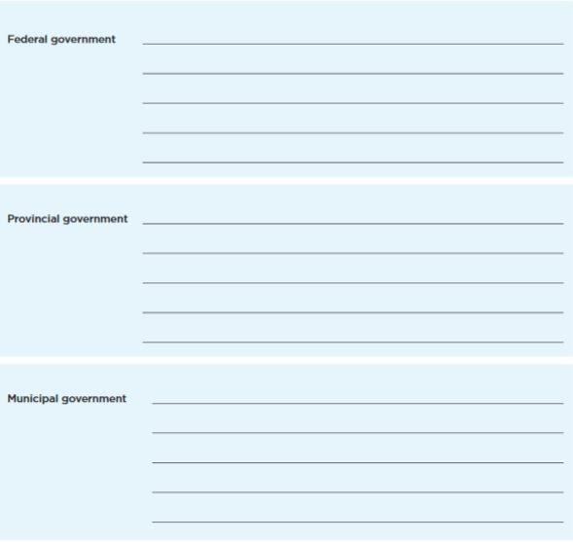
APPENDIX E

