About this Lesson
This lesson introduces the concept of retail sales tax through a race called HST Derby. During the race, students cooperate in teams to calculate HST on a variety of purchases.

Grade Level | Course(s)/subject(s) | Learning Goal(s) | Suggested  Timing
8 | Mathematics, grades 1–8 (2005) | At the end of this lesson, students will:  - describe the purpose and role of taxation and calculate its impact on purchases | 80 minutes

Curriculum Links
Mathematics, grades 1–8 (2005)
Number Sense and Numeration
Solve problems involving per cent expressed to one decimal place (e.g., 12.5%) and whole number per cents greater than 100 (e.g., 115%).
Solve problems involving per cent that arise from real-life contexts (e.g., discount, sales tax, simple interest). (Sample problem: In Ontario, people often pay an HST of 13% when they make a purchase. How much is the final purchase after calculating the tax?)

Inquiry Question
How do we calculate the HST on a variety of everyday items?

Materials List
- HST Worksheet (Appendix A)
- Five Sample Sales Receipts (Appendices B, C and D)
- A Book of Sales Receipts from an Office Supplier OR Copies of Blank Receipts (Appendix E)
- Sales Tags for HST Derby (Appendix F)
- Calculators – one per group
- Word Wall of Key Terms (HST, tax, remit, etc.)

Timing  (Mins.) | Lesson Sequence | Assessment for and as Learning Opportunities (self/peer/teacher)
MINDS ON
5–10 minutes | WHOLE CLASS  Show students an everyday item (e.g., a stapler, an article of clothing, etc.), and state the price of it. Ask if the price tag reveals the actual amount a person would pay when at the cash register in a store. (It is likely that students will respond that sales tax is applied and the final cost to the consumer will be higher.) Ask how much sales tax currently is in Ontario (13%).  Generate a whole class discussion by asking the following:  - What is the purpose of a sales tax? (Pay for public services.)  - Why do retailers collect this money from their customers? (The government requires them to do so.)  - Why do you think sales tax is not included in the price tag price in Ontario? (Other countries do include it in the price. Sample responses: They want the item to appear cheaper. They do not want customers to think the extra cost is the retailer’s fault. Not all items have the extra cost included. Not all items are taxable.)  - When you think to purchase an item, do you factor the sales tax into your total cost?  Often when we make a purchase, we do not factor in the final cost of the tax. This means we frequently spend significantly more than we were originally planning. | Observations/Notes

Timing  (Mins.) | Lesson Sequence | Assessment for and as Learning Opportunities (self/peer/teacher)
ACTION
50–60 minutes | WHOLE CLASS  Instructions  Explain to students that today’s lesson is called HST Derby. Introduce the concept of a derby explaining that a derby is a race. The goal of the activity is to work in teams in a relay race format in order to calculate the cost of HST on various items.  Before starting the derby, students will explore points of information about Ontario’s Harmonized Sales Tax (HST).  Create a word wall of terms on the board prior to the instruction. Using visual images or a dramatic simulation, ensure that students understand the following concepts:  - HST (or Harmonized Sales Tax) is an extra charge that must be added to the price of goods or services sold.  - The seller must remit (send in) all the HST that they have collected on behalf of the government. The government uses the money that it collects to provide services to the community.  - The amount of HST that is added to the price of an item is calculated as a percentage of the item’s price. Remember, some “items” can also be services, such as getting a haircut.  The percentage that is added to the price (rate) varies from province to province. In Ontario, the rate is 13% – a combined rate of the Ontario (provincial) sales tax and federal sales tax.
Is HST added to everything? NO! Some items and services are considered tax exempt (no tax is charged), such as: basic groceries, prepared food and beverages sold for $4 or less, prescription drugs, most health and education services, childcare, most agricultural products, farm livestock, and many medical devices.
Option: show images of these items as they are explained by pasting representative images of each on the board.

Timing  (Mins.) | Lesson Sequence | Assessment for and as Learning Opportunities (self/peer/teacher)
ACTION (cont’d.)
 | PAIRS/GROUP  Guided Practice: Calculating HST  Return to the example given at the start of the “Minds on.” Ask if any students already know how to calculate the rate of HST on this product.  Invite a volunteer to practise and model their approach on the board. Explain and model two HST calculations. To calculate what is X% of Y (Example: What is 13% of $135?):  - Convert 13% to a decimal: 13/100 = 0.13  - Multiply $135 x 0.13 = $31.05 HST • To calculate what percentage $A is of $B (Example: What per cent is $30 of $160?)  - Divide 30/160 = 0.1875  - Multiply 0.1875 x 100 = 18.75%  Hand out the sample receipts to the class (Appendices B, C and D). Review Receipt #1 together and help the students determine what percentage HST was charged on the total. Reinforce the concept of HST-exempt items.  Distribute the HST Handout (Appendix A). Working in pairs, have students complete the worksheet and submit individual responses for assessment. Before moving on to the derby, ensure that every student feels comfortable calculating HST. | HST Worksheet  (Appendix A)
WHOLE CLASS
Starting the Derby
Signal the start of the game by flicking the lights or ringing a bell. The student in position one walks to the starting point desk. They select a price tag from the starting point desk and walk past their group to the end point desk, sit at the desk and use the calculator to calculate the HST listed on their price tag. They fill out the amount on the receipt and bring it to the starting point desk. Student one tags the person closest to the front who is sitting in position two.

 | Timing  (Mins.) | Lesson Sequence | Assessment for and as Learning Opportunities (self/peer/teacher)
ACTION (cont’d.)
Everyone in the group moves forward in the row and student one goes and sits at the back of their team’s row.
Student in position two picks up the price tag from the starting point desk and takes it to the end desk to do their price tag calculation and continue the relay by tagging student three when finished.
Whichever group completes all receipts in the shortest amount of time and with the most correct totals wins the HST Derby.
CONSOLIDATION/DEBRIEF
5–10 minutes |  | WHOLE CLASS  To debrief the lesson and activity, prompt discussion using the following questions:  - Why are taxes like the HST added to the price of goods or services?  - Should all people have to pay HST? Why or why not?  - Some items are tax exempt, as you learned. Based on the types of items in this category, speculate on the reason for their exemption.  - What other, if any, types of items should be exempt? Why?  - Speculate as to what happens to HST when it is remitted to the government. How can you find out what happens to it?

HST Worksheet
Instructions
- Using the sales receipts provided, record the following on the chart below:
- the total from each receipt (how much customer had to pay)
- the sub-total of each receipt (the total price of all items before the HST was added)
- the amount of HST charged on each receipt

- Calculate and record on the chart:
- At what per cent was the HST calculated and charged on the subtotal of each receipt?
- be sure to show your calculations in the last column of the table

Receipt total | Subtotal PRIOR to addition of HST | HST amount charged | YOU CALCULATE:  At what % of the subtotal was the HST charged?

Challenging your Thinking
- Why are some of the HST percentage calculations in the chart above not at Ontario’s provincial rate?
______________________________________________________________________________
______________________________________________________________________________
______________________________________________________________________________

- Al-Noor goes to a hamburger joint with his friend to purchase two hamburgers. The burgers cost $3.95 each. Al places the order and pays $8.93 for his purchase. Al’s friend informs him that she could have purchased the two burgers for only $7.90. How could she have done this?
______________________________________________________________________________
______________________________________________________________________________
______________________________________________________________________________
APPENDIX A
Sales Receipt 1
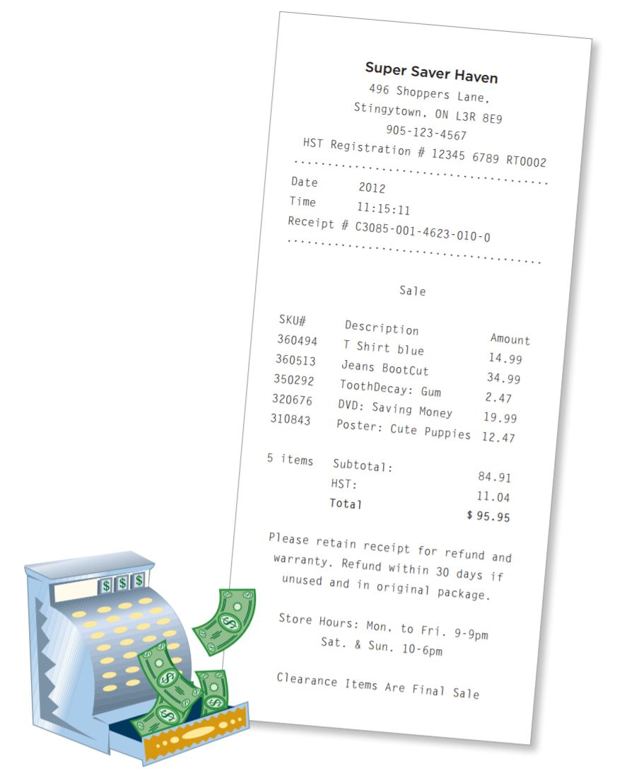
APPENDIX B
Sales Receipt 2 and 3
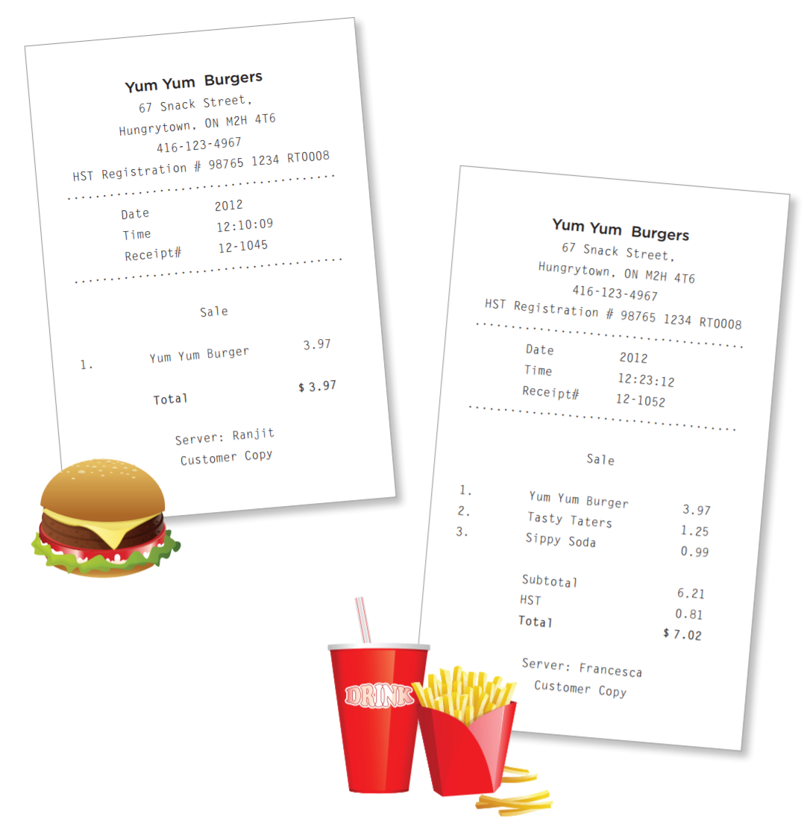
APPENDIX C
Sales Receipt 4
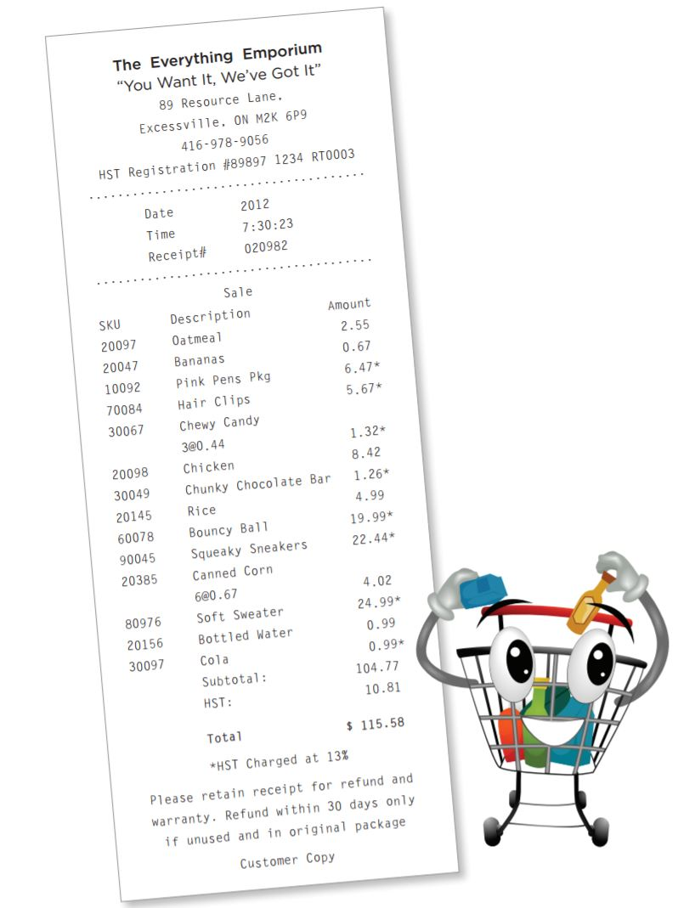
APPENDIX D
Materials for HST Derby
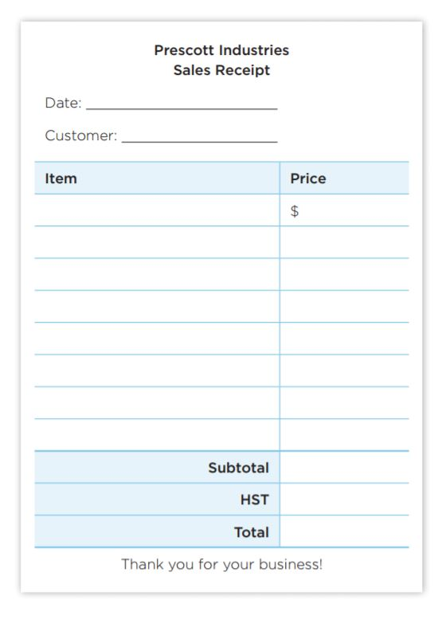
APPENDIX E
Sales Tags
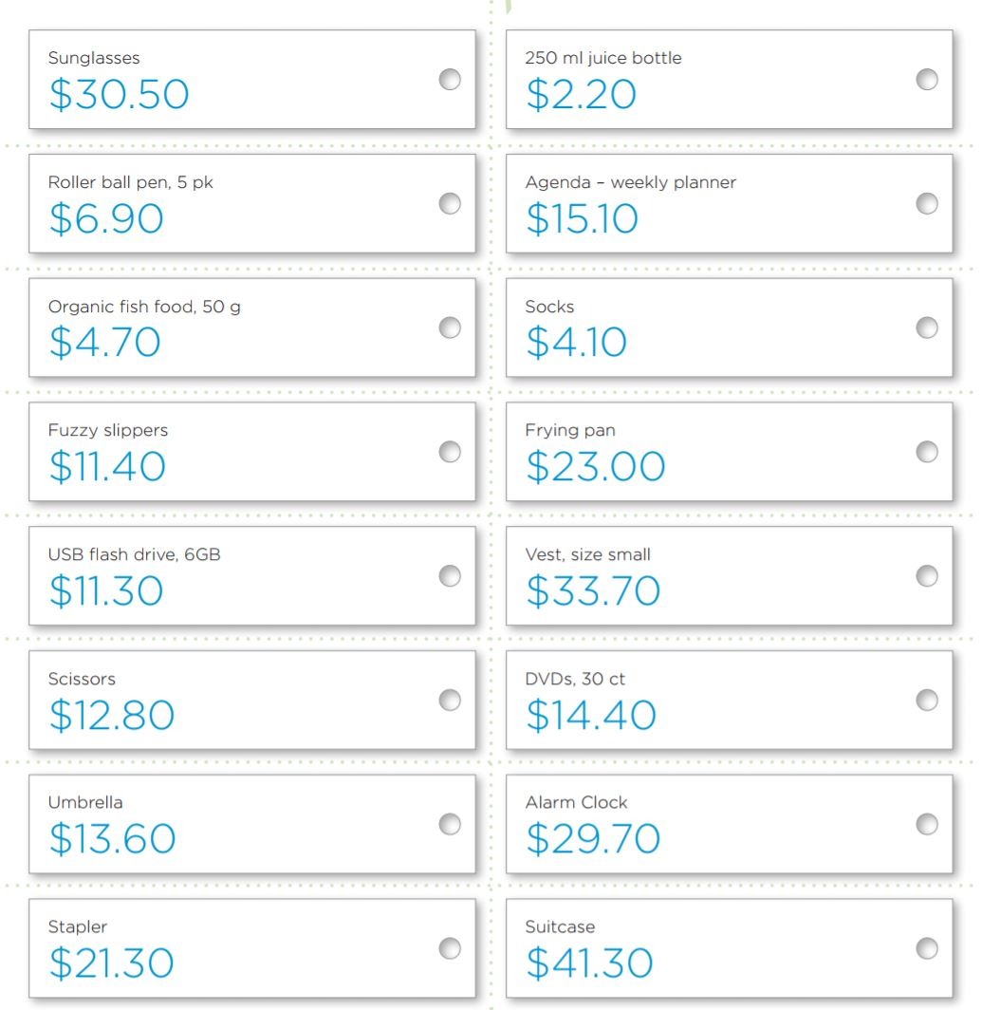
APPENDIX E

