About this Lesson
In this lesson, students evaluate needs and wants by planning and organizing a multi-paragraph writing piece in response to the question: “What would you do if money grew on trees?”

Grade Level | Course(s)/subject(s) | Learning Goal(s) | Suggested  Timing
7 | Language, grades 1–8 (2006) | At the end of this lesson, students will:  - differentiate between needs and wants  - reflect on their role as active citizens and the financial implications | 80–100 minutes  (2 x 40–50 minute periods)

Curriculum Links
Language, grades 1–8 (2006)
Language
Writing
1.5 Identify and order main ideas and supporting details and group them into units that could be used to develop a multi-paragraph piece of writing, using a variety of strategies.

2.8 Produce revised draft pieces of writing to meet identified criteria based on the expectations (e.g., adequate development of information and ideas, logical organization, appropriate use of form and style, appropriate use of conventions).

Inquiry Question
What would the consequences to society be if we had as much money as we wanted?

Materials List
- Writing Template for each student (Appendix A)
- A bulletin display of a large tree with play money (variety of bills) pasted on the tree’s branches to represent the leaves. Alternately, use chalk to draw the tree on the board with paper play money as its leaves (Appendix B). Either option should be set up before the lesson begins.
- Lined paper for each student (rough copy)

Timing  (Mins.) | Lesson Sequence | Assessment for and as Learning Opportunities (self/peer/teacher)
MINDS ON
5–10 minutes | WHOLE CLASS  Prior to students coming into the classroom, hang on the wall or draw on the board a money tree (see Appendix B for an example). Be sure to display play money with various denominations.  State to the class: “As you can see, something unusual occurred in our classroom during the night.” Draw attention to the money tree.  Involve the class in counting the money and explain that in today’s class the students are going to act as stewards of this money and decide where and how it will be used.
Context for Learning
- touch on the concept of inflation (as we have more money, our money is worth less)
- what do we consider wants and needs?

Timing  (Mins.) | Lesson Sequence | Assessment for and as Learning Opportunities (self/peer/teacher)
ACTION
30–40 minutes | WHOLE CLASS  As a class, generate a list of criteria to guide the purchase and/or saving decisions (e.g., food, shelter, cellphone plans). Encourage students to think about the best interests of the group while prompting the class to consider how the money might be used for individual and charitable purposes.  PAIRS/SMALL GROUPS  Think-Pair-Share  Allow students three minutes to engage in a think-pair-share to identify various ways that the class could use the money. Pairs should shortlist to one preferred idea.  WHOLE CLASS  Regroup as a class and share the ideas, recording the ideas on chart paper or on the board. Match the responses generated against the criteria developed. | Check for completion
WHOLE CLASS
Instruction: “Needs” Versus “Wants”
Explain the differences between items that people need and items that people want. Using a T-Chart on the board, sort some of the responses that are provided by these criteria to demonstrate the difference.
Challenge students to think about how “needs” and “wants” may differ in communities in various parts of the world. (For example, a blanket is a need for someone in a cold climate, but may only be a want for someone who lives in a warmer climate. In our modern day world, is the Internet a “need”? Some governments think it is.)
Next, explain the concept of charitable donations and ask students to consider whether any of the money should be allocated to the community for individuals and groups who are in need of goods, services and assistance.
Students brainstorm charitable institutions with which they are familiar from their personal experience and are asked to consider these options. Share additional examples onscreen or highlight programs in the school community that might need funding.

 | Timing  (Mins.) | Lesson Sequence | Assessment for and as Learning Opportunities (self/peer/teacher)
 | ACTION (cont’d.)
 | 20–30 minutes | INDIVIDUAL  Activity: Writing About “Needs” Versus “Wants”  At the end of the group discussion, ask each student to reflect on the ideas that have been shared by writing a short report that explains how they would spend the money from the classroom money tree. Encourage students to plan their response on the template provided.  Hand out the Pre-Writing Worksheet (Appendix A, page 5) and define for the students the different stages of writing (e.g., brainstorming, rough draft, editing and final draft).  Focus students’ attention on the Pre-Writing Worksheet and direct them to start the activity by considering their own individual “needs” and “wants.”  (Optional: Identify something you consider a “need” that may not have been a “need” in the past. Defend this “need” and explain why this has become a “need” in modern society.)
CONSOLIDATION/DEBRIEF
5–10 minutes |  | WHOLE CLASS  Check for understanding by eliciting responses from the class on the following questions:  - How would a charitable organization decipher between a “need” and a “want” for an individual or group asking for goods, services or other kinds of assistance?  - Think about your own set of “needs” and “wants” when it comes to having money. In what cases is it possible to have a “need” that is also a “want”?  - What is the connection between your “needs” and “wants” and your personality, age and life experience?  - Can “needs” change over time? Or are there only basic “needs” (i.e., food, shelter, clothing) and everything else is a “want”?

If Money Grew on Trees
By: _________________________________________________

Congratulations! You have just been given money in the amount of $___________ that grew on our classroom money tree!

Writing Task
Explain how you would spend the money from the classroom tree by organizing your response into three paragraphs:

- In paragraph one, describe in full sentences some of your own “needs” and “wants.”

- In paragraph two, describe the thinking process you followed when trying to figure out if your
idea was a “want” or a “need.” Give an example of something that may be a “need” for you,
but a “want” for someone else.

- In the final paragraph, name the type of charitable organization to which you would most likely donate if you had a large amount of money. Why would you choose this organization, and what kinds of things would you like them to buy with your money? If you decide to keep the money for yourself or your family, explain how you would save and manage the sum and how it would be used.

- Before writing your final copy, fill out the Pre-Writing Worksheet and compose a rough draft on a separate sheet of paper.

- Produce an error-free final draft by ensuring that at least one other person has read and helped identify any errors in your final piece.
APPENDIX A
If Money Grew on Trees (cont’d.)
Pre-Writing Worksheet

Paragraph One
In the first column of the chart, list all of the things you need to survive (“needs”). In the second column, list all of the things you would like to have if you had surplus money after having met your needs (“wants”).
NEEDS
WANTS

APPENDIX A
If Money Grew on Trees (cont’d.)
Paragraph Two
Use this space to jot down key points that you will make in this paragraph.
________________________________________________________________________________
________________________________________________________________________________
________________________________________________________________________________
________________________________________________________________________________
________________________________________________________________________________
________________________________________________________________________________
________________________________________________________________________________
________________________________________________________________________________
________________________________________________________________________________

Paragraph Three
Use this space to jot down key points that you will make in this paragraph.
________________________________________________________________________________
________________________________________________________________________________
________________________________________________________________________________
________________________________________________________________________________
________________________________________________________________________________
________________________________________________________________________________
________________________________________________________________________________
________________________________________________________________________________
________________________________________________________________________________

APPENDIX A
Sample Tree
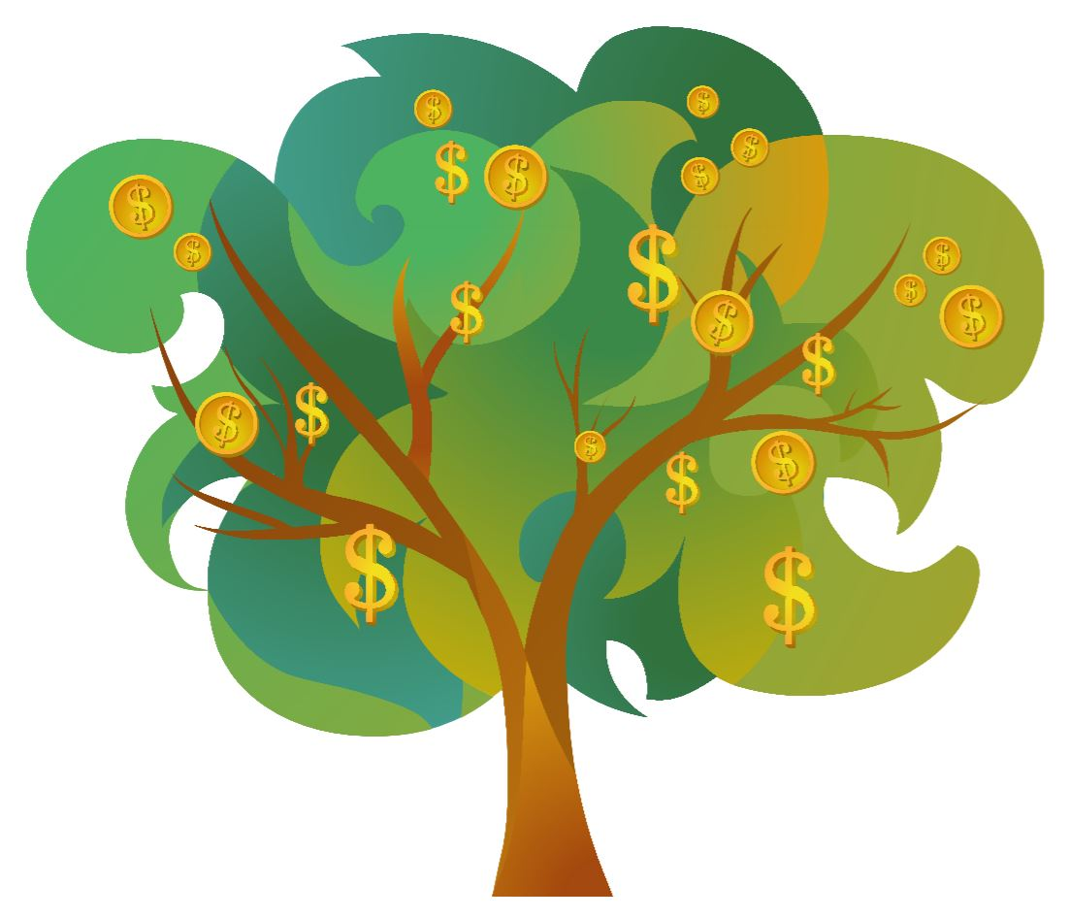
APPENDIX B
Sample Money
APPENDIX B

