About this Lesson
In this lesson, students compare costs associated with participating in various sports and graph the results. Students then consider ways families can stay fit without spending a lot of money.

Grade Level | Course(s)/subject(s) | Learning Goal(s) | Suggested  Timing
5 | Mathematics  Health & Physical Education | At the end of this lesson, students will:  - use financial symbols and terminology  - make simple financial decisions for simulated situations for amounts up to $1,000  - conduct simulated purchases for amounts up to $1,000  - identify reasons and ways to save money | 40–60 minutes

Curriculum Links
Mathematics, grades 1–8 (2005) Mathematics
Number sense and numeration
- read, represent, compare and order whole numbers to 100,000, decimal numbers to hundredths, proper and improper fractions, and mixed numbers
- solve problems involving the multiplication and division of multi-digit whole numbers, and involving the addition and subtraction of decimal numbers to hundredths, using a variety of strategies

Data Management
- collect and organize discrete or continuous primary data and secondary data and display the data using charts and graphs, including broken-line graphs
- read, describe and interpret primary data and secondary data presented in charts and graphs, including broken-line graphs

Curriculum Links (cont’d.)
Health & Physical Education, grades 1–8 (2015), Physical Education
Active Living
A2. Demonstrate an understanding of the importance of being physically active, and apply physical fitness concepts and practices that contribute to healthy, active living.

A3. Demonstrate responsibility for their own safety and the safety of others as they participate in physical activities.

Inquiry Question
What are the costs associated with participating in organized sports?

Materials List
- Pencil crayons, ruler
- Examples of bar graphs (see Appendix A)
- Graph paper
- Student copies of worksheets (Appendix B):
  - Hockey player equipment costs
  - Soccer player equipment costs
  - Basketball player equipment costs
  - Ballet dancer equipment costs
  - Swimmer equipment costs

Timing  (Mins.) |  | Lesson Sequence |  | Assessment for and as Learning Opportunities (self/peer/teacher)
MINDS ON
10–15 minutes |  |  | WHOLE CLASS  Ask students to describe various sports and/or physical activities that they enjoy, especially those requiring safety equipment or specialized dress or uniforms.  Record student responses on chart paper or board.  Select one sport from the answers provided. To add variety to the lesson, select a sport for this teacher-directed example that is not included on the worksheets. Additional sports could include lacrosse, gymnastics, fencing, judo, skateboarding, football, baseball, figure skating or snowboarding.  Choose a sport and draw a stick figure on the board. Have student volunteers draw the equipment needed for that sport on or next to the figure. Explain to students that the items required to play this sport cost money. Provide approximate costs for the equipment they have drawn by labelling those costs on the figure. Add up the total together.  Explain that in today’s lesson students will be comparing the costs of different sports that require equipment and that they will then organize their data into bar graphs to analyze fees and expenses associated with different sports. | Assessment FOR Learning
Context for Learning
Students should be familiar with how to construct a simple bar graph, addition and unit rate.

Timing  (Mins.) |  |  | Lesson Sequence | Assessment for and as Learning Opportunities (self/peer/teacher)
 | ACTION
 | 20–30 minutes | WHOLE CLASS  Instruction  - Using a data projector or on chart paper, show students examples of several bar graphs (e.g., favourite ice cream flavours – Appendix A). Ask students to interpret the representation.  - Encourage students to generate conclusions about what aspects of a bar chart make it useful.  - Conduct a quick survey to determine a class preference (e.g., favourite ice cream, pet or sport) to help teach the value and purpose of a graph.  - Describe and show where to place information on the  x- and y-axes.  - Describe how the increments are evenly spaced and count by 1s, 5s, 10s or other numbers, which are easy to skip-count.  Explain that students will be developing their own bar graphs using information that they will have calculated about the costs of five sports (hockey, soccer, basketball, swimming and ballet dancing). |  | Assessment FOR Learning (Teacher Observation)
 | ACTION (cont’d.)
 |  | PAIRS/SMALL GROUPS  Activity: Making graphs  Working in pairs or trios,  - Distribute worksheets for hockey, soccer, basketball, ballet dancing and swimming (see worksheets in Appendix B), as well as one sheet of graph paper per pair/trio.  - Help students add up the equipment costs of each sport.  - Using the totals from the worksheets, have students create a bar graph showing the cost of each sport: hockey, soccer, basketball, swimming and ballet dancing. Note: Students may point out that some costs are higher or lower, given their understanding. Point out that this is according to whether or not the consumer buys name brand, celebrity-endorsed or used equipment. |  | Assessment AS Learning (Self/Peer)

Timing  (Mins.) |  |  | Lesson Sequence | Assessment for and as Learning Opportunities (self/peer/teacher)
 | ACTION (cont’d.)
- Remind students to use the x-axis to show the five different sports. Suggest that students use the y-axis to show the cost amounts in increments of $50.
- Explain that while league and membership fees are explained on the worksheets, students will be graphing equipment costs only.
- Have students colour in the bars of their graph and explain that this technique can be used to improve the readability of the graph.
- Optional – have students produce the graph using a computer.
CONSOLIDATION/DEBRIEF
10–15 minutes |  | WHOLE CLASS  Gallery walk  Display a variety of student graphs on the classroom walls and encourage a gallery walk around the room.  Rank the sports investigated by the class from most expensive to least expensive. |  | Assessment AS Learning (Peer)
 |  | WHOLE CLASS or INDIVIDUALLY  Discuss the questions below as a class or ask students to journal one question:  - Should the cost of a sport or activity determine whether or not someone is able to participate? Explain.  - How can a school or community organization help those in need participate in an expensive sport?  - Think of three ways by which families can keep fit without spending any money.  - The cost of a sport or activity could also be an investment. Why? |  | Assessment AS Learning (Self)

Sample Bar Graph
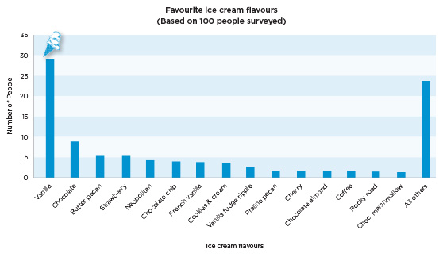
APPENDIX A
Cost Worksheets
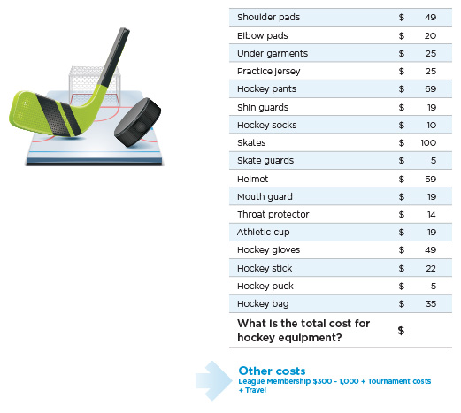
The Cost of Playing Hockey
APPENDIX B
Cost Worksheets (cont’d.)
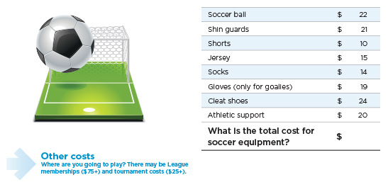
The Cost of Playing Soccer
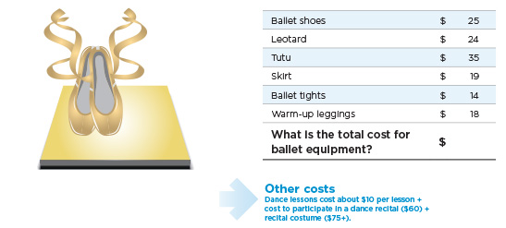
The Cost of Ballet
APPENDIX B
Cost Worksheets (cont’d.)
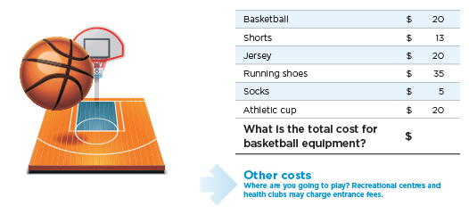
The Cost of Playing Basketball
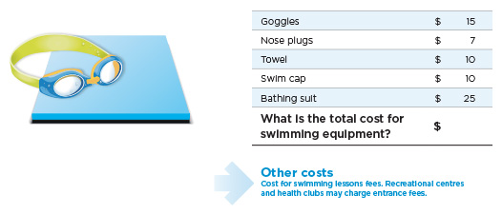
The Cost of Swimming
APPENDIX B

