About this Lesson
This lesson explores the cost of music piracy from the point of view of artists, composers, consumers and other stakeholders in the Canadian music industry. The lesson includes a focus on Canada’s Copyright Act to clarify legal and ethical issues surrounding the licensing, reproduction and digital distribution of music.

Grade Level | Course(s)/subject(s) | Learning Goal(s) | Suggested  Timing
9–12 | AMU1O/2O – Music  ASM2O Media Arts  Also Law and Canadian Studies courses  CIC4E Making Personal Economic Choices | At the end of this lesson, students will:  - describe laws and regulations that affect financial life (e.g., taxes, savings policies and laws, consumer protection, etc.)  - describe responsibilities of individuals and organizations to act ethically and in socially responsible ways  - explore post-secondary opportunities (further education and careers) related to each subject area studied | One period

Curriculum Links
The Arts, grades 9 and 10 (2010)
Music (AMU10/2O)
Foundations
C3.3 Identify ethical and legal responsibilities associated with music.

Reflecting, responding and analyzing
- identify and describe a variety of music-related work opportunities that reflect their own skills and knowledge

Curriculum Links (cont’d.)
Media Arts (ASM2O)
Foundations
C3.2 Describe some ethical and legal practices associated with media arts, particularly with respect to copyright laws, and apply these practices when creating media art works.

Making Personal Economic Choices (CIC4E)
Market Fundamentals
D1.2 Explain how and why producers and consumers participate in grey and black markets, and analyze some consequences of participation in these markets.

Inquiry Question
How does music piracy affect the individuals involved and what effect does it have on society
in general?

Materials List
- MP3 player and speakers
- Internet access
- Projector and screen
- Pre-recorded class performance of a musical piece
- Electronic devices with Internet access and web browsing capability (e.g., computers, smartphones, tablets, etc.)
- Student copies of Canada’s Copyright Act (Appendix A)
- Student copies of Perspective on Music Piracy Handout (Appendix B)
- Anti-Piracy Cards (Appendix C)

Timing  (Mins.) | Lesson Sequence |  | Assessment for and as Learning Opportunities (self/peer/teacher)
MINDS ON
 | Listening  Play a recording of the class, band or symphony performing a musical piece. (Record the class in advance or choose a recording that is copyright-approved for public performance.)  Think-Pair-Share  Prompt students to discuss the steps a person would take if they wanted to distribute 100 copies of that recording to share with other students in the school. (Students may respond with ideas that don’t consider copyright. For  example, “Create MP3 file and share it by email.”)  Word wall  Create a word wall on the board with the following terms: Royalties, Public Domain, Copyright, Music Piracy, Stakeholders, Music Industry, Legal, Illegal, Ethical, Unethical, File Sharing. Explain that these terms and concepts will be explored in today’s lesson. |  | Students will perform a role play to demonstrate their understanding of the ethical and legal aspects  of music piracy by examining the issue from the perspectives of the  music consumer, the artist/composer and  other music industry stakeholders.  Collect: Perspectives on Music Piracy (Appendix B)
Context for Learning
Bill Fold is a character who is constantly getting himself into financial scrapes. Use the scenario below to provide students with a context for learning.
Bill decides to download some free music from a website that his friend has told him about. The next day, he receives a notice from his Internet provider warning him that if he participates in illegal downloading again, they will shut down his Internet service. Until he received this warning, Bill did not know that downloading music for free was wrong. What should he have considered before taking his friend’s advice?

Timing  (Mins.) |  | Lesson Sequence |  | Assessment for and as Learning Opportunities (self/peer/teacher)
ACTION
Instructions
After sharing student responses from the Think-Pair-Share, describe the legal and ethical steps involved in making and distributing a musical recording by introducing the concept of music “royalties.”
Explain that unless a piece of music is in the “public domain” (e.g., was composed before a certain point in history), the composer of the music is to be paid a royalty for every copy of the composition that is recorded and distributed.
In order to be paid a royalty, musicians and producers must obtain copyright permission from the composer and register the piece with a musical rights agency.
Explain that one of the organizations in Canada that provides this service is called the Society of Composers, Authors and Music Publishers of Canada (SOCAN). Agencies like SOCAN help to track how many copies of a piece are sold so that the musical artist and composers receive an appropriate percentage of the sales revenue from the download or CD sale of their piece. (Show SOCAN website on-screen, if possible.)
Explain that many digital file-sharing sites have been criticized because they do not track a song’s use and, in many cases, no royalties or artist payments are collected on behalf of the composer or musicians for the recording’s use.
Thus, downloading free music by a consumer using an unauthorized file-sharing website is, at the very least, unethical and, in many cases, illegal.
Emphasize that it is a music consumer’s responsibility to learn more about the websites they are using to download music.
As a class, have students brainstorm some of the benefits of acquiring an authorized digital copy of music (possible suggestions could include: it is legal, composers and artists are paid, file does not get damaged, accessible from the Internet, does not take up physical space, cannot be stolen from you, better protected from computer viruses, jobs are created by the new distribution method).

Timing  (Mins.) |  | Lesson Sequence |  | Assessment for and as Learning Opportunities (self/peer/teacher)
ACTION (cont’d.)
Brainstorm
Ask students to think about various careers in the music industry. Create a list on the board (answers will likely include producers, artists, labels, marketers, etc.).
Briefly discuss the financial consequences of piracy on each stakeholder in the Canadian music industry.
Hand out copies of Canada’s Copyright Act (Appendix A) and provide highlighters to each student or provide electronic copies for students who use computers. Explain that this act is in place to protect artists and their compositions. This act prohibits the replication of music without permission from the copyright holder and sets the rules regarding legal permissions for use.
Encourage students to work in pairs and to read an appropriate section of the copyright act in a read-aloud to a partner. Suggest that students attempt to interpret
any of the rules that pertain to music by writing their interpretation of the law in plain language next to each clause. Assist in the interpretation of the document after the partner read-aloud is complete.
Role play
To reinforce understanding of the consequences of piracy and copyright infractions, have students create a role play that highlights the issues and consequences of music downloading from the perspectives of different stakeholders. Assign one of the perspectives below to each group. You can provide the scenarios or students can make up their own situation to highlight the perspective.
- Musician
- Director of a music company
- Copyright lawyer
- Consumers of music
- Company involved in distributing illegal copies of music
- Online users who participate in file sharing
Have groups perform the role play.

 | Timing  (Mins.) | Lesson Sequence | Assessment for and as Learning Opportunities (self/peer/teacher)
CONSOLIDATION/DEBRIEF
During and after each perspective has been presented within the role play, invite students to complete the Music Royalties Perspective Handout (Appendix B).
Option: Assign this as homework so that students can perform further research.
Ask students to reflect on the following questions:
- What are some of the financial effects on the Canadian music industry when consumers use unauthorized sources to download music?
- Who is to blame for music piracy?
- What are some of the justifications people use when obtaining unauthorized copies of digital music?
- What are ethical methods for obtaining an authorized copy of digital music?
Offer to have students sign an Anti-Piracy Card
(Appendix C) in support of artists and the Canadian
music industry.

Sample from Canada’s Copyright Act
Copyright Act R.S.C., 1985, c. C-42
Note: this Act was amended by Copyright Modernization Act S.C. 2012, c. 20

PART I
Copyright and Moral Rights in Works
Copyright
Copyright in works
3. (1) For the purposes of this Act, “copyright”, in relation to a work, means the sole right to produce or reproduce the work or any substantial part thereof in any material form whatever, to perform the work or any substantial part thereof in public or, if the work is unpublished, to publish the work or any substantial part thereof, and includes the sole right.
- to produce, reproduce, perform or publish any translation of the work,
- in the case of a dramatic work, to convert it into a novel or other non-dramatic work,
- in the case of a novel or other non-dramatic work, or of an artistic work, to convert it into a dramatic work, by way of performance in public or otherwise,
- in the case of a literary, dramatic or musical work, to make any sound recording, cinematograph film or other contrivance by means of which the work may be mechanically reproduced or performed,
- in the case of any literary, dramatic, musical or artistic work, to reproduce, adapt and publicly present the work as a cinematographic work,
- in the case of any literary, dramatic, musical or artistic work, to communicate the work to the public by telecommunication,
- to present at a public exhibition, for a purpose other than sale or hire, an artistic work created after June 7, 1988, other than a map, chart or plan,
- in the case of a computer program that can be reproduced in the ordinary course of its use, other than by a reproduction during its execution in conjunction with a machine, device or computer, to rent out the computer program, and in the case
- of a musical work, to rent out a sound recording in which the work is embodied,
- in the case of a work that is in the form of a tangible object, to sell or otherwise transfer ownership of the tangible object, as long as that ownership has never previously been transferred in or outside Canada with the authorization of the copyright owner, and to authorize any such acts.

Source: http://laws-lois.justice.gc.ca/eng/acts/C-42/FullText.html
APPENDIX A
Handout: Perspective on Music Piracy
Reflect on how music piracy affects each stakeholder in the music industry.
- Explain how royalty payments are structured for this stakeholder.
- Comment on the position you believe the stakeholder would take on music piracy.
- Explain any actions that you believe should be taken by the individual or group to reduce and eliminate music piracy in Canada.

Perspective #1: Musicians/composer
1. Royalty Structure  ______________________________  ______________________________  ______________________________ | 2. Stakeholder’s position  ______________________________  ______________________________  ______________________________
3. Your ideas about how musicians/composers could help prevent music piracy
______________________________________________________________________________
______________________________________________________________________________
______________________________________________________________________________
Perspective #2: Copyright lawyer
1. Royalty Structure  ______________________________  ______________________________  ______________________________ | 2. Stakeholder’s position  ______________________________  ______________________________  ______________________________
3. Your ideas about how copyright lawyers could help prevent music piracy
______________________________________________________________________________
______________________________________________________________________________
______________________________________________________________________________

APPENDIX B
Handout: Perspective on Music Piracy (cont’d.)
Perspective #3: Consumer/purchaser of legal music
1. Royalty Structure  ______________________________  ______________________________  ______________________________ | 2. Stakeholder’s position  ______________________________  ______________________________  ______________________________
3. Your ideas about how consumers could help prevent music piracy
______________________________________________________________________________
______________________________________________________________________________
______________________________________________________________________________
Perspective #4: Website providers
1. Royalty Structure  ______________________________  ______________________________  ______________________________ | 2. Stakeholder’s position  ______________________________  ______________________________  ______________________________
3. Your ideas about how website providers could help prevent music piracy
______________________________________________________________________________
______________________________________________________________________________
______________________________________________________________________________

APPENDIX B
Anti-Piracy Cards
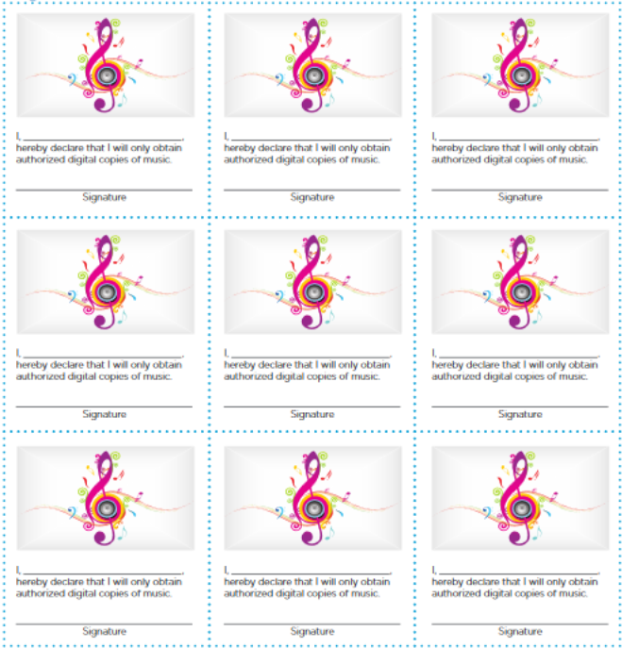
APPENDIX C

