About this Lesson
Students will calculate and compare the cost of caring for different pets for one year and explore some of the personal benefits of owning a pet.

Grade Level | Course(s)/subject(s) | Learning Goal(s) | Suggested  Timing
6 | Mathematics | At the end of this lesson, students will:  - use financial symbols and terminology  - make simple financial decisions using a budget template  - compare the benefits and costs of spending decisions | 40–50 minutes

Curriculum Links
Mathematics, grades 1–8 (2005)
Number sense and numeration
- read, represent, compare and order whole numbers to 1,000,000, decimal numbers to thousandths, proper and improper fractions, and mixed numbers
- solve problems involving the multiplication and division of whole numbers, and the addition and subtraction of decimal numbers to thousandths, using a variety of strategies
- demonstrate an understanding of relationships involving per cent, ratio and unit rate

Data management and probability
- collect and organize discrete or continuous primary data and secondary data and display the data using charts and graphs, including continuous line graphs
- read, describe and interpret data, and explain relationships between sets of data

Inquiry Question
Do the financial costs outweigh the personal benefits of owning and caring for a pet?

Materials List
- Chart paper and markers
- Student copies of Pet Expense Table (Appendix A)
- Student copies of Calculating the Cost of My Pet in the First Year (Appendix B)
- Student copies of My Furry Friend Reflection Sheet (Appendix C)
- My Furry Friend Rubric (Appendix D)
- Images of Seven Pets (Appendix E)
- Pet Cards (Appendix F)

Timing  (Mins.) |  | Lesson Sequence |  | Assessment for and as Learning Opportunities (self/peer/teacher)
MINDS ON
5–10 minutes |  | WHOLE CLASS/SMALL GROUPS  Learning stations  Before the start of class, set up seven learning stations by moving desks into groups of up to five. Post an image of a different pet on the wall near each station (Appendix E) and hang a piece of chart paper close to the pet image.  As students enter the classroom, invite them to look at the images on the wall and have them sit in the station near the animal they think would make the best pet.  Be sure to even out the group numbers if a significantly large number of students select only one or two animals. (Ask students to consider moving to their second choice.)  Have each group discuss and determine the benefits of owning the pet they selected. Ask groups to share their thinking with the class. |  | Assessment FOR Learning (Teacher Observation)
Context for Learning
- ensure that you are familiar with the personal situation of children in the class
- be mindful of wealth issues that might arise when students begin discussing pets
ACTION
20–30 minutes | WHOLE CLASS  Explain to students that in today’s lesson they will be examining the cost of pet ownership in the first year by calculating expenses associated with their animal.
 | Brainstorm  While students are in their co-operative groups, direct them to think of all possible expenses associated with their pet of choice. Invite students to record their ideas with a marker on the chart paper hanging near their station.  Instruction  Hand out the Pet Expense Table (Appendix A) to each student. Introduce students to the various costs of pet ownership, and identify any items that they did not record during their brainstorming.  Model sample calculations on the board to help students understand how to represent relationships using unit rates. (For example: If treats for my dog cost $2.75 per bag and I buy a bag of treats for my dog six times a year, what is the total?) |  | Assessment FOR Learning (Peer)
 | INDIVIDUALLY  Using the Calculating Pet Costs in the First Year Handout (Appendix B), have students individually calculate the total cost of pet ownership for the first year. Emphasize that students must show their work on the sheet.  Remind students that some of the costs are only calculated once (e.g., the cost of buying the animal), whereas other costs are per month (e.g., the food). |  | Assessment AS Learning (Self)

 | Timing  (Mins.) | Lesson Sequence | Assessment for and as Learning Opportunities (self/peer/teacher)
CONSOLIDATION/DEBRIEF
10–15 minutes |  | SMALL GROUPS  Presentation of findings  While in their groups, encourage students to share their first year pet ownership costs with each other. | Assessment AS Learning (Peer)
 |  | Using the My Furry Friend Reflection Sheet (Appendix C), foster discussion by asking students the following:  - Which pet would be the most rewarding to own?  Why?  - Are there other costs involved in caring for a pet that do not cost money?  - Now that you know the costs of keeping your pet, would you change your choice?  Why or why not?  - Which math strategies are the most useful in helping a person calculate expenses over time? | Assessment AS Learning (Self)

Pet Expense Table
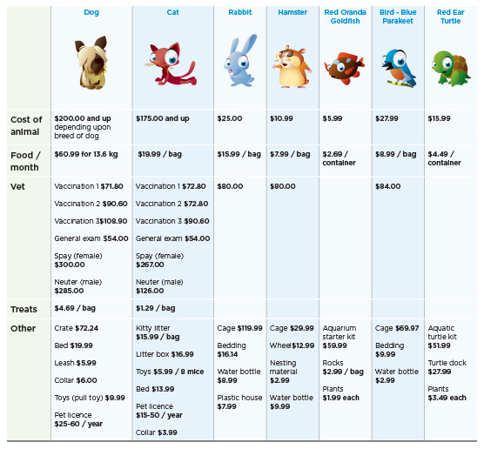
Please note: Costs are based on 2011 prices.
APPENDIX A
Calculating Pet Costs in the First Year
My Name:__________________________ Pet’s Name: _____________________________

Expenses | Instruction: Use the Pet Expense Table as a reference to calculate the various costs associated with owning your pet in the first year.  Show your calculations in the fields below and be sure to explain your reasoning for certain choices. (e.g., how often would you buy food for your pet?) | Cost per year
Cost to purchase the pet
Food per month
Veterinarian
Treats
Other
Total cost of your pet for a year

APPENDIX B
Reflection Sheet
Name: ____________________________________ Date: ___________________________

The most expensive pet per year is: __________________________________________________

The least expensive pet per year is: __________________________________________________

List the pets in order of expense from least to most:
- ________________________________________
- ________________________________________
- ________________________________________
- ________________________________________
- ________________________________________
- ________________________________________
- ________________________________________

Based on what you know regarding pet expenses, which pet would you choose? Why?
(You may choose any of the pets, but support your answer as to why the pet you chose would be worth it.)
_________________________________________________________________________
_________________________________________________________________________
_________________________________________________________________________

How can mathematics help you to understand expenses over time? Why is this important?
_________________________________________________________________________
_________________________________________________________________________
_________________________________________________________________________
_________________________________________________________________________
APPENDIX C
Rubric
Category | Level 1 | Level 2 | Level 3 | Level 4
Mathematical concepts | Explanation shows inadequate understanding of the mathematical concepts used to solve problem. | Explanation shows partial understanding of the mathematical concepts used to solve the problem. | Explanation shows considerable understanding of the mathematical concepts used to solve problem. | Explanation shows full understanding of the mathematical concepts used to solve the problem.
Mathematical reasoning | Little evidence of mathematical reasoning shown. | Some evidence of mathematical reasoning shown. | Uses efficient mathematical reasoning. | Uses intricate  and sophisticated mathematical reasoning.
Mathematical errors | The mathematical solutions have many errors. | The mathematical solutions have some errors. | The mathematical solutions have minor errors. | The mathematical solutions have few or no errors.
Completion | The problem and reflection are missing many components. | The problem and reflection are missing some components. | The problem and reflection are completed in full. | The problem and reflection are completed in full. Extra details added (pictures or detailed explanations).
Mathematical reflection and explanation | The reflection and explanation are difficult to understand or are incomplete. | The reflection and explanation include critical components, but lack clarity. | The reflection and explanation are clear. | The reflection and explanation are detailed and clear.

Comments: ______________________________________________________________________
________________________________________________________________________________
Student’s Name: _______________________________ Mark: ________________________
APPENDIX D
Pets – Dog
APPENDIX E
Pets – Cat
APPENDIX E
Pets – Rabbit
APPENDIX E
Pets – Hamster
APPENDIX E
Pets – Goldfish
APPENDIX E
Pets – Parakeet
APPENDIX E
Pets – Turtle
APPENDIX E
Pet ID Sample Cards
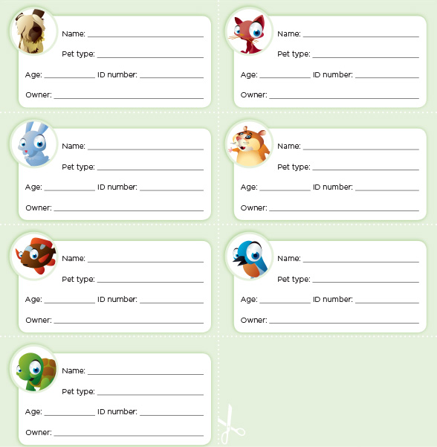
APPENDIX F

