About this Lesson
This lesson teaches students how to calculate money amounts and make change by conducting simulated purchases through a classroom store activity.

Grade Level | Course(s)/subject(s) | Learning Goal(s) | Suggested  Timing
5 | Mathematics | At the end of this lesson, students will:  - identify forms of money  - conduct simulated purchases for amounts up to $1,000 | 40–50 minutes

Curriculum Links
Mathematics, grades 1–8 (2005)
Number Sense and Numeration
- read, represent, compare and order whole numbers to 100,000, decimal numbers to hundredths, proper and improper fractions, and mixed numbers

Inquiry Question
How can a simulation of a store in our classroom help us better understand how commerce works in the real world?

Materials List
- Have students bring to class pictures of five items from magazines, flyers or catalogues that they want to sell during the classroom store activity (or teacher can provide magazines, flyers and catalogues for this purpose).
- Observation Checklist (Appendix A)
- Chart paper (cut into strips) and markers
- Blank stickers to use as price tags
- Play Money (Appendix B) Note: if play money is not available, students can draw the bills and coins they would give as change on a small piece of paper
- Five Receipt Templates per student (Appendix C)

Timing  (Mins.) | Lesson Sequence | Assessment for and as Learning Opportunities (self/peer/teacher)
MINDS ON
5–10 minutes | SMALL GROUPS  Provide a strip of paper and a marker to every student.  Organize students into groups and ask them to brainstorm different retail stores they know which sell products (as opposed to services).  Have each student use a marker to record at least one store name on the strip of paper.  Collect the strips of paper and, with the students’ help, sort stores into categories (e.g., grocery, clothing, toy stores, etc.) by taping paper strips under each category heading.  WHOLE CLASS  Ask students if they have ever tried to sell or market items they have owned, and encourage them to elaborate as to how and where they did this. (Answers might include garage sales, lemonade stands, paper routes, online auctions with parents, etc.)  Ask students to explain the difference between a buyer and a seller and then define the word “retailer.”  Have students comment on any issues that retailers might need to consider as they prepare items for sale (money for change, quality of product, pricing, ethical advertising). | Assessment FOR Learning (Teacher observation)

Timing  (Mins.) |  | Lesson Sequence |  | Assessment for and as Learning Opportunities (self/peer/teacher)
MINDS ON (cont’d.)
Explain to students that today they will be setting up a storefront and that each person will have a chance to sell items to their classmates using play money.
The learning goals of the activity are to think about the process involved in selling something to the public and to practise making correct change.
Context for Learning
It is suggested that students participate in the activity “Counting Change” before they undertake this activity to ensure they have an understanding of rounding and making change.
ACTION
20–30 minutes | WHOLE CLASS/SMALL GROUPS  Activity: Classroom store  Set up  Arrange students in groups of four and have them set up their desks as a storefront/selling area.  Let the groups decide how they will display, organize and promote the items (images) that they have brought to sell (e.g., encourage students to post their images on the wall or poster board, etc.).  Have students invent a store name and encourage groups to co-operate in making a sign, jingle or motto to advertise their store and its items.  Instruction  Provide guidelines for pricing items and model examples of how to make change with bills and coins by conducting several demonstrations with the class. Explain the idea of a “float” and how it is used. Define and explain the term “transaction.”

Timing  (Mins.) |  | Lesson Sequence |  | Assessment for and as Learning Opportunities (self/peer/teacher)
ACTION (cont’d.)
20–30 minutes | In their small groups, have students discuss appropriate prices for their items. Students then label their images of items with price stickers. Encourage students to select prices that will require them to make change (for example, $17.99).  Provide each group with a float for making change. (Suggestion – give each group a shoebox in which to store their float/play money.) Remind the group to count their float in advance of selling and have them remember the amount or record it on their shoebox.  Recording transactions  Divide the class into buyers and sellers. Explain that one-half of the class will sell their products first, while the other half will walk around the room making purchases.  Provide ample play money to the buyers and hand out five Receipt Templates (Appendix C) to the sellers.  Before the stores are open for business, model to the class how to record transactions on the receipts (Appendix C). Be sure to make it clear that each seller must produce a receipt for every product sold. |  | Assessment AS Learning (Peer)
 | After 15 minutes, have buyers and sellers switch roles.  While students are participating in the activity, use the Observation Checklist (Appendix A) to check on individual student’s understanding. |  | Assessment AS Learning (Teacher – Observation)

 | Timing  (Mins.) |  | Lesson Sequence |  | Assessment for and as Learning Opportunities (self/peer/teacher)
CONSOLIDATION/DEBRIEF
10–15 minutes |  | SMALL GROUPS  Help groups add up the money they made from selling their items and then show them how to subtract the float to obtain their sales total. Have groups share their totals with the class. |  | Assessment AS Learning (Peer)
 |  | WHOLE CLASS  As a class, have students discuss some of the challenges they encountered when selling and making change by answering the following questions:  - What was the most difficult part of making change?  - Were there any tricks you used to help you calculate the correct change?  - What selling techniques worked best?  - Why do you think it is important for retailers to keep a record of their transactions? |  | Assessment AS Learning (Teacher – Whole Class)

Observation Checklist
Date: ______________________

Student name | Marketing strategy | Appropriate  pricing | Actively engaged in selling and buying | Makes correct change | Able to add up money they have made

APPENDIX A
Play Money
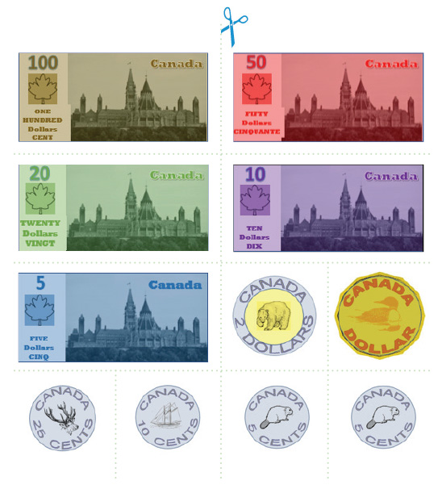
APPENDIX B
Receipt Template
Hand out five to each student before activity begins.
Transaction Receipt
Name of Seller: ____________________
Date: ____________________________
Item Name: _______________________
Cost of Item: ______________________
Cash received: _____________________
Change given back: _________________
Signature of buyer: _________________
Transaction Receipt
Name of Seller: ____________________
Date: ____________________________
Item Name: _______________________
Cost of Item: ______________________
Cash received: _____________________
Change given back: _________________
Signature of buyer: _________________
Transaction Receipt
Name of Seller: ____________________
Date: ____________________________
Item Name: _______________________
Cost of Item: ______________________
Cash received: _____________________
Change given back: _________________
Signature of buyer: _________________
Transaction Receipt
Name of Seller: ____________________
Date: ____________________________
Item Name: _______________________
Cost of Item: ______________________
Cash received: _____________________
Change given back: _________________
Signature of buyer: _________________
APPENDIX C

