About this Lesson
In Canada, universal health care is something many of us take for granted. Given these tough economic times, can we afford to maintain the system in its current form? This lesson explores the financial implications of health care spending through a tableau activity.
This is intended as an introduction to the issue of health care policy as it relates to financial literacy and should be followed by further study about the intricacies of social policy.

Grade Level | Course(s)/subject(s) | Learning Goal(s) | Suggested  Timing
10 | CHV2O – Civics and Citizenship | At the end of this lesson, students will:  - identify the forms of government and their responsibilities  - understand the need to plan for the future  - describe laws and regulations that affect their financial life (e.g., taxes, savings  - policies and laws, consumer protection, etc.) | Two  periods

Curriculum Links
Canadian and World Studies, grades 9 and 10 (2013)
Civics and Citizenship (CHV2O)
Political inquiry and skill development
A1.1 Formulate different types of questions to guide investigation into issues, events, and/or developments of civic importance.

A1.6 Evaluate and synthesize their findings to formulate conclusions and/or make informed judgments or predictions about the issues, events, and/or developments they’re investigating.

Developing transferable skills
A2.3 Apply the concepts of political thinking when analyzing current events and issues involving Canada and the world.

Curriculum Links (cont’d.)
Civic Issues, democratic values
B2.1 Identify the political parties in Canada and their position on the political spectrum, and explain how the beliefs/values that underpin them may affect their perspectives on and/or approaches to issues of civic importance.

Civic engagement and action
C2.1 Analyze ways in which various beliefs, values and perspectives are represented in their communities, and assess whether all perspectives are represented or are valued equally.

Inquiry Questions
What are the areas of responsibilities of the various levels of government in the Canadian health care system, and what if any are the limitations to their responsibilities?

Materials List
- 2 Truths And A Lie: Health Care Edition (Appendix A) with a different grouping of statements cut out for each of the three groups
- Tableau Fact Sheets for each group (Appendix B)
- Tableau Peer Response (Appendix C)
- Tableau Reflection Rubric (Appendix D) or develop a rubric in class

Timing  (Mins.) | Lesson Sequence | Assessment for and as Learning Opportunities (self/peer/teacher)
MINDS ON
Two truths and a lie
Engage the students in the lesson by using the two truths and a lie strategy. Divide class into three groups, and distribute a set of three health care statements (Appendix A) to each group.
Have students share their three statements with the class. Ask the class to guess which one of the three statements is the lie.
Conclude the Minds On activity by pointing out that health care is a complex issue and that today’s activity will help students understand some basic issues regarding the management of the system, as well as its costs and benefits.

Timing  (Mins.) |  | Lesson Sequence |  | Assessment for and as Learning Opportunities (self/peer/teacher)
MINDS ON (cont’d.)
Context for Learning
Bill Fold is a character who is constantly getting himself into financial scrapes. Use the scenario below to provide students with a context for learning.
Bill Fold is away on vacation. He has fallen and he can’t get up! He calls the paramedics, and is taken to the hospital by ambulance. He’s examined, kept for medical observation for a day and released. He receives a bill for nearly $6,000 based on the following costs:
- Ambulance: $540
- Emergency room visit: $715
- Magnetic Resonance Imaging (MRI) test: $1,750
- One day in the ward: $3,055
Bill didn’t bank on such an expensive vacation. What should he have done? Would this have happened if he’d been back home in Ontario?
ACTION
 | Tableau  If students have not used tableau as a form of expression, spend a few moments discussing it.  Explain that tableau is a form of drama that creates a still “portrait.” Compare the dramatic form to a photograph, which is in essence a still scene. Have students offer examples of how people can express ideas, emotions, values and other forms of information using only the positioning of their bodies, props and facial expressions. Either model some examples or have three or four students create a “freeze” (example could include a frozen moment showing three people at a football game while their team is losing).  Divide the class into three groups, explaining that each group will present a tableau to help convey information about how money is spent on our health care system in Canada.  Explain that each group will receive a fact sheet and that they will have 15 minutes to read the content and create a still tableau with three to four frames (freezes) that convey pertinent information from their sheet. |  | Collect: Tableau Peer Response (Appendix C)  Use: Tableau Reflection Rubric (Appendix D)

 | Timing  (Mins.) |  | Lesson Sequence |  | Assessment for and as Learning Opportunities (self/peer/teacher)
 | ACTION (cont’d.)
Explain that students will transition through the still frames one by one by ringing a bell or flipping the lights to signal each new scene.
Emphasize that each person in the group should participate in at least one of the freezes. Ensure that each group also assigns a narrator who will describe to the class the story of each dramatic frame. As each group presents their tableau, spectators should take notes using the Tableau Peer Response Handout (Appendix C).
CONSOLIDATION/DEBRIEF
Summarize the lesson by discussing the following:
- Which levels of government do you believe should be involved in health care? How or why?
- What groups or individuals are most in need of health care?
- Are there any medical expenses that are not covered by our health care system?
- What could someone do to protect themselves from:
- Medical expenses that are not covered by our health care system; and
- Unexpected medical expenses when travelling out of country?
- There has been a lot of discussion about implementing a two-tiered health care system.
- How would a two-tiered system affect individual Canadians and the health care industry?
- What groups/communities might benefit or be disadvantaged?
- How do you think Canada’s political parties would vote (for/against) on the issue of a two-tiered health care system? Explain why.
The United States health care system experienced reform through the Patient Protection and Affordable Care Act to provide more Americans with access to health insurance, more affordable health insurance plans and an expected level of health care. How do you think Canada’s health care system compares with this new health care system?

2 Truths and a Lie: Health Care Edition
Statement group 1
- TV and film star Kiefer Sutherland’s grandfather is credited with bringing universal health care to Canada. [True: Tommy Douglas, Kiefer’s maternal grandfather, began provincial health care programs in Saskatchewan in the 1960s where he was premier.]
- Canada’s total health care spending ranks 8th among G20 countries and 12th on a per capita basis. [True: As a comparison, the U.S. ranks first on total spending, and 3rd on per capita spending according to the OECD’s 2008 report.]
- As a Canadian, you are covered for medical expenses throughout the country.
[False: You are only covered in your own province.]

Statement group 2
- Ontario doctors can open private practices and charge patients whatever fees they want. [False: Provincial ministries regulate fees that can be charged.]
- Between 60 per cent and 78 per cent of all U.S. bankruptcies involve the inability to pay medical expenses. [True: The cost of health care can be unaffordable.]
- Both federal and provincial governments are involved in health care payment and regulation. [True: Health care addresses multiple levels of government.]

Statement group 3
- In 2016, Ontario spent approximately $50 billion on health care, the most of any province. [True: The total spending on health care in Canada was approximately $228.1 billion. ]
- In Canada, the largest proportion of health care spending is on physician’s fees. [False: The largest proportion, 29.5 per cent, was spent on hospitals and other institutions in 2016. The third largest proportion, 15.3 per cent, went to physicians. Drugs accounted for 16 per cent.]
- In 2016, Nunavut health care expenditure per capita was approximately $14,301. [True: The lowest per capita spending was Quebec, at $5,822.]

https://www.cihi.ca/sites/default/files/document/nhex-trends-narrative-report_2016_en.pdf
APPENDIX A
Tableau Fact Sheets
GROUP 1 FACT SHEET: FEDERAL-PROVINCIAL ROLES

a. Medicare
- Canada’s national health insurance program is called Medicare.
- All residents have “reasonable access to medically necessary hospital and physician services, on a prepaid basis.”
- National program: Each province and territory has its own plan, with “common features and basic standards.”
- Roles and responsibilities are shared by federal and provincial-territorial governments.
- The Canada Health Act (CHA) outlines the principles governing our health care system.
- CHA: Provinces and territories must follow the act in order to get the full amount of federal payments.
- “Provincial and territorial governments are responsible for the management, organization and delivery of health services for their residents.”
- The portability criterion of the CHA requires that the provinces and territories extend medically necessary hospital and physician coverage to their eligible residents during temporary absences from the province or territory. This allows them to travel or be absent from their home province or territory and yet retain their health insurance coverage.

Source: Health Canada http://www.hc-sc.gc.ca/hcs-sss/medi-assur/index-eng.php

b. Canada Health Transfer (CHT)
- Largest federal government transfer (payment) to provinces creates long-term/predictable health care funding.
- Supports Canada Health Act by striving for “universality; comprehensiveness; portability; accessibility; and, public administration.”
- Grows by 6 per cent each year until 2013–14; $27 billion in 2011–12, and over $30 billion in 2013–14.

Source: Department of Finance Canada http://www.fin.gc.ca/fedprov/cht-eng.asp
APPENDIX B
Tableau Fact Sheets (cont’d.)
GROUP 2 FACT SHEET: INTERNATIONAL COMPARISONS (2008 OECD DATA)

A. Total per capita health spending: Private (e.g., dental, drug plans) and government
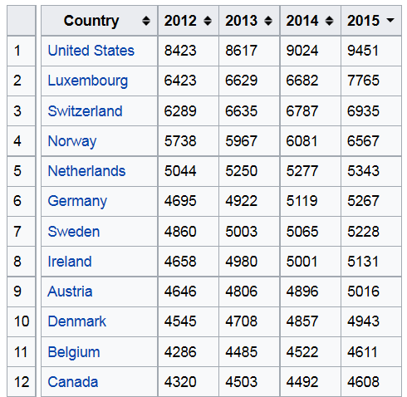

Top 12 countries ranked by 2015 data

Source: https://en.wikipedia.org/wiki/List_of_countries_by_
total_health_expenditure_per_capita

B. PUBLIC (government) per capita health spending:

Top 16 countries ranked by 2016 data

Source:
https://data.oecd.org/healthres/health-spending.htm
1
2
3
4
5
6
7
8
9
10
11
12
13
14
15
16

APPENDIX B
Tableau Fact Sheets (cont’d.)
GROUP 3 FACT SHEET: TWO-TIER HEALTH CARE?

TWO-TIER HEALTH CARE: WHAT IS IT?
The average physician in Canada sees approximately 3,150 patients per year, and sometimes wait times can be long for non-emergency medical treatments. The fees that doctors and hospitals collect are regulated. Since all fees are paid by the government for people residing in that province, doctors cannot discriminate based on how much money you have or if you can afford to pay “extra” for services. Because everyone has the same access to services, we call this a “single-tier” system.
A lot of people talk about instituting a “two-tiered” medical system in Canada. The current government-funded model only allows for government payment of medical services. But what if doctors could charge individuals for medical care with no caps or limits? What if they could open patient-paid clinics with no government-paid services at all?
In these circumstances, if a person could afford to see the patient-paid doctor, they might not have to wait for surgery, tests or even to see the doctor.

WHAT DO CANADIANS THINK?
A 2004 poll commissioned by the Montreal Economic Institute and conducted by Leger Marketing found that 51 per cent of Canadian adults want a two-tiered health care system. However, the results have been questioned since the organization that commissioned the research is in favour of a two-tiered system.
Another poll conducted by EKOS Research Associates in 2002 concluded that, given the chance, 70 per cent of Canadians would pay $1,000 to have a family member jump to the top of the list for heart bypass surgery.

WHAT ARE THE ISSUES WITH TWO-TIERED HEALTH CARE?
While some people would obviously benefit from a two-tiered system, would this be fair to all? It would mean that if a person has money to spend on health care, they might get better or more service. Opponents of the two-tiered system fear that the quality of medical services available to those with less money would suffer, since doctors might be more inclined to treat only wealthier patients. In addition, there might be fewer doctors available for government-paid health care – people might suffer.

Other relevant sources:
http://www.medical-research-papers.com/canadas-health-care-system-one-tier-versus-two-tier.html

http://induecourse.ca/on-two-tiered-medicine-in-canada/
APPENDIX B
Tableau Peer Response
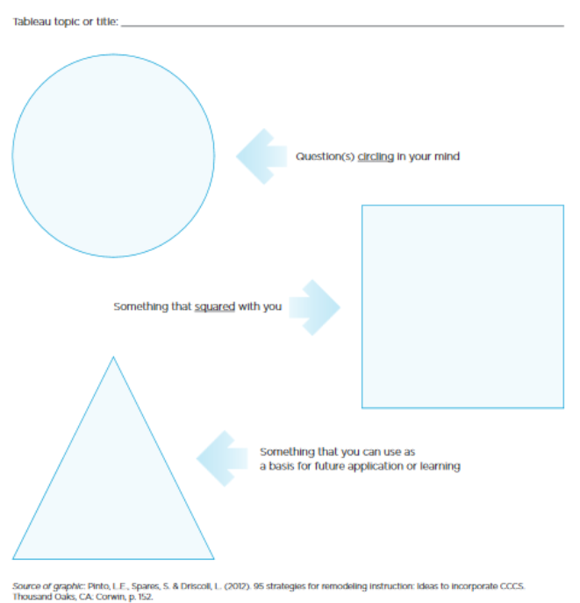
APPENDIX C
Tableau Peer Response (cont’d.)
REFLECTION
Once you have completed taking notes on the tableaus, complete a reflection that:
- Discusses your role in your own group’s tableau process, including what you contributed, and what you would do differently if you had another opportunity to create the same tableau.
- Summarizes what you learned and includes any questions that remain about health care following this activity.

Staple your response to your circle-square-triangle sheets and hand them in as a group.
APPENDIX C
Tableau Reflection Rubric
Category | Level 4  (80%–100%) | Level 3  (70%–79%) | Level 2  (60%–69%) | Level 1  (50%–59%)
Knowledge  and understanding | Worksheets and reflection demonstrate a high degree of understanding of concepts and impact on individuals. | Worksheets and reflection demonstrate considerable understanding of concepts and impact on individuals. | Worksheets and reflection demonstrate some understanding of concepts and impact on individuals. | Worksheets and reflection demonstrate limited understanding of concepts and impact on individuals.
Thinking | Questions posed in circle-square-triangle and summarized in reflection demonstrate thorough consideration of issues. | Questions posed in circle-square-triangle and summarized in reflection demonstrate considerable consideration of issues. | Questions posed in circle-square-triangle and summarized in reflection demonstrate some consideration of issues. | Questions posed in circle-square-triangle and summarized in reflection demonstrate limited consideration of issues.
Communication | Reflection conveys thorough information about the student’s role in the thought process and sense-making of tableaus. | Reflection conveys considerable information about the student’s role in the thought process and sense-making of tableaus. | Reflection conveys some information about the student’s role in the thought process and sense-making of tableaus. | Reflection conveys limited information about the student’s role in the thought process and sense-making of tableaus.
Application | Student demonstrated active participation in the tableau, based on teacher observation and on role described in reflection. | Student demonstrated considerable participation in the tableau, based on teacher observation and on role described in reflection. | Student demonstrated some participation in the tableau, based on teacher observation and on role described in reflection. | Student demonstrated limited participation in the tableau, based on teacher observation and on role described in reflection.

Comments: ______________________________________________________________________
________________________________________________________________________________
Student’s Name: _______________________________ Mark: ________________________
APPENDIX D

