About this Lesson
Forming a percussion ensemble can be expensive. This lesson explores using repurposed items to create soundscapes and rhythmic music. The lesson demonstrates that having a zero-budget need not be a barrier to making music.

Grade Level | Course(s)/subject(s) | Learning Goal(s) | Suggested  Timing
9 | AMU1O | At the end of this lesson, students will:  - identify ways to save money  - set personal goals using a problem-solving approach | 70 minutes

Curriculum Links
The Ontario Curriculum: The Arts, Grade 9–10 (2010)
Creating and performing
A3.2 Apply compositional techniques when composing and/or arranging simple pieces of music.

Reflecting, responding and analyzing
B2.1 Identify and describe ways in which traditional music reflects the society in which it was created and how it has affected communities or cultures.

Foundations
C2.2 Identify and describe shared and unique characteristics of types of music from around the world, including Aboriginal music.

Inquiry Questions
What is the correlation between using repurposed items and saving money, in the specific context
of a percussion band?

Materials List
Prior to this lesson, ask students to bring in an object from their homes that can be used as a percussive or soundscape instrument (be sure to have extra objects on hand for those who forget to bring something).
- Student copies of Repurposing an Object: Problem-Solving Model (Appendix A)
- Student copies of Musical Object Versatility Rubric (Appendix B)
- Image/video of a steel pan
- Image/video of a cajón
- Video of a percussion group playing non-traditional instruments

Timing  (Mins.) | Lesson Sequence | Assessment for and as Learning Opportunities (self/peer/teacher)
MINDS ON
Viewing/listening
Show authorized video clip of a percussion group using non-traditional instruments (such as Stomp, Blue Man Group , etc ).
Explain and then discuss the resourcefulness of the musicians in creating music with everyday/repurposed items.
Context for Learning
Bill Fold is a character who is constantly getting himself into financial scrapes. Use the scenario below to provide students with a context for learning.
Bill Fold always wanted to play a musical instrument. He believed that with just a few lessons and a brand new drum kit it wouldn’t take him long to achieve his dream of becoming a musical icon. After browsing the local music store to find a percussive instrument to play, Bill’s jaw drops. The price of the most basic drum set is way out of his reach. Even the sheet music seems expensive for his budget. Feeling a little disillusioned by the entry costs to a music career, Bill’s aspirations are dashed. That is, until he walks out of the store and accidentally trips over two metal garbage cans. The rhythmic ruckus of the clashing cans gives him a brilliant idea that might just solve his problem.

Timing  (Mins.) | Lesson Sequence | Assessment for and as Learning Opportunities (self/peer/teacher)
ACTION
 | Instructions  Display an image/show a video of a cajón. Ask students to suggest everyday items that could be used as a cajón.  Explain that the instrument originated in Peru, and that people created cajóns from shipping crates or dresser drawers. Discuss:  - Why did people create cajóns?  - Why do you think cajóns originated from materials that had already been used (dresser drawers/shipping crates), rather than new materials?  Next, display a few examples (video/image) of a variety of steel pans. Explain that the instrument originated in the Republic of Trinidad and Tobago and that people created steel pans from oil barrels.  Explain how the cajón and the steel pan instruments may give us clues about features of the communities in which they originated:  - The cajón originated from repurposed cod shipping crates, suggesting that fishing, at that time, may have been an important industry for that community and economy.  - The steel pan originated from repurposed oil drums, indicating that petroleum may have been a notable industry for that community and economy.  Partner work  Have each student share the object they have brought to class.  Ask students to consider if and/or how their objects are in some way representative of their community. Share findings with the class. | Through class discussion, ensure that students understand the correlation between using repurposed items and saving money.  Collect: Repurposing an Object: Problem-Solving Model (Appendix A).

 | Timing  (Mins.) |  | Lesson Sequence |  | Assessment for and as Learning Opportunities (self/peer/teacher)
 | ACTION (cont’d.)
Group work
Assign class to small groups of three or four students.
Have students work through the problem-solving model (Appendix A) to consider the cost efficiency and practical use of their instruments. Have members of the group assess the musical capabilities of their own object or that of a partner’s using the template provided (Appendix B).
Allow time for students to experiment with and demonstrate the range of sounds of their object in order to create a short soundscape. Encourage students to use their objects in ways that highlight the objects’ exceptionalities (outlined in Appendix B).
Allow students sufficient time to rehearse and seek input from peers.
Give students the opportunity to share their soundscapes with the class.
CONSOLIDATION/DEBRIEF
Model a variety of call and response exercises and create a full-class experience with all of the repurposed objects.
Ask students to reflect on the experience of repurposing and ask the following critical-thinking questions:
- How have individuals from various cultures found ways to make music when faced with limited financial resources?
- Describe how the object or repurposed item you played contributed to the overall composition in terms of its origin (where you found it)? What effect did it have on the music produced?
- What are the advantages and disadvantages of a repurposed instrument in comparison to using a modern instrument?
- What challenges did you face in the problem-solving process?
- How do you think Canada’s political parties would vote (for/against) on the issue of a two-tiered health care system? Explain why.

Repurposing an Object: Problem-Solving Model
Name: ___________________________ Object: ______________________________

Complete the following problem-solving steps to decide how best to use the repurposed object in your ensemble.
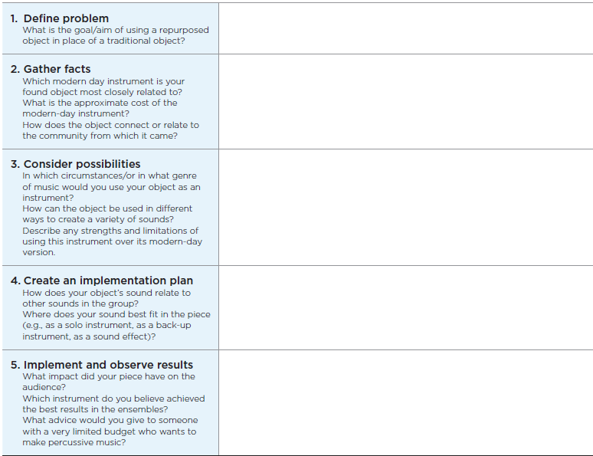

Calculate your savings:
Approximate retail price of similar modern-day instrument: $ _____________
Estimated cost of repurposed item: $ ____________
Your savings: $____________
APPENDIX A
Musical Object Versatility Rubric and Implementation Plan Rubric (2 pages)
Student’s Name: _______________________________ Mark: ________________________
Object #:________________ Description:________ ________________________________

Look for | Level 4  (80%–100%) | Level 3  (70%–79%) | Level 2  (60%–69%) | Level 1  (50%–59%)
Dynamics | Object is capable of a high degree of dynamic contrast. | Object is capable of considerable dynamic contrast. | Object is capable of some dynamic contrast. | Object has very limited dynamic contrast.
Rhythmic accuracy | Object is capable of a high degree of rhythmic accuracy. | Object is capable of considerable rhythmic accuracy. | Object is capable of some rhythmic accuracy. | Object has very limited rhythmic accuracy.
Pitch | Object is capable of sounding many pitches with a high degree of accuracy. | Object is capable of sounding many pitches with considerable accuracy. | Object is capable of sounding more than one pitch. | Object is only capable of sounding one pitch.

Comments: ______________________________________________________________________
________________________________________________________________________________
________________________________________________________________________________

APPENDIX B
Musical Object Versatility Rubric and Implementation Plan Rubric (2 pages)
Criteria | Level 4  (80%–100%) | Level 3  (70%–79%) | Level 2  (60%–69%) | Level 1  (50%–59%)
Knowledge and understanding
The student’s implementation plan reflects knowledge and understanding of topic through the use of appropriate terminology and concepts. | The plan reflects thorough knowledge and understanding of topic. | The plan reflects considerable knowledge and understanding of topic. | The plan reflects some knowledge and understanding of topic. | The plan reflects limited knowledge and understanding of concept.
Thinking and investigation
The student uses critical-thinking skills to justify and draw conclusions. | The student uses critical-thinking skills to justify and draw conclusions with a high degree of effectiveness. | The student uses critical-thinking skills to justify and draw conclusions with considerable effectiveness. | The student uses critical-thinking skills to justify and draw conclusions with some effectiveness. | The student uses critical-thinking skills to justify and draw conclusions with limited effectiveness.
Communication
The student communicates  information clearly and accurately. | The student communicates information with a high degree of clarity and accuracy. | The student communicates information with considerable clarity and accuracy. | The student communicates information with some clarity and accuracy. | The student communicates information with limited clarity and accuracy.

Comments: ______________________________________________________________________
________________________________________________________________________________
________________________________________________________________________________

APPENDIX B

