About this Lesson
In this lesson, students will explore the pros and cons of spending and saving, and the effect of interest on saving and borrowing. Class discussions cover the importance of starting early with retirement and other savings plans, the importance of an emergency fund, and how to apply the
Rule of 72.

Grade Level | Course(s)/subject(s) | Learning Goal(s) | Suggested  Timing
11–12 | HIP4O – Personal Life Management MCR3U – Functions  CIE 3M – The Individual and the Economy | At the end of this lesson, students will understand:  - why saving is important for financial decision-making  - what is an RRSP and a TSFA and the difference between them | 75 minutes

Curriculum Links
Social Sciences and Humanities, grades 9 to 12 (2013)
Personal Life Management (HIP4O)
Self and others
B1.1 Compare the role of adolescents and adults and identify responsibilities they themselves will assume and personal qualities they will require as they take on adult roles.

B1.2 Identify their personal short-term and long-term goals and the essential skills and knowledge needed to achieve them.

Daily living skills
C1.4 Analyze the relationship between effective decision-making and personal well-being.

C2.3 Explain the reasons for setting aside a portion of income as saving.

Curriculum Links (cont’d.)
Economics and personal finances
E1.1 Explain the impact of various economic changes on individual finances (e.g., changes in interest rates, consumer prices, employment rates; fluctuations in the value of the dollar; inflation; border closures; changes in the supply of or demand for various commodities).

E1.3 Identify and describe strategies they can use to plan for and manage unexpected financial crises (e.g., saving money, making investments, owning property, borrowing money, using credit, preventing and/or repairing the damage from identity theft and fraud).

Mathematics, grades 11 and 12 (2007)
Functions (MCR3U)
Discrete functions
- determine through investigation using technology (e.g., the TVM solver on a graphing calculator, online tools), the effects of changing the conditions (e.g., payments, frequency of payments, the interest rate, the compounding period) of ordinary simple annuities
(e.g., long-term savings plans, loans)

Canadian and World Studies, grades 11 and 12 (2015)
The Individual and the Economy (CIE3M)
Fundamentals of Economics
B4. Financial Planning: demonstrate an understanding of key considerations related to personal financial planning, and use economic data to analyze the costs and benefits of personal financial decisions.

Inquiry Question
How much money do you need to retire? Do you have to set money aside or can you live on just CPP and OAS?

OR

Using the learning context, how do you save enough money for a down payment? Why own a home?

Big Idea: We like to spend, but preparing for the future requires setting aside money today and the earlier the better.

Materials List
- Appendix A – Financial Goals
- Appendix B – Save or Spend
- Appendix C – TFSA
- Appendix D – Where to Put the Money?
- Appendix E – Saving vs. Spending Quiz
- Access to Internet
- Chart paper

Timing  (Mins.) | Lesson Sequence | Assessment for and as Learning Opportunities (self/peer/teacher)
MINDS ON
15 minutes | Class: Human bar graph  - Write the letters A to D – one each on a separate sheet of paper.  - Post those letters in your room.  - Distribute handout – Saving vs. Spending Quiz (Appendix E).  - Have the students complete the quiz but they are NOT to put their names on the paper.  - Each student is then to crumple up the quiz and toss into the centre of the room.  - Each student is to retrieve one paper  (not their own).  - For each question, have students line-up under the letter according to the answer on their paper (not what they think is the answer).  - Discuss the results after each question. | Assessment FOR Learning: Observation
 | Individual: Computer application  - Save or spend? Most of us will likely prefer to spend now and save later. Does it really matter if we spend now and save later?  - Ask students to think of an item that they are currently saving for or would like to save for soon. Have students determine how much they need to save per month/year to purchase their desired item. | Assessment FOR Learning: Discussion

Timing  (Mins.) |  | Lesson Sequence |  | Assessment for and as Learning Opportunities (self/peer/teacher)
MINDS ON (cont’d.)
- Students can complete the financial goals worksheet (spreadsheet or Appendix A) and use an online savings calculator, graphing calculator or spreadsheet to complete their calculation.
- Encourage students to change their savings timeline and rates of return to see what happens.
- Other factors such as inflation and variable return rates could be considered.
Context for Learning
Use the scenario below to provide students with a context for learning. Two of Sam’s friends have recently purchased condos. Sam thinks it might be a good idea for him to purchase one, too. He has some money saved but knows that it is not enough for a down payment. What can he do to get a down payment faster?
ACTION
15 minutes | WHOLE CLASS  Case study  - Distribute Save or Spend? (Appendix B)  - Explain that a registered retirement savings plan (RRSP) is an account registered with the federal government that you use to save for your retirement. (Note: RRSPs are saving vehicles and not investments themselves – they are the container in which you put your investments.)
 | - RRSPs are deferred tax plans, you get a tax break in the year you invest, but you pay tax when you withdraw from the plan. The amount of tax (withholding) you pay depends on how much you withdraw. The assumption is that you withdraw money when your income is lower, since this money adds to your income. |  | Assessment FOR Learning: Discussion

Timing  (Mins.) | Lesson Sequence |  | Assessment for and as Learning Opportunities (self/peer/teacher)
ACTION (cont’d.)
- Discuss the benefits of saving in an RRSP (e.g., contributions are tax-deductible, savings grow tax free, you can borrow from your RRSP to buy your first home or pay for your education) as well as the drawbacks (e.g., contribution limits, taxes withheld with early withdrawals, etc.). For more information, visit: http://www.getsmarteraboutmoney.ca/en/managing-your-money/investing/rrsps-for-retirement/Pages/Five-reasons-to-open-an-RRSP.aspx
- Remind students that a quick way to determine how fast money will double is the rule of 72 – To determine this rate, divide the time by 72. To determine the length of time, divide the rate by 72.
- Ask students to complete questions 1 to 3 in Appendix A independently then discuss results in pairs and as a class (you may wish to assess this in addition to any class discussion).
- Review the terms investment period and investment value:
  - Investment period: length of time you invest
  - Investment value: how much your investment is worth
- To complete questions 4 and 5 on the handout, direct students to the RRSP calculator or use included spreadsheet calculator. (You could also have students complete a geometric series calculation or Ti83 TVM calculator to validate their results.)
- Have students compare and discuss answers with a partner.
15 minutes | Class Discussion: TFSA  Teacher Prompt: RRSP are great tools (if one is disciplined) to save for your retirement, buy a home, pay for your education (if you pay the fund back within a certain time limit), but it is not the only savings vehicles open to Canadians. The other is a TFSA.  - Have students complete Appendix C – TFSA.  - Discuss answers in class. | Assessment FOR Learning: Discussion

 | Timing  (Mins.) |  | Lesson Sequence |  | Assessment for and as Learning Opportunities (self/peer/teacher)
 | ACTION (cont’d.)
 | 20 minutes |  | Individual: Where to Invest  - Have students complete Appendix D for next class.  - Other factors include (but not limited to):  - Spending habits  - Can you save that amount for 25 years?  - Future income  - Future tax rates  - Will you keep money in TFSA or replace it if withdrawn?  - Current tax savings on RRSP  - RRSP assumes you save your tax refund and invest |  | Assessment AS Learning: Appendix D
CONSOLIDATION/DEBRIEF
10 minutes |  | Class: Discussion  Discuss the critical questions below:  - On chart paper, record and discuss savings tips and display it in the class.  Tips can include:  - Start early  - Set up an emergency fund  - Pay yourself first  - Make savings automatic  - Grow your savings – Rule of 72  Complete Appendix D for homework. Address any issues or points of confusion. Have a guided discussion on what some other factors may be.

Financial Goals
Decision-making plays an important role in the financial planning process. We must make choices in order to maximize our ability to accomplish our goals with limited resources. Goals are accomplished by applying the ongoing, five-step financial planning process – Set SMART goals, analyze information, create a plan, implement plan, and monitor and modify the plan.
Goals are considered SMART when they are Specific, Measurable, Attainable, Realistic and have a Timeframe.

Instruction:
Write at least one short-term, one intermediate-term, and one long-term personal financial goal using the SMART model.

 | SMART Goals | Steps | Obstacles/Estimated Costs | Timeline
Short-term Goal
(<1 year)
Medium-term Goal
(1 to 3 years)
Long-term Goal
(3 years)

APPENDIX A
Save or Spend
Spend or save? Most of us will likely choose or prefer to spend now and save later. Does it really matter if we spend now and start saving later?

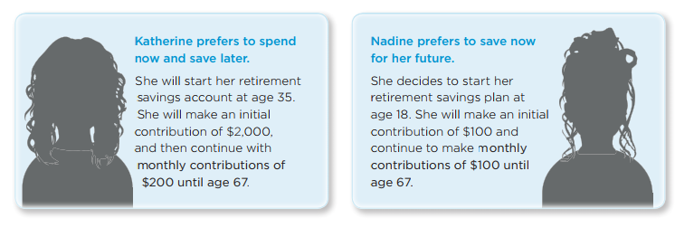
Let’s look at two friends who have different goals and saving habits.
- How much will Katherine have contributed to her RRSP at age 67?
- How much will Nadine have contributed to her RRSP at age 67?
- Who do you think will have the larger amount at age 67? Why?
- Calculate how much both savings plans are worth if their investments grew at a rate of 5% compounded annually. Use an online calculator to help you get your answer.
- How much would each have to contribute monthly given the same initial contributions if they both wish to retire at 60?
- How much would that give them month to live on (annuity)?
- What conclusions can you draw regarding investment period and investment value? Specifically, what impact does time have on investment value?
APPENDIX B
Tax-Free Savings Accounts
View the following website https://www.getsmarteraboutmoney.ca/invest/savings-plans/tfsas/ (or similar) and answer the following questions.

- What is a TFSA?
- Why is it attractive as a savings plan?
- What can be held in a TFSA?
- What is the limit in the last two years you can contribute to a TFSA? What happens if you
over-contribute?
- List four advantages of starting a TFSA.
- List at least four differences between a TFSA and RRSP.
APPENDIX C
Where to Put the Money?
You have saved the money for a down payment for a new house, arranged appropriate financing and moved in. After completing your new budget, you find you have an extra $400 a month you can invest for the next five years. You earn $65,000 a year before taxes and have some short-term and long-term goals.

- What type of investments would you put into your RRSP and why? Calculate the value of your investments after 25 years? What would be the total money you would receive if you withdraw the entire amount (reminder, the withholding tax differs according to the amount you withdraw - up to $5,000 = 10%; between 5,000 and $15,000 = 20% and more than $15,000 = 30%). What other factors do we need to consider?

- What type of investments would you put into your TFSA and why? Calculate the value of your investments after 25 years? What would be the total money you would receive if you withdraw the entire amount? What other factors do we need to consider?

- Suppose you decide to take the extra money and put it as an extra payment on your mortgage. Your new condo cost you $275,000 of which you put down the minimum. You have a five-year closed mortgage with a rate of 3.2%.
- Calculate the minimum amount needed for the down payment.
- Calculate the difference between putting the money down annually versus just paying off your mortgage.
- What do other factors do we need to consider?
APPENDIX D
Saving vs. Spending Quiz
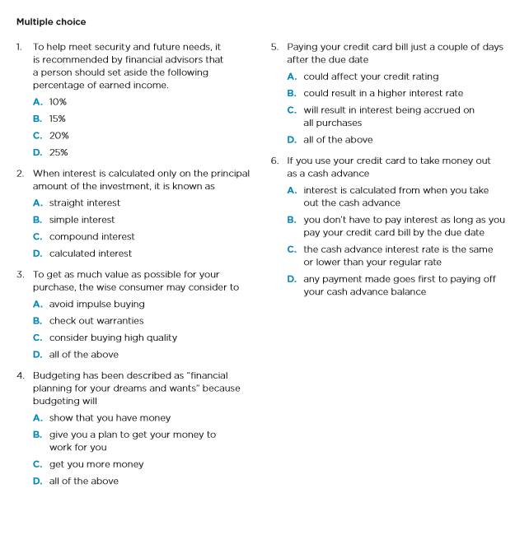
APPENDIX E

