About this Lesson
Students explore opinions about taxation and distributive justice by participating in a thought experiment that involves examining two sides of the argument of taxing the rich based on
opposing readings.

Grade Level | Course(s)/subject(s) | Learning Goal(s) | Suggested  Timing
8 | Language, grades 1–8 (2006) | At the end of this lesson, students will:  - identify a variety of forms of income  - identify various factors that affect income | 40–50 minutes

Curriculum Links
Language, grades 1–8 (2006)
Oral communication
1.2 Demonstrate an understanding of appropriate listening behaviour by adapting active listening strategies to suit a wide variety of situations, including working in groups.

1.4 Demonstrate an understanding of the information and ideas in increasingly complex and difficult oral texts in a variety of ways.

2.3 Communicate in a clear, coherent manner, using a structure and style appropriate to the purpose, the subject matter and the intended audience.

Reading
1.1 Read a wide variety of increasingly complex or difficult texts from diverse cultures, including literary texts.

1.4 Demonstrate understanding of increasingly complex and difficult texts by summarizing important ideas and explaining how the details support the main idea.

1.5 Students extend understanding of texts, including increasingly complex or difficult texts, by connecting the ideas in them to their own knowledge, experience and insights, and to other texts and the world around them.

Inquiry Question
To what extent would taxing the rich have a positive and/or negative effect on the Canadian economy?

Materials List
- Sticky notes or small pieces of paper to stick on the board
- Markers
- Chart paper
- Thought Experiment 1: Taxation? No Way! (Appendix A)
- Thought Experiment 2: Taxation? Absolutely! (Appendix B)
- Distributive Justice Cards (Appendix C)
- Assessment for Learning (Appendix D)
- Tax Bracket Job Chart (Appendix E)

Timing  (Mins.) | Lesson Sequence | Assessment for and as Learning Opportunities (self/peer/teacher)
MINDS ON
5–10 minutes | WHOLE CLASS  Brainstorm  Students brainstorm the different ways a person can make money and earn income. Encourage them to think of different income levels in both high- and low-income jobs. Ask students to write their responses on sticky notes or small pieces of paper.  Have students post their responses on the board, next to similar responses from other students (e.g., place all examples of waged work together).  Write general headings above the responses on the board to group ideas.  Encourage students to think of other ways to make money that would not fall under the headings that the class has generated. Write down their ideas.  Write the different income brackets and levels of taxation. Have the students research the different jobs to find an average wage for the different positions. Create a Tax Bracket Job Chart (Appendix E) from the income levels and taxation and place the sticky notes of the jobs under the different positions.

Timing  (Mins.) |  | Lesson Sequence |  | Assessment for and as Learning Opportunities (self/peer/teacher)
MINDS ON (cont’d.)
 |  | Explain to students that in this lesson they are going to learn about taxation and the influence of government tax rules on a person’s income, both the benefits that come from tax revenue as well as the possible incentives and disincentives that arise from taxation policies. To arrive at an understanding, they will be exploring two thought experiments. It is important to first explain that thought experiments provide a way of examining the nature of an issue by considering opinions from different perspectives.
ACTION
20–30 minutes | Activity: Thought experiment  Divide the class into small groups and explain the term “distributive justice.” Inform the class that when people earn a living in Canada, the government requires them to pay taxes on their income. The percentage that individuals pay is based on how much money they earn. Generally, those who earn a higher income are taxed more heavily than those who earn less. Explain that arguments abound about what rate of taxation is fair for each group. (This may be an opportunity to introduce groups in Canada who are not subject to the same rules of taxation and to explain reasons for this.)  Read-aloud  As a class, read-aloud:  Thought Experiment 1  Taxation? No Way! (Appendix A). Have students discuss this thought experiment in table groups. Circulate among the groups to help foster discussion.  Repeat a class read-aloud, this time with:  Thought Experiment 2  Taxation? Absolutely! (Appendix B). Provide time for groups to discuss the second thought experiment and make comparisons to the first reading.

 | Timing  (Mins.) |  | Lesson Sequence |  | Assessment for and as Learning Opportunities (self/peer/teacher)
CONSOLIDATION/DEBRIEF
5–10 minutes |  | WHOLE CLASS  Whole Class discussion  Debrief as a large group to look for consensus and disagreement.  Draw on the questions below to flesh out the discussion:  - Do either of these thought experiments accurately portray our world? Explain.  - What do these thought experiments leave out about our world?  - How could the arguments in the thought experiments be improved?  - What evidence beyond what you have read is needed to come to a more informed opinion about this issue? How can we obtain that evidence?  - Would the levels of taxation impact your desire to work harder? What would you think, as a higher income earner, if you had to pay almost 40% of everything you earned to taxes (given that you worked for the money, but that that money is also used to provide programs for those who have less)?  Students summarize their conclusions from the readings on the back of the Distributive Justice Card (Appendix C).

Thought Experiment 1: Taxation? No Way!
Imagine that you are in a band. You and your friends practise day and night to play for very little money. You post your songs online and slowly gather a following. One day your friend inherits enough money from his late aunt to fund the creation of an album. You gain additional popularity and at last can play in better and better venues. Fans love your music and go out of their way to pay for your music (rather than pirating it). After years of hard work, your fans reward you with so much money that your salary for the year is $250,000. Your projected salary for next year is even more, $500,000.

All seems to be going well, but then you open the newspaper and read editorials demanding that people who make $250,000 or more should pay higher taxes. You never thought about it before but it seems that you – not the government or other people – should be the one deciding what you want to do with your money. After all, your fans freely gave you their money in return for your music, which you created through years of hard work. If your fans did not want you to have this money, then they would not have given it to you. If someone gives you their money, by what right does someone else (or the government) have to take so much of it?

Group discussion questions:
- What do you think about this thought experiment?
- Do you agree with the author’s point of view on taxation? Why or why not?
APPENDIX A
Thought Experiment 2: Taxation? Absolutely!
Imagine that you wake up to find yourself in a world where the amount of money you are able to obtain is decided by an invisible hand. You and the others who live in this world indirectly guide the invisible hand through your individual consumer decisions (what you decide to spend your money on). However, you cannot assemble to discuss and decide together how you would like the invisible hand to distribute money.

Some people who work very hard are able to get the attention of the invisible hand and are rewarded with large amounts of money, while others who work just as hard are ignored. You initially cry out that this is unfair, but a robed figure nearby reprimands you. He informs you that while it may seem unfair, a person’s financial situation is never stable. Sometimes, those who have great wealth become impoverished and those who are poor become rich. “The invisible hand does not play favourites,” he says. Others gather around and, although they agree with the robed figure, they are concerned that despite the possibility of change in social class (from being poor to being wealthy or vice versa), there always remains a group that has most of the money and another group that has very little. Despite their hard work, there will always be rich and poor.

Some of the invisible hand’s most ardent worshippers among the crowd clamour that there is “no alternative” and that the invisible hand is the best possible ruler we could have. Just as you are about to speak, you are whisked away to an undisclosed location outside of human time and space. In this limbo, a fellow named Ron Jawls tells you that the invisible hand is actually a human creation called the market economy and that you were on Earth all along. He tells you that we could create a fairer economic system if we wanted to, and that you are not yet in the world but are standing outside of it. In fact, you have not yet been born into the world! After you calm down, he says that before you are born into the world you have a choice: you can either keep the world as it is, controlled only by the invisible hand (which may or may not favour you), or you can tax the wealthy in order to give money and provide health care and education for those who are not favoured by the invisible hand (which may include you). Jawls argues that if we choose to keep a system of wealth distribution (led by the invisible hand) that enriches some but impoverishes others, those who are wealthy ought to pay more tax to help those who are poor.

Group discussion: You do not know if you will end up in a wealthy family, in a good part of town or even if you will be blessed with the abilities you currently possess.
- What do you think about this thought experiment? Do you agree with the author’s point of view on taxation? Why or why not?
- If people feel that these rules are unfair, what can they do to encourage changes to the rules of taxation?
APPENDIX B
Distributive Justice Cards
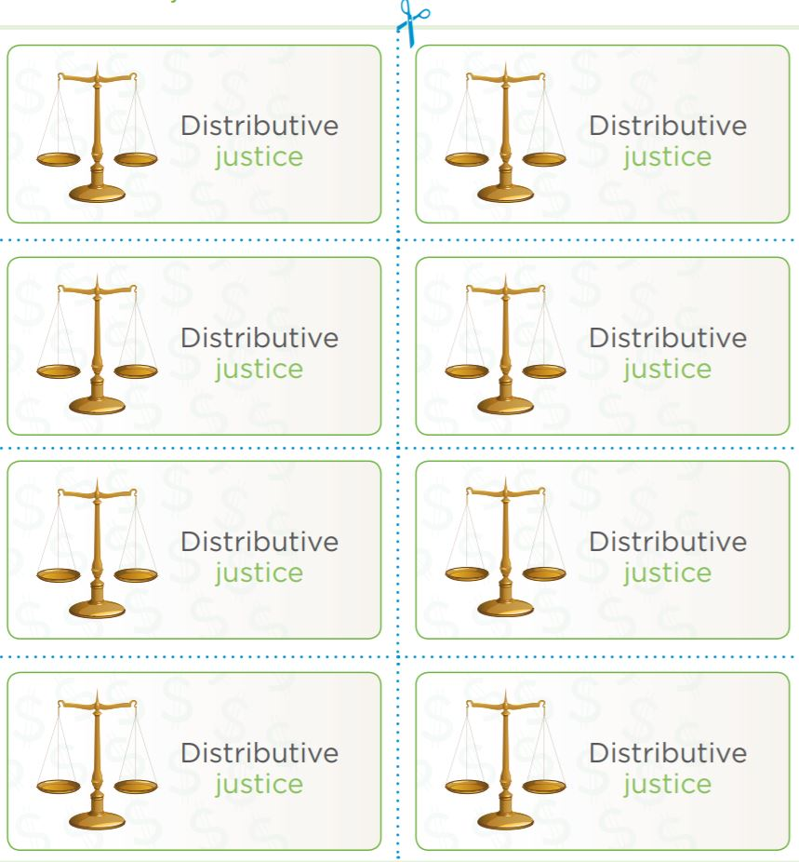
APPENDIX C
Assessment for Learning
Look for:  The student… | STUDENT NAMES
Communicates in
a clear manner
Demonstrates structure and style appropriate to the purpose and subject matter
Contributes to group inquiry
Completes the
task in the time allotted
Demonstrates expert understanding of the information
and ideas in increasingly complex oral tasks
Listens to peers
Responds to peers with insight and purpose

APPENDIX D
Tax Bracket Job Chart
Tax Bracket Job Chart (Based upon Single Taxable Income Tax Brackets and Rates 2017)

Income | $0 to $9,325 | $9,325 to $37,950 | $37,950 to $91,900 | $91,900 to $191,650 | $191,650 to $416,700 | $416,700 to $418,400 | $418,400+
Tax Rate | 10% | 15% | 25% | 28% | 33% | 35% | 39.60%
Jobs

APPENDIX E

