About this Lesson
In this lesson, students will learn how to round prices without using the penny, and practise giving and receiving change. This lesson can lead to the lesson, The Classroom Store.

Grade Level | Course(s)/subject(s) | Learning Goal(s) | Suggested  Timing
5 | Mathematics | At the end of this lesson, students will:  - identify forms of money  - make simple financial decisions for amounts up to $1,000  - conduct simulated purchases for amounts up to $1,000 | 40–50 minutes

Curriculum Links
Mathematics, grades 1–8 (2005)
Number Sense and Numeration
- read, represent, compare and order whole numbers to 100,000, decimal numbers to hundredths, proper and improper fractions, and mixed numbers

Inquiry Question
Without the penny in circulation, how do buyers and sellers round money amounts consistently?

Materials List
- One set of play money for each pair of students (Appendix A). One set includes:
  - Two $10 bills
  - Two $5 bills
  - Two toonies
  - Two loonies
  - Five quarters
  - Three dimes
  - Three nickels
- Student copies of Counting Change: Student Worksheet (Appendix B)
- Student copies of Practise Making Change (Appendix D)

Timing  (Mins.) | Lesson Sequence | Assessment for and as Learning Opportunities (self/peer/teacher)
MINDS ON
5-10 minutes | WHOLE CLASS  Brainstorm  Ask students to take out one sheet of blank paper and something to write with. Tell students that on the count of three, you will give them 60 seconds to name as many Canadian coins and bills that are still in circulation as they can and write it on the paper on their desk (complete list: nickel, dime, quarter, loonie, toonie, $5 bill, $10 bill, $20 bill, $50 bill, $100 bill).  Once 60 seconds is over (to signal this you can flick the light switch on and off), ask for a volunteer to be the note-taker for the class and have this student come up to the board. Give students the opportunity to share their currency list (ask a different student to share only one currency so that as many students as possible can participate). As students share their answers, have the note-taker record them on the board.  Ask students if they know what change the Government of Canada made to Canadian coins in 2013. After discussing the phasing out of the penny, ask the note-taker to erase “penny” off the board if it was included in the list that the class generated. | Assessment FOR Learning (Teacher – observation)

 | Timing  (Mins.) | Lesson Sequence | Assessment for and as Learning Opportunities (self/peer/teacher)
 | MINDS ON (cont’d.)
Context for Learning
- Understanding of decimals to hundredths
ACTION
20–30 minutes |  | WHOLE CLASS  Discussion  Ask students, “When we are talking about money, what does ‘change’ mean?” After discussing responses, explain that change is the money you get back when you make a purchase. When you buy something, you will often give the merchant more money than the amount due because you do not have exact coins and bills. The money you get back from the merchant is the extra that was paid – change (you may want to illustrate this with an example).  Explain that now that we do not use the penny, this means that when we buy something and we are paying with cash, we have to round the total that we owe to the nearest nickel (5 cents).
 |  | Guided practice  Distribute Counting Change: Student Worksheet (Appendix B) to the class.  Recreate the table in question 1 on a chalkboard, make a transparency or project it. Read out the scenario at the top of Appendix B as a class and fill in the table and answer question 2 together using the steps of scaffolding:  - “I do, you watch”  - “I do, you help”  - “You do, I help”  - “You do, I watch” | Assessment AS Learning (Teacher – Whole Class)
 |  | PAIRS  Divide the class into pairs and distribute one set of play money to each pair. Work on questions 3 and 4 together as a class (continue scaffolding by working on the first two examples together, and allowing pairs to work on the next three on their own). Invite pairs to share their answers with the class. | Assessment AS Learning (Peer)
 | ACTION (cont’d.)
 |  | Activity: Making change  After completing the worksheet, announce to students that they will practise giving change with their partner.  Distribute one copy of Practise Making Change (Appendix D) to each pair. Explain to students that now the price of the video game has to be between $11.80 and $11.89 (write these numbers on the board).  Ask students to choose which partner will start off as the buyer and which will start as the seller. The seller will determine the price of the video game and how much change is owed. The buyer will determine the amount of money that is owed to the seller (after rounding to the nearest nickel) and the amount they will pay with their play money. Ask students to record their transactions in Appendix D. | Assessment AS Learning (Peer)
 |  | Encourage students to use the play money and pass it back and forth. After four rounds, ask partners to swap roles and practise for another four rounds.  Observe each pair for assessment (Appendix E). | Appendix AS Learning (Teacher – Rubric)
 | CONSOLIDATION/DEBRIEF
 |  | Have students submit Appendices B and C for assessment (see: Making Change: Rubric, Appendix E)  WHOLE CLASS  Ask critical questions to engage students in further reflection and understanding of the concepts in a class discussion:  - What were some strategies you used when you were practising with your partner (e.g., counting forwards versus counting backwards, strategies that worked versus strategies that didn’t work)?  - What did you find challenging to do? Why was it challenging?  - How is what you learned helpful for when you go shopping with a parent or guardian? | Assessment AS Learning (Teacher)

Timing  (Mins.) | Lesson Sequence | Assessment for and as Learning Opportunities (self/peer/teacher)
EXTENSION
 | If you are proceeding with The Classroom Store lesson the next day, ask students to bring to class pictures of five items from magazines or catalogues that they want to sell during tomorrow’s classroom store activity.

Play Money
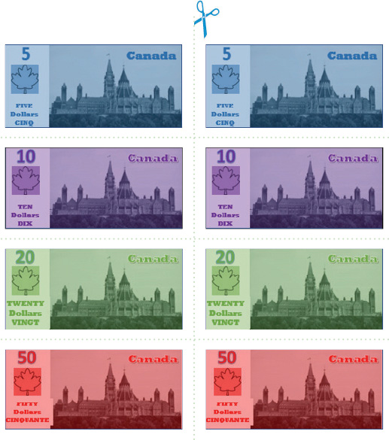
APPENDIX A
Play Money (cont’d.)
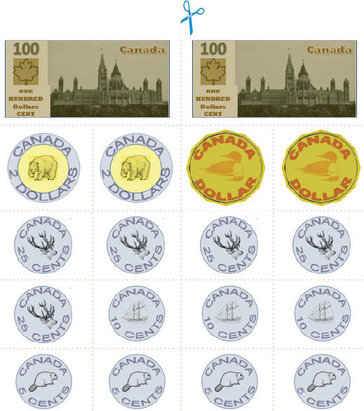
APPENDIX A
Counting Change: Student Worksheet
A new video game that you have been waiting for is now in-stock at the electronics store! You know the price will be between $11.50 and $11.59.
- What amount of money will you owe for each of these prices? Practise rounding to the nearest nickel.

Cost of a Video Game
Price of the Game | Round up or round down? | What you owe
$11.50 | No rounding | $11.50
$11.51
$11.52
$11.53
$11.54
$11.55
$11.56
$11.57
$11.58
$11.59

- When you get to the store, you see that the price for the game is $11.54 (including tax). How much will you pay for the game? Did you have to round up or round down to the nearest nickel?
APPENDIX B
Counting Change: Student Worksheet (cont’d.)
- You look in your wallet and find the following coins and bills:
- Two $10 bills
- Two $5 bills
- Two toonies
- Two loonies
- Five quarters
- Three dimes
- Three nickels
Show five different ways that you can pay for the video game using the money in your wallet. In the boxes below, draw the bills and coins that you would use and write the total money you give to the merchant. The first example is done for you. (Remember, the cost of the game is $11.54.)
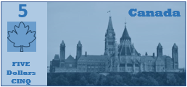
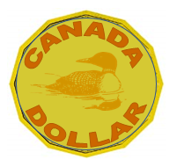
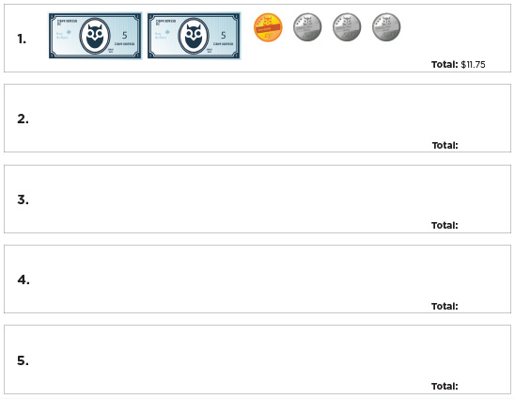
APPENDIX B
Counting Change: Student Worksheet (cont’d.)
- How much change can you expect to receive when you pay for the video game?
Show the change you will receive for each of the five examples from question 3 by drawing the bills and coins.
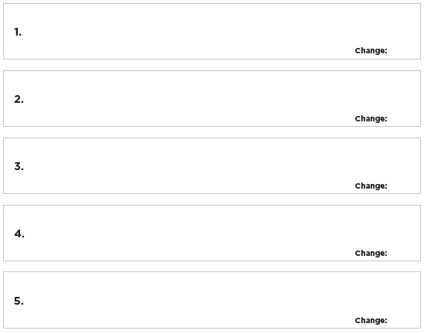
.
APPENDIX B
Counting Change: Teacher Resource
A new video game that you have been waiting for is now in-stock at the electronics store! You know the price will be between $11.50 and $11.59.
APPENDIX C
- What amount of money will you owe for each of these prices? Practise rounding to the nearest nickel.

Cost of a Video Game
Price of the Game | Round up or round down? | What you owe
$11.50 | No rounding | $11.50
$11.51 | Round down | $11.50
$11.52 | Round down | $11.50
$11.53 | Round up | $11.55
$11.54 | Round up | $11.55
$11.55 | No rounding | $11.55
$11.56 | Round down | $11.55
$11.57 | Round down | $11.55
$11.58 | Round up | $11.60
$11.59 | Round up | $11.60

- When you get to the store, you see that the price for the game is $11.54 (including tax). How much will you pay for the game? Did you have to round up or round down to the nearest nickel?
I will owe $11.55. I had to round up to the nearest nickel.

Practise Making Change
Round 1
APPENDIX C
Buyer’s name: ___________________ Seller’s Name: ___________________
Price: ___________

Amount you owe: ___________

Amount paid: ___________

Change: ___________
Price: ___________

Amount you owe: ___________

Amount paid: ___________

Change: ___________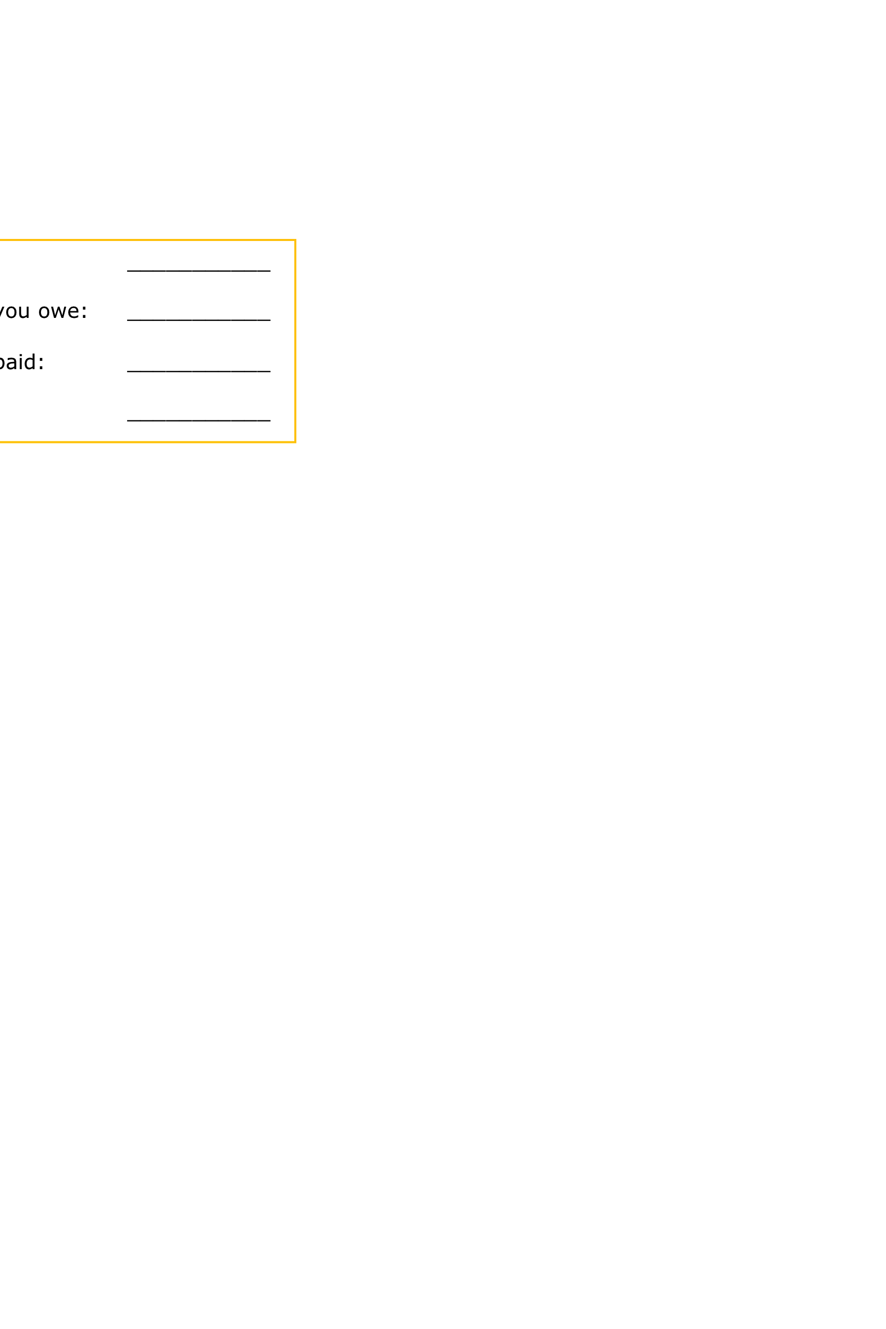 ___________

Change: ___________

Price: ___________

Amount you owe: ___________

Amount paid: ___________

Change: ___________

Price: ___________

Amount you owe: ___________

Amount paid: ___________

Change: ___________
Round 2
Buyer’s name: ___________________ Seller’s Name: ___________________
Price: ___________

Amount you owe: ___________

Amount paid: ___________

Change: ___________ ___________

Change: ___________
Price: ___________

Amount you owe: ___________

Amount paid: ___________

Change: ___________
Price: ___________

Amount you owe: ___________

Amount paid: ___________

Change: ___________
Price: ___________

Amount you owe: ___________

Amount paid: ___________

Change: ___________
APPENDIX D

