About these Lesson
In these lessons, students will learn key financial terms and some basics rules to help them manage their money. Students will also learn investment vehicles and how to structure different types of investment portfolios.

Grade Level | Course(s)/subject(s) | Learning Goal(s) | Suggested  Timing
10–12 | BBI1O/BBI2O – Introduction to Business  MBF3C – Foundations for College Mathematics  GWL3O – Designing Your Own Future GLS4O/GLE4O/GLE3O – Advanced Learning Strategies: Skills for Success After Secondary School  CLE 3M – The Individual and the Economy | At the end of these lessons, students will:  - describe investment options  - identify and select investments best suited for their future | 40–75 minutes

Curriculum Links
Grades 9 and 10, Business Studies (2006)
Introduction to Business (BBI1O/BBI2O)
Finance
- Demonstrate an understanding of effective investment practices.
- Gather and interpret information about investment alternatives (e.g., stocks, mutual funds, real estate, GICs, savings accounts), and compare the alternatives by considering the risk and the rate of return.

Grades 11 and 12 Mathematics (2007)
Foundations for College Mathematics (MBF3C)
Personal Finance
- Gather and interpret information about investment alternatives (e.g., stocks, mutual funds, real estate, GICs, savings accounts), and compare the alternatives by considering the risk and the rate of return.

Curriculum Links (cont’d.)
Grades 11 and 12 Guidance and Career Education (2006)
Designing Your Own Future (GWL30)
Personal Knowledge and Management Skills
- Describe the range of individual differences in how people manage themselves in dealing with issues such as risk, stress, change, time, planning and personal finance in various settings (e.g., school, workplace, community).

Grades 11 and 12 Guidance and Career Education (2006)
Advanced Learning Strategies: Skills for Success After Secondary School (GLS4O/GLE4O/GLE3O)
Planning for Transition
- Demonstrate an understanding of the personal financial skills that will be required for the future
(e.g., budgeting, banking, saving, borrowing money).

Canadian and World Studies, Grades 11 and 12 (2015)
The Individual and the Economy (CIE3M)
Fundamentals of Economics
B4. Financial Planning: demonstrate an understanding of key considerations related to personal financial planning, and use economic data to analyze the costs and benefits of personal financial decisions.

Inquiry Question
Why aren’t most Canadians prepared to retire? (http://bc.ctvnews.ca/majority-of-canadians-aren-t-prepared-for-retirement-study-1.3278742)
Learning how to invest is an important step in planning your future.

Materials List
- Basic Rules of Money Management (Appendix A)
- Financial Goals (Appendix B)
- Risk vs. Reward Game (Appendix C)
- Power of Compounding Spreadsheet
- Investment Risk (Appendix D)
- Investment Product Investigation (Appendix E)
- Investment Choices (Appendix F)
- Internet/Computer Lab
Timing  (Mins.) | Lesson Sequence | Assessment for and as Learning Opportunities (self/peer/teacher)
MINDS ON
Day 1
Class: Discussion
Teacher Prompt:
What does it mean to be financially independent?
(Not an exhaustive list)
- Wealth
- Afford the things I need
- To have what I want
- To retire in comfort and at a young age
- To help others
- Security/feel like they have enough
Pose the inquiry question or context for learning story (B)
10 minutes | Individual: Doodle  On a piece of people, draw or list how you see yourself when you retire, include how old are you, where you live, family life, what you are doing/hobbies/interests  Compare your vision or goals with your neighbour and discuss  - Similarities  - Differences  How much money do you think it will take to give you that lifestyle?  There are too many variables and unknowns to give an exact answer. (This is what the experts say.) | Assessment FOR Learning: Discussion, Observation

Timing  (Mins.) | Lesson Sequence | Assessment for and as Learning Opportunities (self/peer/teacher)
MINDS ON (cont’d.)
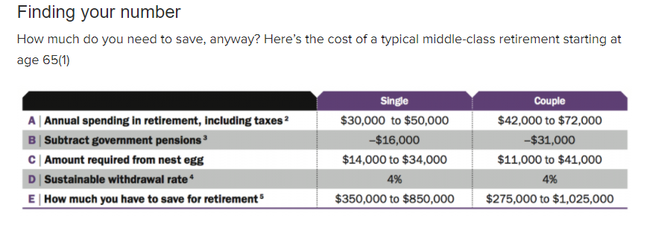
Aston, D. (2014, November 14). How much money you need to retire. Retrieved August 09, 2017, from http://www.moneysense.ca/save/retirement/how-much-money-you-need-to-retire/

Teacher Prompt
Were you accurate with your guess? The question now becomes, how do we get there? The rest of the lesson will focus on investing basics and what you can do now to start?
So, how do you become financially independent?
Let’s examine four basic inventing concepts.
Context for Learning
Bill is always running short of money while his co-worker who earns the same wage, pays all his bills on time, is debt-free and still has money remaining for savings and entertainment. How can Bill take control of his financial situation?

Timing  (Mins.) | Lesson Sequence | Assessment for and as Learning Opportunities (self/peer/teacher)
ACTION
Concept 1: Know yourself (Planning required)
Investing is a marathon, not a sprint. It takes hard work over the course of a lifetime.
In looking at this quote, what seems to be the main ingredients (time, hard work, planning)?
https://www.getsmarteraboutmoney.ca/videos/investor-office-financial-success-is-a-marathon-not-a-sprint/
The first step in developing an appropriate investment strategy is to be clear about what your financial goals are. Planning is a key to developing your financial independence and investing is making priorities with your money.
20 minutes | Individual: Setting Financial Goals  Review the SMART model method, distribute and discuss Appendix B.  Have students share their results with partner and/or small group to ensure that goals are smart and reflective of their life goals.  Finally, “Successful Investing takes time, discipline and patience. No matter how great the talent or effort, some things just take time…” – Warren Buffet | Assessment OF Learning: Financial Goals
10 minutes | Concept 2: Know your limits  (what you are willing to risk)  A person’s attitude towards risk is key to the way they will make decisions about their investments. If you are willing to accept a higher level of risk, it generally means you can expect higher rate of returns, but your potential to lose is also greater. If your risk tolerance is low, you can expect lower returns, but your potential for any loss is low.  (For more information: https://www.getsmarteraboutmoney.ca/invest/investing-basics/understanding-risk/risk-tolerance/)  Class: Internet quiz  https://www.getsmarteraboutmoney.ca/tools/risk-profile-quiz/

 | Timing  (Mins.) | Lesson Sequence | Assessment for and as Learning Opportunities (self/peer/teacher)
 | ACTION (cont’d.)
 | 25 minutes | Class: Risk or Reward Game  Hand out Appendix C and read rules and play game.  Debrief game (see sample questions in Appendix C). | Assessment FOR Learning: Observation
CONSOLIDATION/DEBRIEF
5 minutes |  | Review concepts on planning and risk tolerance.  Review and discuss any questions related to Financial Goals  Student to submit Goal sheets for assessment the next class | Assessment FOR Learning: Observation

Timing  (Mins.) | Lesson Sequence | Assessment for and as Learning Opportunities (self/peer/teacher)
MINDS ON
Day 2
Guide a discussion on the importance of planning and risk tolerance, highlighting points made from yesterday’s lesson and from students’ questions that needed clarification.
Students to submit goal sheets for assessment.
10 minutes | Using the context for learning or similar story, have students discuss why aren’t most Canadians prepared to retire? (http://bc.ctvnews.ca/majority-of-canadians-aren-t-prepared-for-retirement-study-1.3278742)  Yesterday, we examined the first two concepts. Today, we will introduce the last two. | Assessment FOR Learning: Discussion
Context for Learning
Bill has recently started a new job, however, this job does not have a company pension plan. Bill would like to retire at 60 or 65, but is not sure what he has to do to make that a reality.

Timing  (Mins.) | Lesson Sequence | Assessment for and as Learning Opportunities (self/peer/teacher)
ACTION
Concept 3: Know how to build wealth not debt
Once you know what you are saving/investing for, and what you are willing to risk, you need to start building wealth, but you can’t build wealth if you accumulate debt. Debt must be eliminated before you can be financial independent.
10 minutes | - Eliminate Debt  Debt can have a crushing impact on your finances and limits your opportunities. Your first step is to get your debt eliminated or under control.  Have you ever had a friend not pay you back when they borrowed money from you?  - How did you feel about your friend?  - Did it change the way you acted towards them?  - Would you lend to your friend again?  Why would a bank want to know your credit score?  - Ability to pay back  - At what rate should they lend money to you?  - Shows like Till Debt Do Us Part and Princess demonstrate that many people simply ignore their debt.  What are the consequences of just ignoring your debt?  - Students give good and bad reasons for ignoring debt  For example:  - have the money to do what you want now  - becomes so large you can’t deal with it  - prevents you from meeting your financial goals or having the lifestyle you want  Class Video: Tips for Investing with The Wealthy Barber  https://www.getsmarteraboutmoney.ca/videos/tips-for-investing-with-the-wealthy-barber/  Discuss any questions that arise with the video – you may wish to show this video after the next section on building wealth. | Assessment FOR Learning: Discussion

Timing  (Mins.) | Lesson Sequence | Assessment for and as Learning Opportunities (self/peer/teacher)
ACTION (cont’d.)
Distribute or show Appendix A.
Teacher Note
Additional lessons that go into detail about debt and credit are available.
https://www.inspirefinanciallearning.ca/index.php/teachers/teaching/by-grades/grade-11/funny-money-understanding-credit-and-your-credit-report/
https://www.inspirefinanciallearning.ca/index.php/teachers/teaching/by-grades/grade-9/funny-money-cost-of-borrowing/
https://www.inspirefinanciallearning.ca/index.php/what-is-credit/
15 minutes | - Purchase assets that increase in value  To stay healthy, experts tell us  - Eat better foods  - Eat smaller meals throughout the day  - Exercise regularly  - Drink more water  - Get more sleep  The problem is not that most people don’t know these things, rather they are not easy to practise, simple concepts yes, easy to do, NO. The same can be said for building wealth.  There are a few simple (but hard to practise) things we can do to achieve this:  - Spend less than you make (note on debt)  Pay-yourself-first – this phrase was popularized by Dave Chilton in his book, “The Wealthy Barber.” Essentially it means to invest 10% of your money you make first and live on the other 90%. This is tough to do at the start but, like exercise, soon becomes a habit. If you’re having trouble doing this, take it automatically out of your account and deposit it into your investments. We generally don’t miss what we don’t see.

Timing  (Mins.) | Lesson Sequence | Assessment for and as Learning Opportunities (self/peer/teacher)
ACTION (cont’d.)
- Invest in wealth-building assets. A savings account, although safe, does not earn enough interest to accumulate wealth and is often less than the cost of living (does not cover inflation costs). To determine the worth of these assets, apply the rule of 72. This is the method to estimated how long your investment will double (i.e., divide interest rate by 72 to determine how long your money will double).

Class Video: Long-Term Wealth
https://www.youtube.com/watch?v=_Uoa_k18WkI
Distribute and discuss Appendix A.

- Start Early – The Power of Compounding
Teacher Prompt:
Earlier in the class, I asked you how much you thought you would need to retire. Most of you probably thought retirement was just too far away, but the reason you should start thinking about retirement now is something called compounding.
(Teacher note: Reintroduce the rule of 72)
10 minutes | (Teacher Note: Load Power of Compounding spreadsheet)  Brittany and Stephanie are sisters. At age 19, Stephanie manages to deposit $2,000 into an investment earning 12% per year. For the next seven years, she deposits $2,000 every January 1 until she turns 25 and then she stops, but leaves the money in the account until age 65. Brittany, starts saving when she turns 27 and manages to also deposit $2,000 at the beginning of January every year until she turns 65. How would have the most money at age 65 from their investments? How much would you expect would be in their accounts?  Surprised?  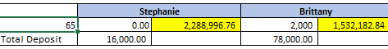  (Teacher Note: Show spreadsheet – you can change rate, amount, compounding term and initial principal.) | Assessment FOR Learning: Discussion

Timing  (Mins.) | Lesson Sequence | Assessment for and as Learning Opportunities (self/peer/teacher)
ACTION (cont’d.)
Concept 4: Know your investments – Educate yourself
“Risk comes from not knowing what you’re doing.” –
Warren Buffet
- Know the terms
To understand and appreciate any game, you need to know the terms and rules of the game. The same can be said for investments/finance.
15 minutes | Group: Dictionary game  How to play the dictionary game:  - Split everyone into character groups (or groups of three-five). Pass out the worksheets (one per team, sample attached). Each team will need to create definitions for each word. The object is to create the most dictionary-sounding definitions, even if they don’t know what the word means. After about five or six minutes, collect all the worksheets.  - Read the first word aloud. Read, or show on document camera, all the team’s definitions for the word, including the correct word definition. Each team must choose or vote which definition they believe is correct. (Interactive white boards or clickers work well.)  - If the team picks the right definition, they get two points. If a team’s definition gets chosen by other teams, the team with the definition will get one point for every team they fool. Continue with the rest of the words. The team with the most points wins the game.  Suggested terms  Key aspects to personal finances: (not a complete list)  - 10% solution  - PYF (Pay Yourself First)  - (Importance of) Compound interest  - Eliminate debt (before accumulating wealth)  - Diversification (think hockey pool, fantasy sports team)  - Risk  - Liquidity | Assessment FOR Learning: Discussion, Observation

Timing  (Mins.) | Lesson Sequence | Assessment for and as Learning Opportunities (self/peer/teacher)
ACTION (cont’d.)
- Return on Investment
- Rule of 72
- Mutual funds
- Stocks
- Bonds
- ETF
- TFSA
- Mortgage
- Savings Account
- Capital gains
- Asset Allocation
- Net worth
- RRSP
- Defined Benefit Plan
- Defined Contribution Plan
- Compound Interest
- Expected return
- Variable Interest Rate
- Fixed Interest Rate
- Step-up Interest Rate
10 minutes | 2. Read  There is a wealth of information to help you understand the concept better, a sample list is included such as:  - The Wealthy Barber by David Chilton  - The Millionaire Next Door by Thomas J. Stanley and William D. Danko  - The Debt Free Graduate by Murray Baker  - Following the Goods: Financial Management for the Young and Ambitious by Adam Goodman.

 | Timing  (Mins.) | Lesson Sequence | Assessment for and as Learning Opportunities (self/peer/teacher)
 | ACTION (cont’d.)
3. Get Help
When you are ready, it is important to get the advice or coaching that will allow you to achieve your goals and that is usually from a financial professional, such as certified financial planner, accountant or banker.
Some things to consider when selecting your adviser or coach:
- What qualifications and experience does the adviser have?
- What kinds of clients and investments does the adviser specialize in?
- What services does the adviser’s firm provide?
- What fees and commissions does the firm charge?
- Are the adviser and the firm registered with the provincial securities regulator to trade the types of investments you’re interested in?
- Are they members of an industry association?
- Do they have a good reputation and references?
- Have they been disciplined by the provincial or territorial securities regulator or an industry association?
CONSOLIDATION/DEBRIEF
5 minutes |  | Review savings vs. investing  https://vimeo.com/84123322  Review the four basic concepts.  Review the context for learning story – what would they now tell Bill?  Give students an opportunity to express what they have learned and are still unclear about through poll or exit card.

Timing  (Mins.) | Lesson Sequence | Assessment for and as Learning Opportunities (self/peer/teacher)
MINDS ON
Day 3
Distribute back financial goals sheets with assessment.
Take opportunity to address any common misconceptions about setting financial goals.
10 minutes | Review  Class Video: Savings and Investing  https://www.canada.ca/en/financial-consumer-agency/services/financial-basics/financial-basics-videos/financial-basics-video-saving-investing.html  Guide a discussion on the four concepts of becoming financially independent, highlighting points made from previous lesson and from students’ questions and/or comment cards that needed clarification.  Prepare  Class Video: Investing in Your Early Years  https://www.getsmarteraboutmoney.ca/videos/investing-in-your-early-years-with-preet-banerjee-and-rob-carrick/
Context for Learning
Bill has followed the advice given him, but does not know where the best place to put his money.

Timing  (Mins.) | Lesson Sequence | Assessment for and as Learning Opportunities (self/peer/teacher)
ACTION
30 minutes | Group: Jigsaw  - Break class into groups of four. Each person in the group is to research one of the types of Investments from Appendix E.

 | Timing  (Mins.) | Lesson Sequence | Assessment for and as Learning Opportunities (self/peer/teacher)
 | ACTION (cont’d.)
 | 15 minutes | When students have completed their research into the investment tool, form expert groups, review and enhance answers. | Assessment FOR Learning: Discussion, Observation
 | 15 minutes | Student will reform with original group and “teach” their investment tool to the members of their group.
CONSOLIDATION/DEBRIEF
5 minutes |  | Review any misconceptions and errors regarding investment options.  Student should complete an exit card:  - What I found most interesting  - What I am still confused over  - What one thing everyone should know

Timing  (Mins.) | Lesson Sequence | Assessment for and as Learning Opportunities (self/peer/teacher)
MINDS ON
10 minutes | Day 4  Guide a discussion on the investment products highlighting points made from yesterday’s lesson and from students’ exit questions that needed clarification.  Class Video: How to Become a Savvy Investor  https://www.getsmarteraboutmoney.ca/videos/how-to-become-a-savvy-investor-with-gail-bebee-and-rob-carrick/
Context for Learning
Bill Fold takes an investor profile quiz and learns that he’s a risk taker. What does that mean? What investments what be the best fit for him? Why?

 | Timing  (Mins.) | Lesson Sequence | Assessment for and as Learning Opportunities (self/peer/teacher)
 | ACTION
 | 50 minutes | Individual: Summative Task  Distribute and hand out Appendix F.  Teacher Note:  - If class has access to a spreadsheet program, you may wish to have them graph their investment mix.  - You may wish to have the student prepare a proper report and use the appendix as a guide in preparation of that report.  - If extra time is available, students could engage in peer evaluation before submission of report. | Assessment OF Learning: Investment Choices
CONSOLIDATION/DEBRIEF
10 minutes |  | Review the summative task.  Discuss any concerns or misconceptions.  Have students complete and submit for the next period.

Basic Rules of Money Management
It is essential to acquire the skills necessary to practise good money management to ensure that we
meet our financial obligations and goals. By practising the following basic rules of money management, you can confidently control your personal finances and your future:
- Set short-, mid- and long-term financial goals.
- Create a realistic budget by knowing your income and tracking your expenses.
- Distinguish between needs and wants.
- Don’t allow your expenses to exceed your income.
- Save 10 to 15% of your net income.
- Pay your bills on time.
- Use credit wisely by including debt payments into your monthly budget and pay the balance in full every month to avoid interest charges.
- Plan for periodic and major expenses such as tuition or purchasing a car.
Online banking, debit and credit cards are tools that allow you to more easily conduct your financial affairs.
Spreadsheets, calculators and financial apps are tools that can make it easier for you to track and manage your finances.

Managing debt
- Pay your bills on time. If you are unable to pay your bills as agreed, contact your creditors and explain your situation. Contact a local non-profit credit counselling service for unbiased professional advice.
- Don’t sign a credit contract until you have read it and understood it. If you don’t understand it, ask questions until you are satisfied.
- Never sign a blank sheet. Your signature is your promise to pay and a contract is a legal document. Know the implications.
- Try to pay off any debt quickly. Avoid those prolonged low monthly payments and avoid having to refinance at high interest rates.
- Deal with known, respected and established companies and make sure you understand the total cost of your purchases.
- Avoid signing up for extra credit cards that you do not need.
APPENDIX A
Setting Financial Goals
Decision-making plays an important role in the financial planning process. We must make choices in order to maximize our ability to accomplish our goals with limited resources. Goals are accomplished by applying the ongoing, five-step financial planning process – Set SMART goals, analyze information, create a plan, implement plan, and monitor and modify the plan.
Goals are considered SMART when they are Specific, Measurable, Attainable, Realistic and have a Timeframe.
Instruction:
Write at least one short-term, one intermediate-term, and one long-term personal financial goal using the SMART model.

 | SMART Goals | Steps | Obstacles/Estimated Costs | Timeline
Short-term Goal
(<1 year)
Medium-term Goal
(1 to 3 years)
Long-term Goal
(3 years)

APPENDIX B
Risk vs. Reward Game
Time required: 45 minutes
This game is designed to reinforce the concept of risk tolerance. Risk tolerance refers to the amount of risk that an investor feels comfortable with and can afford to take. The individual games (thumb wrestling/rock, paper, scissors/coin toss) have been selected for ease of set-up, familiarity and time to play. You may wish to demonstrate how each game is played before beginning the activity.
Materials
- Fake $100 bills – enough for each person to have 10 bills (any valuation is fine as long as you have the same amount for each student)
- Coins
Before play – read to class
Risk is the amount of uncertainty about the expected return on an investment, including the possibility that some or all of the investment may be lost. Today, we are going to examine your risk tolerance, the amount of risk you feel comfortable with and can afford to “invest.” You will be given $1,000 in $100 bills. Your goal is to try to win as much money from your peers as possible in the allotted time by challenging them to one of three games:
- Thumb wrestling
- Rock, paper, scissors
- Coin toss
Rules:
- You can only challenge one player at time.
- The player issuing the challenge determines the game.
- You must accept any challenge.
- Sudden death, no two out of three.
- Challenger has to have a coin and is “heads” on the coin toss (this simply speeds up the game).
- Students may not challenge a classmate two times in a row.
Pre-brief (Do before you start the game)
- You have been given free money to use. How will you invest it? What will be your strategy?
- Which investment strategy of the three will give you the best return and why?
- Will you use the same challenge or change it up according to whom you challenge?
- Take two minutes to determine how you will “invest” your money.
Variation
- create a safe zone where students can stand and not be challenged
- before playing, determine the number allowed in the safe zone and length of time to stay
Debrief (sample questions)
- Which method did you choose? Why did you choose it?
- Were you the challenger or the one challenged?
- Did you have a strategy before or during the activity?
- How does the activity relate to investments?
- Would this activity be different if you had 100 bills?
- Would your strategy have changed if you had played with real money?
- How is the safe zone like a chequing account?
APPENDIX C
Investment Risk
(adapted from Taking Stock In Your Future Intermediate Guide)

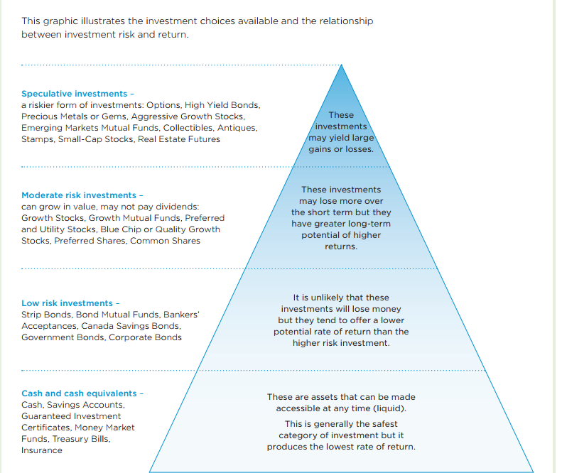

APPENDIX D
Investment Product Investigation
Complete the following:

Saving Plans
(https://www.getsmarteraboutmoney.ca/invest/savings-plans/)

- What is a GIC?
- Why would you wish to hold a GIC in your portfolio?
- What is a TFSA?
- What financial items can be held in a TFSA?
- Why would you wish to hold a TFSA in your portfolio?
- What is an RRSP?
- What financial items can be held in a RRSP?
- Why would you wish to hold a RRSP in your portfolio?
- What is a RESP?
- How does it differ from a TFSA or RRSP?
- Why would you wish to hold a RESP in your portfolio?
APPENDIX E
Investment Product Investigation (cont’d.)
Bonds (Corporate/Government)
(https://www.getsmarteraboutmoney.ca/invest/investment-products/bonds/)

- What is a bond?
- What are the types of bonds?
- How do bonds work?
- How do you buy and sell bonds?
- What affects the price of bonds?
- Why would you wish to hold a bond in your portfolio?
APPENDIX E
Investment Product Investigation (cont’d.)
Stocks
(https://www.getsmarteraboutmoney.ca/invest/investment-products/stocks/)

- What are stocks?
- What is the difference between common and preferred stock?
- What is the difference between blue chip, growth and speculative stocks?
- What is a dividend?
- What types of dividends are given by companies?
- What are some factors that affect stock prices?
- Define: Buying on margin, stock option, selling short and IPO.
- Define the following: Earning per share, Price to Earnings Ratio and Dividend Yield.
- What would you wish to hold stocks in your portfolio?
APPENDIX E
Investment Choices
Exchange Traded Fund
(https://www.getsmarteraboutmoney.ca/invest/investment-products/etfs/)

- What is it?
- How much does it cost?
- How do they work?
- Why would you hold an ETF in your portfolio?
Mutual fund
(https://www.getsmarteraboutmoney.ca/invest/investment-products/mutual-funds-segregated-funds/)

- What is it?
- What is Management Expense Ratio?
- What is NAV (Net Asset Value)?
- Describe two common types of mutual funds.
- Why would you hold mutual funds in your portfolio?
APPENDIX F
Investment Choices (cont’d.)
Risk Profile: The risk profile is an individual’s ability to assume financial risk as part of their investment portfolio. The reward in assuming higher risks lies in the possibility of generating higher returns. However, your ability and willingness to take financial risks depends directly on you and your environment such as age, life stage, habits and lifestyle.
- Describe your risk profile. (If necessary, revisit the risk profile questionnaire – https://www.getsmarteraboutmoney.ca/invest/investing-basics/understanding-risk/risk-tolerance/

Investment Goals: “If you don’t know where you are going, you might wind up someplace else.” – Yogi Berra
- Examine your financial goals and describe your main goals in the space provided. Consider the following questions in your answer:
- What are your upcoming financial needs and goals?
- When will you need money to meet or achieve these goals?
- How much do you have to invest?
- Do you know how much money can be invested on a monthly or yearly basis?
- Will you be adding to your portfolio each year?
APPENDIX F
Investment Choices (cont’d.)
- Review the results of your risk self-assessment, as well as your education and career goals and future lifestyle choices. Imagine that you have $25,000 to invest. List the types of investments you would choose for your portfolio, and the amount of each investment you would choose. If you decide to invest more than $25,000, clearly indicate where you are getting the money.
(Note: This should match what you stated in question 2).

Investment | Amount Invested | Expected Return/Why | Risk | Liquidity | Why I Chose It

APPENDIX F

