About this Lesson
Students will gain an understanding of how risk applies to investments and understand their own risk tolerance personality when it is applied to investments.

Grade Level | Course(s)/subject(s) | Learning Goal(s) | Suggested  Timing
9-12 | BBI1O/BBI2O  Introduction to Business  MBF3C  Foundations for College Mathematics  GWL3O  Designing Your Own Future  GLS4O/GLE4O/GLE3O  Advanced Learning Strategies: Skills for Success After Secondary School | By the end of this lesson students should understand why people invest, understand the concept of risk tolerance and recognize which investment(s) best fits their individual risk tolerance personality  Big Idea: Learning how to invest and understanding your investment personality is an important step in planning your future. | 1st of 3  75-minute periods

Curriculum Links
Grades 9 and 10, Business Studies (2006)
Introduction to Business (BBI1O/BBI2O)
Finance
- Demonstrate an understanding of effective investment practices
- Gather and interpret information about investment alternatives (e.g., stocks, mutual funds, real estate, GICs, savings accounts), and compare the alternatives by considering the risk and the
rate of return
Grades 11 and 12 Mathematics (2007)
Foundations for College Mathematics (MBF3C)
Personal Finance
- Gather and interpret information about investment alternatives (e.g., stocks, mutual funds, real estate, GICs, savings accounts), and compare the alternatives by considering the risk and the
rate of return
Grades 11 and 12 Guidance and Career Education (2006)
Designing Your Own Future (GWL30)
Personal Knowledge and Management Skills
- Describe the range of individual differences in how people manage themselves in dealing with issues such as risk, stress, change, time, planning and personal finance in various settings (e.g., school, workplace, community)

Curriculum Links (cont’d.)
Grades 11 and 12 Guidance and Career Education (2006)
Advanced Learning Strategies: Skills for Success After Secondary School, (GLS4O/GLE4O/GLE3O)
Planning for Transition
- Demonstrate an understanding of the personal financial skills that will be required for the future (e.g., budgeting, banking, saving, borrowing money)

Inquiry Question
Why is setting goals critical to understanding investment?

Materials List
- Appendix A: Your Investment Personality
- Internet

Timing  (Mins.) | Lesson Sequence | Assessment for and as Learning Opportunities (self/peer/teacher)
MINDS ON
5  minutes | Note: Depending on your time, class ability and interest, you may wish to include items from any of the three lessons.  Class Discussion  Teacher Prompt: Who in class is saving for something? (Solicit answers)  Place answers on screen or board and, as a class, determine whether they are long-term goals or short-term goals. Teachers may wish to complement this discussion with a labelling of goals as needs versus wants.  Then ask for some ideas about how they might try to achieve those goals or where the money will come from? (ideas might include: work, gifts, investments). | Assessment of Learning: Discussion

Timing  (Mins.) | Lesson Sequence | Assessment for and as Learning Opportunities (self/peer/teacher)
ACTION
35 – 40 minutes | Teacher Prompt: What determines whether you can meet your goals to a large extent depends on your investing personality.  Individual Activity: Investing and Risk Tolerance  Distribute Appendix A: Investor Personality.  Think-Pair Share  Have students discuss answers with partner before taking  up in class. Compare and contrast individual/pair risk tolerance results.  Class Discussion  Conduct a quick review of questions or items not understood.  Teacher Prompt: Although tolerance risk may provide some insight into your ability to handle risk, it may not align with your willingness to handle risk.  If you can’t afford to lose the money, you may have to choose a strategy that has low risk attached to it. Often, this comes about to meet shorter-term goals or if you potentially need access to money quickly (liquid investment).  A good rule of thumb in investing is never to spend more than you are willing to lose. (Not willing to lose? Then you must accept low- or no-risk investments.)  Teacher Prompt: Finally, if your risk tolerance is low, it does not mean that you can’t hold very speculative or volatile investments. It just means that you should not hold the vast majority of your assets in aggressive or risky investments.  You could also hold a mixture of investments within an investment class. You may determine that mutual funds meet your investor profile and risk tolerance, and so within those investments you can have a mix of fixed income, equity and speculative funds in proportion to your risk tolerance and investor profile.  To sum up your investing personality, consider:  - How much risk can you handle?  - How much do you expect to earn by your investments?  - How long do you have to invest to achieve your goals?  - How quick do you need access to your money, should you need it? (Liquidity = ability to turn an asset into cash quickly.) | Assessment of Learning: Discussion, Observation

Timing  (Mins.) |  | Lesson Sequence |  | Assessment for and as Learning Opportunities (self/peer/teacher)
CONSOLIDATION/DEBRIEF
 | Review key learnings and ideas from the lesson.  Teacher Prompt: A person’s true risk tolerance is often told by how they sleep when they invest. If they lose sleep when their investments go down (by any amount), then they really have a low-risk tolerance. If they sleep well for small changes in the market, but lose sleep over big changes, then they have a medium-risk personality. Finally, if they sleep well regardless of the changes in the market either way and simply want to maximize their returns in the long run, then they have a high-risk tolerance.  Have students identify any questions relating to the assignment or lesson content that they still might have either through an Exit Card or Digital Post. |  | Assessment as Learning: Exit Card

Your Investment Personality
Investment Personality
- What is investing?
- Why do people invest?
- Complete the “What kind of investor are you?” quiz at https://www.canada.ca/content/canadasite/en/financial-consumer-agency/services/financial-toolkit/investing/investing-1/6.html
Remember there are no right or wrong answers. Of most importance are the following questions:
- You will have a variety of investment goals over your life. Identify one goal you are
(or should be) saving for and the duration (or time) you expect to save for it.
- What kind of return do I expect from my investments?
- How much of my money do I need to have available quickly?

- Take the “Risk tolerance – it’s about you” quiz at
http://itools-ioutils.fcac-acfc.gc.ca/yft-vof/eng/invest-1-8.aspx. How did you score? _____

- What type of risk profile does it show you have? __________________________.
What does it mean (in regard to investing)?
Note: If you need more help, see the chart at the end of this handout.
- Does this seem to match your personality? (Explain in what ways it does or does not match.)
- Once you understand your risk tolerance, you can construct your asset allocation based on the type of investor you are and the suggested amounts.
- Assume you have $5,000 to invest. What investments would you choose to match your
risk profile?
- In the triangle, put actual types of investments you could choose, along with amounts
you would spend on each type.
Use https://www.canada.ca/en/financial-consumer-agency/services/financial-toolkit/investing/investing-3/2.html or other websites to help you decide.
APPENDIX A
Your Investment Personality
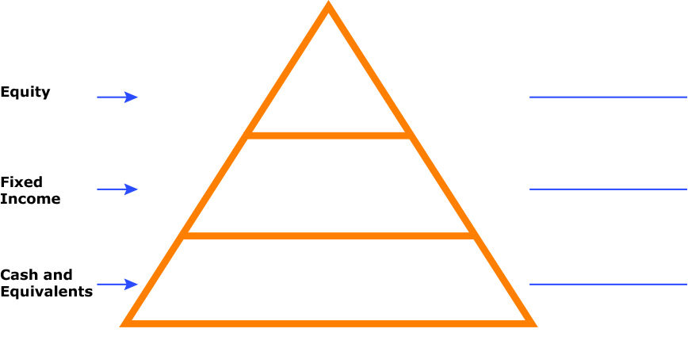

- Examine what you expect your investments to return. Of those you have selected, which ones are likely to give you the rates you expect?
- What is the purpose of having different investments in different categories?
- How does risk factor into investments? How does that impact the investor?
APPENDIX A
Your Investment Personality
Risk Tolerance Results

Risk Tolerance Category | Points
1. Very Conservative | (8 to 12 points)
A Very Conservative investor values principal preservation but is comfortable accepting a small degree of risk and volatility to seek some degree of appreciation. This investor desires greater liquidity, is willing to accept lower returns, and is willing to accept minimal losses.
Suggested Portfolio: 70 – 75% Fixed Income; 15 – 20% Equity; 5 – 15% Cash and Equivalents
2. Conservative | (13 to 20 points)
A Conservative investor values principal preservation but is comfortable accepting a small degree of risk and volatility to seek some degree of appreciation. This investor desires greater liquidity, is willing to accept lower returns, and is willing to accept minimal losses.
Suggested Portfolio: 55 – 60% Fixed Income; 35 – 40% Equity; 5 – 10% Cash and Equivalents
3. Moderate | (21 to 28 points)
A Moderate investor values reducing risks and enhancing returns equally. This investor is willing to accept modest risks to seek higher long-term returns. A Moderate investor may endure a short-term loss of principal and lower degree of liquidity in exchange for long-term appreciation.
Suggested Portfolio: 35 – 40% Fixed Income; 50 – 55% Equity; 5 – 10% Cash and Equivalents
4. Aggressive | (29 to 36 points)
An Aggressive investor primarily values higher long-term returns and is willing to accept significant risk.
This investor believes higher long-term returns are more important than protecting principal. An Aggressive investor may endure large losses in favour of potentially higher long-term returns. Liquidity may not be a concern to an Aggressive investor.
Suggested Portfolio: 20 – 25% Fixed Income; 65 – 70% Equity; 5 – 10% Cash and Equivalents
5. Very Aggressive | (37 to 40 points)
A Very Aggressive investor values maximizing returns and is willing to accept substantial risk. This investor believes maximizing long-term returns is more important than protecting principal. An Very Aggressive investor may endure extensive volatility and significant losses. Liquidity is generally not a concern to
a Very Aggressive investor.
Suggested Portfolio: 0 – 10% Fixed Income; 80 – 100% Equity; 0 – 10% Cash and Equivalents

Definitions for risk tolerance terms provided by https://access.investor.stifel.com/PDF/RiskClassificationDefinitions.pdf
APPENDIX A
The Investing Personality (Sample Answers)
Investment Personality
- What is investing?
Using money to make more money, usually with the understanding that some type of risk is involved and value of which increases over time.
- Why do people invest?
To accomplish the financial goals, you have set for yourself (whether they are short- or
long-term).
- Complete the “What kind of investor are you?” quiz at https://www.canada.ca/content/canadasite/en/financial-consumer-agency/services/financial-toolkit/investing/investing-1/6.html
Remember there are no right or wrong answers. Of most importance are the following questions:
- You will have a variety of investment goals over your life. Identify one goal you are (or should be) saving for and the duration (or time) you expect to save for it. Answers vary
- What kind of return do I expect from my investments? Answers vary
- How much of my money do I need to have available quickly? Answers vary
- Take the “Risk tolerance – it’s about you” quiz at
http://itools-ioutils.fcac-acfc.gc.ca/yft-vof/eng/invest-1-8.aspx. How did you score? _____
- What type of risk profile does it show you have? __________________________.
What does it mean (in regard to investing)?
Note: If you need more help, see the chart at the end of this handout. Answers will vary
- Does this seem to match your personality? (Explain in what ways it does or does not match.) Answers will vary
- Once you understand your risk tolerance, you can construct your asset allocation based on the type of investor you are and the suggested amounts.
- Assume you have $5,000 to invest. What investments would you choose to match your
risk profile?
- In the triangle, put actual types of investments you could choose, along with amounts
you would spend on each type.
(Use https://www.canada.ca/en/financial-consumer-agency/services/financial-toolkit/investing/investing-3/2.html or other websites to help you decide.)

APPENDIX A
The Investing Personality (Sample Answers)
APPENDIX A
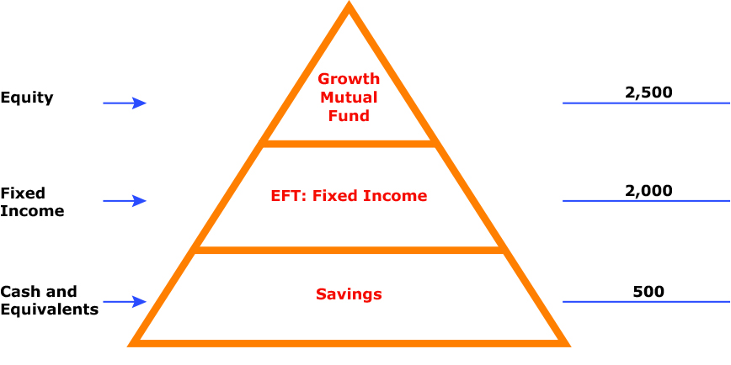

- Examine what you expect your investments to return. Of those you have selected, which ones are likely to give you the rates you expect?
Savings – 0.5%
EFT: Fixed Income – 3%
Growth Mutual Fund – 8%
- What is the purpose of having different investments in different categories?
It is to diversify your investments. It allows your aims to maximize return by investing in different areas that would each react differently to the same event. Most investment professionals agree that, although it does not guarantee against loss, diversification is the most important component of reaching long-range financial goals while minimizing risk.
- How does risk factor into investments? How does that impact the investor?
- How long do you have to invest (to achieve your goals)? – the longer the time, the greater the chance to recover or grow your money or take more risk
- How quick do you need access to your money (should you need it)? (Liquidity – ability to turn an asset into cash quickly) – if you need access quickly, not going to lock money up or take larger risk

