About this Lesson
This lesson explores other uses of Bitcoin, consolidates the learnings from previous lessons and helps students understand the concept of blockchain through an activity.

Grade Level | Course(s)/subject(s) | Learning Goal(s) | Suggested  Timing
9-12 | BBI1O/BBI2O  Introduction to Business  MBF3C  Foundations for College Mathematics  GWL3O  Designing Your Own Future  GLS4O/GLE4O/GLE3O  Advanced Learning Strategies: Skills for Success After Secondary School | By the end of the lesson, students should understand what currency is and whether Bitcoin qualifies as one and how blockchains work. Students will also know how they react to an investment activity.  Big Idea: Something has value, whether it is substantive or not, because we assign value to it. | 3rd of 3  75-minute periods

Curriculum Links
Grades 9 and 10, Business Studies (2006)
Introduction to Business (BBI1O/BBI2O)
Finance
- Demonstrate an understanding of effective investment practices
- Gather and interpret information about investment alternatives (e.g., stocks, mutual funds,
real estate, GICs, savings accounts), and compare the alternatives by considering the risk and
the rate of return
Grades 11 and 12 Mathematics (2007)
Foundations for College Mathematics (MBF3C)
Personal Finance
- Gather and interpret information about investment alternatives (e.g., stocks, mutual funds,
real estate, GICs, savings accounts), and compare the alternatives by considering the risk and
the rate of return
Grades 11 and 12 Guidance and Career Education (2006)
Designing Your Own Future (GWL30)
Personal Knowledge and Management Skills
- Describe the range of individual differences in how people manage themselves in dealing with
issues such as risk, stress, change, time, planning and personal finance in various settings
(e.g., school, workplace, community)

Curriculum Links (cont’d.)
Grades 11 and 12 Guidance and Career Education (2006)
Advanced Learning Strategies: Skills for Success After Secondary School, (GLS4O/GLE4O/GLE3O)
Planning for Transition
- Demonstrate an understanding of the personal financial skills that will be required for the future (e.g., budgeting, banking, saving, borrowing money)

Inquiry Question
Why is setting goals critical to understanding investment?

Materials List:
- Appendix D: Investment Game Instructions
- Appendix E: Investment Game Board
- Appendix F: Investment Game Reflection
- Appendix G: Blockchain Explained
- Five (5) Index Cards

Timing  (Mins.) | Lesson Sequence | Assessment for and as Learning Opportunities (self/peer/teacher)
MINDS ON
5  minutes | Class Discussion:  - Return Appendix C (from Lesson 2)  - Answer any outstanding questions  Teacher Prompt:  In Lesson 2, you were given an overview of what Bitcoins are, how they work and whether they are a good investment strategy for you.  Keep in mind that according to a recent survey, the majority of Canadians who do own Bitcoins do so for investment purposes. However, not all Canadians hold them for that purpose; some use them for transactions.  In the first part of the lesson, we shall examine that aspect of Bitcoins. In the last half of the lesson, we will do an activity to review and illustrate how blockchains function. | Assessment for Learning: Discussion
ACTION
60 minutes | Class/Group Discussion: Bitcoin as currency (optional)  Organize students in groups of four to eight.  Teacher Prompt: A transaction is an exchange of goods or services – either for currency or other goods. In your group, create a list of things that Bitcoins can be used to purchase.  Create a partial list as a whole class by soliciting answers from each group.  Sample links:  https://bravenewcoin.com/news/10-awesome-uses-of-cryptocurrency/  https://99bitcoins.com/who-accepts-bitcoins-payment-companies-stores-take-bitcoins/  https://www.coindesk.com/information/what-can-you-buy-with-bitcoins/  Teacher Prompt: What surprised you about who accepted this currency? Why do you think more retailers have not chosen to accept Bitcoins?  (Note: Teacher Prompts are in bold.)  - What is money? Money is any medium of exchange that can be used to pay for goods and services, and to measure the value of things.  - Does Bitcoin qualify as money? Yes, Bitcoin is a medium of exchange that can be used to purchase goods or services.  - How does Bitcoin differ from traditional currency?  - Only digital – unlike traditional currency, there is no physical exchange of money (store of value) for the goods. All transactions are done on the Internet.  - No centralized authority – Unlike traditional currencies, which are issued by central banks, Bitcoin has no central monetary authority. Instead, digital currencies are based on a decentralized, peer-to-peer (P2P) network.  - Your deposit is not insurable – Since it is not considered legal tender in Canada, if the currency exchange or wallet provider that has your digital currency fails or goes bankrupt, your funds won’t be protected. | Assessment of Learning: Discussion, Observation

Timing  (Mins.) |  | Lesson Sequence |  | Assessment for and as Learning Opportunities (self/peer/teacher)
ACTION (cont’d):
 | - Transactions are not reversible – Once a transaction has been accepted into the blockchain,  it can’t be reversed or stopped (to maintain the integrity of the chain). You could only get a refund if the seller agreed to and issued a new transaction.  - Anonymity – Although each Bitcoin transaction is recorded in a public log, the actual names of the buyers and sellers are not revealed, only their  wallet IDs.  Group Activity: Bitcoin (Investment) Review and Blockchains  Video reviews on blockchain:  https://www.youtube.com/watch?v=3xGLc-zz9cA  https://www.youtube.com/watch?v=9gvxGVohbNE  https://www.youtube.com/watch?v=KP_hGPQVLpA  Or see Appendix G: Blockchain Explained.  Teacher Prompt: During the next part of class, we will do an activity that illustrates blockchain and review some of the concepts we have learned. Although we can’t exactly replicate how blockchain works, we can experience a practical application.  Note to teachers:  - If not already done earlier, organize students into groups of four to eight  - Distribute Appendix D: Investment Game Instructions and review the instructions as a class  - Distribute Appendix E: Investment Game Board  - Play the Investment Game  - Debrief the activity (game) |  | Assessment as Learning: Exit Card
CONSOLIDATION/DEBRIEF:
5 – 10 minutes | Review any outstanding items or clarify any misconceptions  Think-Pair/Group Share: Game Debrief  Have students share results with a partner or as a group. Students should submit Appendix F: Investment Game Reflection as they exit or the next day for or as assessment (or evaluation). |  | Assessment as Learning: Debrief

Investment Game Instructions
Investment Game Instructions
Materials
- Game Instructions
- Game Board
- Tokens (different colour or type for each person)
- Blank Paper for Ledger
- Index Cards
- Scrap paper
- Dice
Object of the Game: The object of the game is to be the first one to have $5,000 in their ledger.
Setup:
- Each player will choose 10 tokens for playing. You may use all or some of the tokens during the game, but may not have more than 10. (Teacher Note: This is to remind them that money is finite.)
- Players will have two roles in the game: making investments and maintaining the ledger for all playing their game
- Each player should rule up a column for each person playing on a blank piece of paper. Place of each player around the board at the top of the column and place $500 underneath the name. This is the starting amount in your investment banking account.
- Each player should write their question (Appendix C) on index cards (one question per card). Plus, each player is to write a grade-appropriate math question or problem.
- Collect all the cards together and switch question “decks” with another group.
- Roll the dice to decide who starts the game. Play will continue in a clockwise direction.
Playing the Game:
- To make an investment, look at the purchase price of all the investments on the board and decide which investments you would like to purchase. The risk and return rate vary from one investment to another, so consider the amount the investment can win or lose, and the odds it has of winning or losing. The odds of winning or losing vary because some numbers are rolled more frequently than others. To see the frequency of each number rolled, see the chart below. The investments on the game board imitate their real-world risk and return rate.
Numbers | Frequency
6, 7, 8 | High
4, 5, 9, 10 | Medium
2, 3, 11, 12 | Low

APPENDIX D
Investment Game Instructions (cont’d.)
- For the first full round, each player may only select from low-risk investments (savings, GIC, money market account, T-bills). When you have decided which investments you would like to purchase, everyone needs to record the purchase price and then you place one of your tokens in the box of each investment you want to make. You may use your full $500 to purchase investments, or you can just use some of it. (Hint: Tying up all your cash in investments may not be the smartest move, since if you or other players roll numbers that cause you to lose on your investments, you won’t have any cash to pay the bank and then you could go bankrupt.) Players can purchase any investment, regardless of whether they or any other player have already purchased that investment. In other words, there can be multiple buttons of the same or different colours in each box.
- Record each player’s investment by subtracting from their cash in the ledger. Calculate the new balance and compare answers with everyone around the table. Once everyone has made their initial investments, decide who goes first by rolling the dice. Whoever rolls the highest number will go first, and then take turns going clockwise.
- Each turn has three parts:
- First a player decides if they want to make more investments. If so, they will place a token on the box for the investment and record in the ledger the designated purchase price for that investment. Each person must keep a record of the transaction.
- The second part of the turn is the roll. Whoever’s turn it is will roll the dice. When the dice are rolled, every player should pay careful attention to the number rolled and to where their investment tokens are on the game board. The number rolled determines who will earn and who will lose money on their investments. Players with a token on an investment with the number rolled as the designated “win” number will collect the “win” amount shown from the bank. Players with a button on an investment with the number rolled as the designated “lose” number will pay the “lose” amount shown to the bank. Each player must pay or collect for every investment that has the number rolled assigned to it. If they have more than one button on the same investment, they must collect or pay the amount shown, multiplied by the number of buttons they have for that investment. For example, imagine that for the money market account, the “win” number 7 is rolled. If a player has two tokens on that investment, that player will collect $50, since the “win” amount is $25.
- Each player must record the new score following the role of the dice for EACH player.
The ledgers are then compared for accuracy. If all the ledgers agree, and if the number rolled is even, it is the next person’s turn. If the number is odd, the person who rolled gets the opportunity to answer an Investment Review Question. Have another player pick up an Investment Review Question Card and ask the question to the player whose turn it is. If the player answers the question correctly, they win an additional $25 and each player must update their ledger to reflect this windfall.
- At the start of each round (each player having thrown the dice once), players are to rule
a new ledger with ending balance (as opening balance) and place old ledgers together
in a pile beside the game board.
- Continue playing until the first person achieves $5,000 in their ledger.
APPENDIX D
Investment Game Instructions (cont’d.)
Debt
Players may encounter a situation in which a number is rolled that causes them to lose money on their investment(s) and creates a negative balance in their ledger. Since ledgers must operate on
the positive side (or “black”), the player must IMMEDIATELY liquidate assets to cover losses.
To do this, they would remove any “liquid” investments. (Liquid investments are noted on the game board. These include: Savings Accounts, Money Market Accounts, Mutual Funds, Stocks, Bonds, and Precious Metals Altcoins and EFT Funds.
To liquidate an asset, the player will remove their token button from the game board and redeem the value of the assets minus 10% fee for selling. They will receive the cash purchase price of that investment less 10% (e.g., if stocks, she will get $270 = $300 – 10%). To avoid bankruptcy,
the player may liquidate as many liquid assets as they need. Players may not, though, liquidate
a non-liquid asset. (Non-liquid assets are noted on the board and include: CDs, T-bills,
Real Estate and Collectibles.)
All ledgers in the game must be updated at this point.
If the player liquidates all their liquid assets but still does not have enough money to cover their loss, they must declare bankruptcy and remove themselves from the game.
Investments
- Players are given 10 buttons for investments and can continue making investments until all 10 are on the board
- Investments can only be purchased at the beginning of a turn, before the player rolls the dice
- Players can purchase any investment for which they have enough money
- A player may own multiple units of the same investment. In other words, a player can have multiple buttons in the same box on the Investment Board.
- More than one player can own the same investment. In other words, there may be multiple-coloured buttons on the same box on the Investment Board.
- Once an investment is made, a player cannot exchange that investment for another
- Players with ledgers in the negative, must liquidate assets immediately as the account must always operate on the positive side

APPENDIX D
Investment Game Board
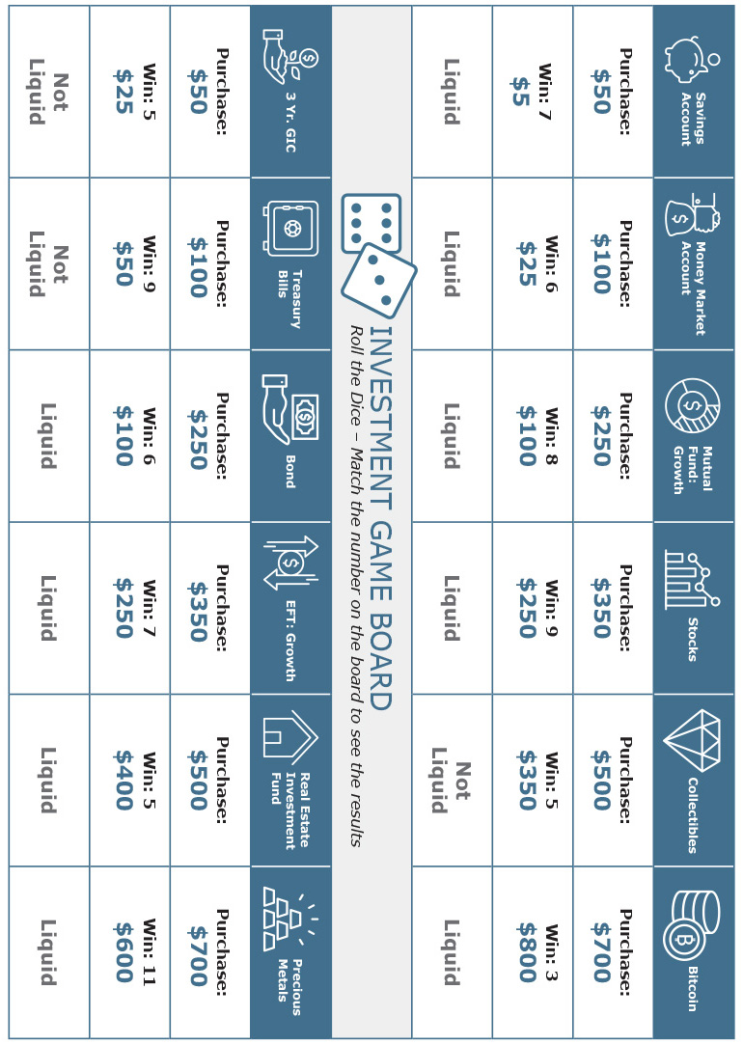
APPENDIX E
Investment Game Reflection
APPENDIX F
Investment Game Reflection
- In what way(s) did the game accurately illustrate blockchains?
- In what way(s) did the game not properly illustrate blockchains?
- Did you have a strategy before you started playing? What was it?
- To what extent, did your strategy reflect or match your Risk Tolerance Personality?
- How might your strategy have changed had the game lasted longer?
- In what way(s) might your strategy have changed had you been using your money? Explain.
- If you were to play the game again, what changes in your strategy might you make? Explain.
Blockchain Explained
What is a Blockchain?
A blockchain is a distributed (shared records among computers or nodes) database or ledger, meaning that the storage for the database is not all connected to a central or common processor. (In fact, they are the records that are distributed to many computers called “nodes.”) It maintains a growing list of ordered records, called blocks. Each block has a timestamp and a link to a previous block.
Cryptography ensures that users can only edit the parts of the blockchain that they “own” by possessing the private keys necessary to write to the file. It also ensures that everyone’s copy of the distributed blockchain is kept in synch.
Blockchains are secure databases by design. The concept was introduced in 2008 by someone or
a group named Satoshi Nakamoto, and then implemented for the first time in 2009 as part of the
digital Bitcoin currency. The blockchain serves as the public ledger for all Bitcoin transactions.
Simple Explanation How Blockchains Work
Alpha wants to send money to Beta. As each transaction occurs (an exchange of goods or services) – and the parties agree to its details – it’s represented online as a block. The information is encoded into a block of digital data and uniquely signed or identified.
The block gets distributed across a peer-to-peer (P2P) network of computers or nodes. The network verifies and timestamps the transaction.
Each block is connected to the one before and after it, creating an absolute, irreversible, immutable, permanent and inflexible chain. (Blocks are chained together, preventing any block from being altered or a block being inserted between two existing blocks.)
Alpha’s record of ownership of money now moves to Beta.
What Makes a Blockchain Unique
Blockchains eliminate a middleman or third-party, making information much more secure. Many businesses are currently examining this technology and adapting it to their business needs for the following reasons:
It’s distributed: Blockchain creates a shared system of record among business network members, eliminating the need to reconcile disparate ledgers.
It’s permissioned: Each member of the network must have access privileges. Information is shared only on a need-to-know basis.
It’s absolute: Consensus is required from all members and all validated transactions are permanently recorded. Even a system administrator can’t delete a transaction
To learn more, watch these videos:
- https://www.youtube.com/watch?v=3xGLc-zz9cA
- https://www.youtube.com/watch?v=9gvxGVohbNE
- https://www.youtube.com/watch?v=KP_hGPQVLpA
APPENDIX G

