About this Lesson
This lesson seeks to help students to understand the concept of FOMO and the impact on their lives in regard to anxiety, debt and stress.

Grade Level | Course(s)/subject(s) | Learning Goal(s) | Suggested  Timing
9-12 | BBI1O/BBI2O  Introduction to Business  HIF1O/2O  Exploring Family Studies  HIP4O  Personal Life Management  CIE 3M  The Individual and the Economy  PPZ3C  Health for Life | At the end of the lesson students should be able to identify:  - Causes of FOMO  - Impact on debt and stress  - Strategy to change | 75 – 150 minutes depending on whether or not optional topics are done and how much class time is given for assignment

Curriculum Links
Secondary curriculum
Business Studies, grades 9 and 10 (2006)
Introduction to Business (BBI1O/BBI2O)
Finance
- Demonstrate financial-planning skills and produce a business or personal financial plan
Personal Life Management (HIP4O)
Daily Living Skills
C1.4: Analyze the relationship between effective decision-making and personal well-being
C2.1: Explain factors that affect the use of money as a resource
C2.2: Demonstrate the use of effective money management strategies
C2.3: Explain the reasons for setting aside a portion of income as savings
C2.4: Demonstrate the use of strategies for effectively managing finances and planning next steps

Curriculum Links (cont’d.)
Social Sciences and Humanities, grades 9 to 12 (2013)
Exploring Family Studies (HIF1O/2O)
Daily Living Skills
C2.3: Describe and demonstrate financial strategies and the financial literacy skills necessary to manage financial resources to meet personal and family financial goals
Canadian and World Studies, grades 11 and 12 (2015)
The Individual and the Economy (CIE3M)
Fundamentals of Economics
B4: Financial Planning: demonstrate an understanding of key considerations related to personal financial planning, and use economic data to analyze the costs and benefits of personal financial decisions
Health and physical education, grades 9 to 12 (2015)
PPZ3C - Health for Life
Social Factors
A2.2 Identify the key social determinants of health and the factors that shape them, and explain how they influence personal health
Financial Literacy, Grades 9–12: Scope and Sequence of Expectations

Inquiry Question
Why does social media cause so much stress, anxiety and debt?

Materials List
- Appendix A: Budget Game
- Appendix B: Understanding Fear of Missing Out
- Internet

Timing  (Mins.) |  | Lesson Sequence |  | Assessment for and as Learning Opportunities (self/peer/teacher)
MINDS ON
5 – 15 minutes |  | Class Discussion  Watch the following video –  https://www.youtube.com/watch?v=hnpQrMqDoqE  Now stress has always existed, but recent studies indicate that millennials (and younger) are the most stressed generation. Why? We have better access to health care – what would cause this (and your) generation to be the most stressed – social media and money.  Class: Graffiti Wall  Put up large sheets of paper around the classroom and write one of the questions below on each sheet. Students circulate in small groups and write a brief response under each question – as an option, they can write the responses in the form of tweets using 140 characters. Circulate groups rapidly between each sheet of paper to add  their comments.  Questions  - What matters most with online friends or followers?  - What are the positive sides to social media?  - What are the potentially negative sides to social media?  - What have you spent money on because of what you saw on social media?  - How does social media create anxiety in your life?  Discuss the answers on the sheet. |  | Assessment of Learning: Observation
ACTION
10 minutes | Teacher Prompt:  Ask the following questions or poll the results  - How many of you regularly check your social media to see what your friends are up to?  - Have you ever come across a picture or Tweet from an event that you couldn’t go to? Did it made you feel sad, angry or anxious?  These emotions are arising from our Fear of missing Out also known as FOMO. Studies have shown that the

Timing  (Mins.) |  | Lesson Sequence |  | Assessment for and as Learning Opportunities (self/peer/teacher)
ACTION (cont’d.)
increased use of social media is correlated with increased
FOMO and causes higher levels of anxiety and feelings of unhappiness. It should be noted that people have always had this fear, but it is elevated as result of social media.
Class Discussion
- Give some reasons this may be the case. (Alternative Question: Your parent and grandparents had the same fear – they called it “Keeping up with the Joneses,” but what is different is a result of social media.)
Sample answers
- Pictures are posted instantly
- Event is posted in real time – don’t hear about next day, now you hear about as it is going on
- Only shows the positive – most post only the highlights
This FOMO leads to anxiety, and anxiety takes things out of perspective. You feel if you don’t go (and spend), you may lose friends, lose the experience. The anxiety causes you to keep from enjoying what you already have. So, you spend so as not to miss out, spending what you can’t afford which leads to more stress – a vicious cycle starts.
5–10  minutes | Teacher Prompt:  Fear of Missing Out Spending  No matter what your social media circle is, someone will always seem to have a more fascinating life than you at any moment and make you feel like your life is dull, that you are missing out unless you do the same. It doesn’t take you long to jump on the bandwagon to emulate your friends and pay for your own social media promotion. This often leads to impulse spending. Many, if not most, of these expenses are unplanned and unaccounted for, and over time, can add up to a lot of money – money that could have grown through investments.  RateHub conducted a survey of Canadians to address FOMO and money. Here is what they found:

Timing  (Mins.) |  | Lesson Sequence |  | Assessment for and as Learning Opportunities (self/peer/teacher)
ACTION (cont’d.)
10 minutes | - 26% of all Canadians have FOMO  - 48% of millennials admit to FOMO with their purchases  - 70% of Canadians believe 25% of their debt comes from FOMO purchases  - Those with incomes less than $35,000 a year and over $100,000 are most likely to have FOMO debt  - Food and entertainment are the most expensive  FOMO items  - 30% would not give up eating out for FOMO  - 25% say FOMO is their main motivation to shop  - 50% feel FOMO when on social media  - 38% would not give up social media because of FOMO  https://www.ratehub.ca/blog/the-cost-of-fomo-infographic/  Other surveys by CreditKarma in the U.S. confirm the  same findings.  Now, you may be thinking, “Why should I care?” You have money and no debts to worry about this time, so why does it matter how you spend your money?  The habits you form now in regard to spending are the habits you will carry forth in to your 20s and beyond. A small debt as a result of your spending in your 20s can balloon into larger debts later in life.  For those in their 20s, the experts list a number of things to do: (Remember, in a few years or fewer, some of you may be in post-secondary studies and you will have debts)
10  minutes | 1. Make and stick to your budget  Regardless of your age, you should learn how to make and stick to a budget.  Creating a budget requires you do four simple steps:  - List all your income after taxes (inflow of money) for the month.  - List all your expenses (outflow of money) for the month. |  | Assessment of Learning: Discussion

Timing  (Mins.) |  | Lesson Sequence |  | Assessment for and as Learning Opportunities (self/peer/teacher)
ACTION (cont’d.)
- Subtract your expense from income
(should equal zero).
- Track what you spend (expense) over the month.
Now a good rule of thumb in creating a budget is the 50-30-20 rule. The rule helps you break down your budget into three categories to help you spend. After you have determined your income after taxes:
- Limit yourself to 50% of the money going to your needs or essential expenses.
- Your essential expenses are those you would almost certainly have to pay, regardless of where you lived, where you worked, or what your future plans happen to include. In general, these expenses are nearly the same for everyone and include housing, food, transportation costs and utility bills.
- Limit your wants to 30% of your after-tax money. This would include vacations or trips, eating out, entertainment, clothing. Be careful, this can add up very quickly.
- “Spend” 20% on debt repayment and savings.
- Remember, before you know it you will be out of university or college and need to start paying back those loans. Debt limits opportunity, so the quicker you pay those off, the more things you will be able to do.
Class Activity (Optional)
Play the budget game – distribute out Appendix A
20  minutes | Teacher Prompt: (continued)  2. Leave the credit cards at home and pay with cash  It is easy to pay by credit as you get the good or experience without having to wait, but eventually you do have to pay back and if you can’t pay in full, you will have to pay interest on the amount borrowed when you used your card. Taking cash will limit how much you can spend. More than half of millennials use credit cards to pay for their FOMO spending.

Timing  (Mins.) |  | Lesson Sequence |  | Assessment for and as Learning Opportunities (self/peer/teacher)
ACTION (cont’d.)
But if you can’t afford to pay your credit card bill in full and on time each month, you could be hit with expensive interest charges that add up over time. Or failing to pay your credit card bill on time (even the minimum) could also affect your credit scores.
If you go to http://itools-ioutils.fcac-acfc.gc.ca/ccpc-cpcc/ccpc-cpcc-eng.aspx you can see the cost of how much it would and how long it would take to pay off your card if you only paid the minimum.
(Teacher Note: Either investigate as a class or direct students to the site and try different amounts and rates)
10  minutes | Teacher Prompt (continued)  3. Try to unplug every once in a while  If your FOMO is serious, try and get away from your social networks altogether for a while. You can have a weekly social media fast; turn off your phone for a couple of hours a day or use blocking tools to restrict your access to specific social networks. You might be surprised by how you can use up all that time productively – like studying, while also preventing yourself from potential impulse buying or splurging.  FOMO and Media (Optional Class Discussion)  - Watch the following video https://youtu.be/TPpVIQoDP4s  - Answer the following questions:  (Note: Anticipated answers appear in parentheses)  - What emotions does this video invoke?  (Answers will vary)  - What are they selling (beyond financing)?  (You can have it all)  - Why would this ad appeal to people?  (Not your fault)  - How does this video show FOMO?  (Answers will vary)  - Other examples of ads (any source) that target FOMO.

Timing  (Mins.) |  | Lesson Sequence |  | Assessment for and as Learning Opportunities (self/peer/teacher)
ACTION (cont’d.)
10 minutes | - Explore their website (as a class, group or individual)  - Assuming you borrow $5,000 to cover your FOMO. How much would you have to pay back assuming you make monthly payments over 36 months? Over 12? (Rates will vary -- as of November 2018 a) $295 (month) X 36 (months) = $10,620 b) 551.12 (month) X 12 (months) = $6,613.44)  - What is the problem with borrowing money to cover your food, experiences, trips, etc.?  (Expenses are not assets and don’t build wealth)  - Why would people use this service knowing that you it will cost you double what you borrow?  (Answers will vary)
10–20  minutes | Individual Assignment: Appendix B  - Distribute Appendix B as an assessment of evaluation  - Think, pair, share to discuss answers
CONSOLIDATION/DEBRIEF
10–15 minutes | WHOLE CLASS  Review:  - Concept of online stress  - How FOMO affects your finances  - Ways to control FOMO  - Concept of budgeting  - How and why you should budget (possible outcomes if a person does not follow a budget and if they do)  Exit Card  If you were to share a key insight from today’s lesson  with a friend, what would you say? Write or illustrate what you’d share.

The Budget Game
In “Square that Budget!” some financial concepts that can be examined are budgeting, income changes, and spending decisions.
Purpose
Managing money means making choices. These choices will be made from a wide variety of influence – including needs, wants and preferences. However, there is never enough money for all the things we’d like. This game will help students decide what is most important to them and how their values influence their money management.
Materials
- Student copies of budget worksheets
- Pencils
Setup
- Distribute one copy of the budget worksheets to each student
- Ask students to take out a pencil (they must be able to erase)
Instructions
- Make the following announcements to your students:
- Congratulations, you have just started your first job! It is exciting to finally have money, but you want to spend it wisely, so you must decide first where you are going to spend it.
- You start with 24 squares of income per month.
- Now, before you get excited, remember, you lose 6 squares to pay for Income Tax, EI and CPP. So, you start the game with 18 squares.
Round #1: Budgeting
- Ask students to look at all the categories in their budget worksheets
- Explain that each item has a set number of squares which must be marked in order to select that item. To select an item, they should checkmark the square box of that item.
- Remind students that first they must select one item in each of the categories with the gold stars (Food, Housing, Furnishings, Transportation, Insurance, and Clothing & Laundry) as these are required categories
Once they have finished selecting items in the required categories, they should continue selecting other items until they have used up their 18 square income.
Round #2: Re-Budgeting
- Announce to students that their income has just been cut to 13 squares due to being laid off
- Ask students to think about what they will change or give up now that they have a smaller
square income.
- Have students remove some selections by erasing their checkmarks and mark new ones.
Remind students to continue to make changes until they have marked only 13 squares.
Consolidation/Debrief
Questions posed to participants: What critical questions or other consolidation activities would support reflection of learning after Round #1? After Round #2? When would you use this activity? How could this fit into your curriculum?
APPENDIX A
The Budget Game
Suggestions
Round #1 Discussion Questions
Ask students to compare their spending choices to those of other players and share their discussion with the class.
- What did you spend your money on?
- How do your values, goals and past experiences affect your spending choices?
- What did you learn about yourself?
- If you also had to pay 2 squares for your student loans, what changes would you have made?
Round #2 Discussion Questions
Encourage students to compare their budget-cutting decisions with other players.
- Why did you make different choices than other players?
- When your budget became tighter, which categories did you spend less squares on?
- Did any category costs not change? Why?
- Are there any categories that are missing in this game that are a part of your own budget?

Budget Game
Purpose
Managing money means making choices. These choices will be made from a wide variety of influence – including needs, wants and preferences. However, there is never enough money for all the things we’d like. This game will help you decide what is most important to you and how your values influence your money management
How to Play
Congratulations, you have just started your first job. It is exciting to finally have money, but you want to spend it wisely, so you must decide first where you are going to spend it.
Round #1 Budgeting
Today, you have a 20 square income. Look at all the categories in The Budget Game. Each item has a set number of squares which must be marked to select that item. First, you must select one item in each of the categories with the gold stars (Food, Housing, Furnishings, Transportation, Insurance, and Clothing & Laundry). Once you have finished selecting items in the required categories, continue selecting other items until you have used up your 20 square income.
Round #1 Discussion Questions
Compare your spending choices to those of other players. What did you spend your money on? How do your values, goals and past experiences affect your spending choices? What did you learn about yourself?
Round #2 Re-Budgeting
Your income has just been cut to 13 squares due to being laid off. What will you change or give up? Erase to remove some selections and mark your new ones. Make the changes until you have marked only 13 squares. Compare your budget-cutting decisions with other players. Why did you make a different choice?
(Adapted with permission from West Virginia Financial Education programs)
APPENDIX A
The Budget Game (cont’d.)
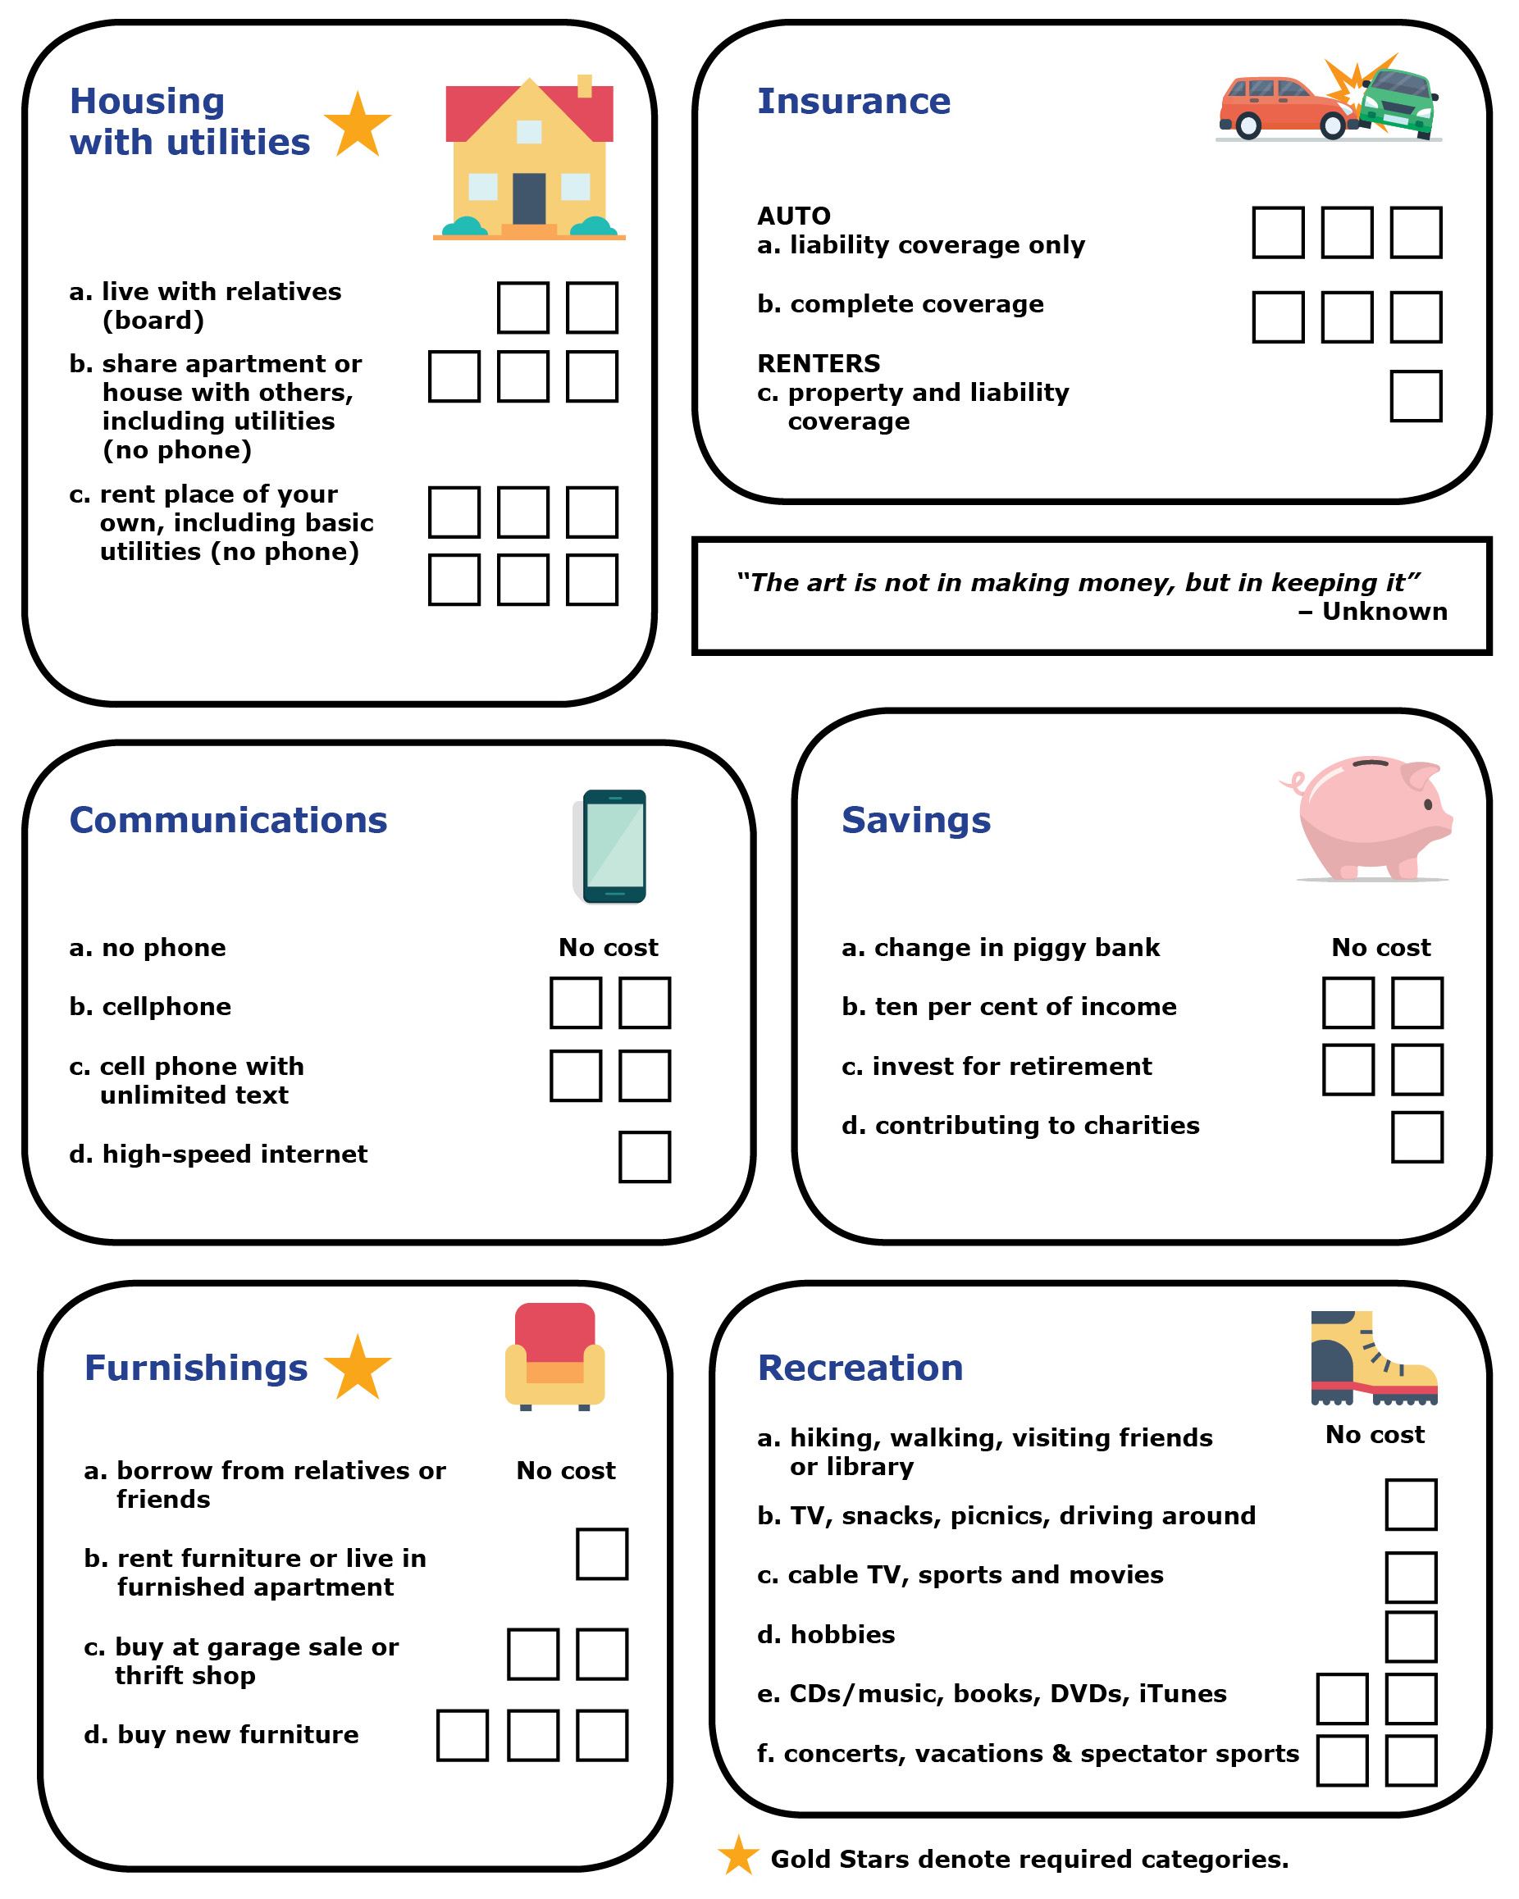
APPENDIX A
The Budget Game (cont’d.)
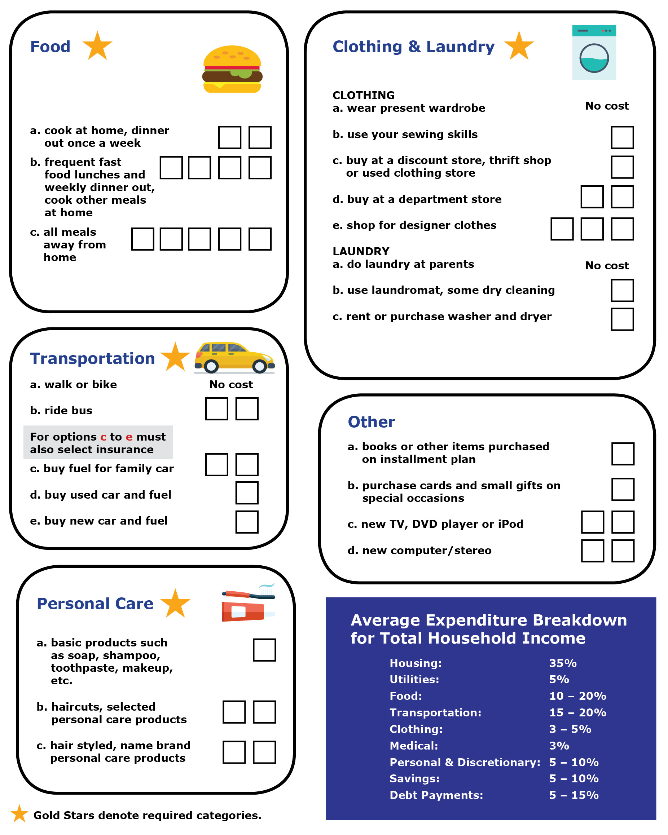
APPENDIX A
Understanding Fear of Missing Out
FOMO and Health
- How would you describe FOMO?
- How would you define stress?
- Do you think that FOMO is regularly experienced by young people (as the studies suggest)?
What might be the reasons they experience it?
- Suggest some tips for avoiding online stress.
FOMO and Spending
- Why may FOMO lead to increase or impulse spending?
- What ways do retail (online and physical stores) encourage this behaviour?
- What additional strategies (beyond the ones mentioned in class) could you use to help you not
impulse spend?
FOMO and Budgets
Case Study: Leaving High School
Taylor is a student who has accepted admission at a university in Ontario 200 km from home. Taylor had decided to experience university life and is exploring the cost to stay in residence first year. Taylor does not have a car, but instead will be using the bus pass issued by the university for travel within the city. Taylor works part-time throughout the year (10 months) and makes about $400 a month after taxes and works as a camp counsellor in the summer (two months) and will make $3,000 after taxes. Various scholarships worth $3,000 have been applied for, but no confirmation has been received that Taylor was successful. Taylor did apply for OSAP and will receive $12,800 for the school year of which $10,000 is a loan and $2,800 is a grant. Her parents have agreed to give her $8,000 a year towards her education.
Tuition for the program and student fees are $8,262 (for the school year). Books and materials will cost approximately $2,200. Taylor has been accepted in residence and has a single room, and her residence fees and meal plan will cost $13,440. The only other current expense is a cellphone, which costs $85 per month.
To ensure that Taylor does not overspend on entertainment, clothing, gifts and trips, create a quick budget using the 50-30-20 rule.

Income (all) (Working, Funding, Parents)
Needs (Essentials) – 50% of Income
Wants – 30% of Income
Savings/Loan Repayment – 20% of Income
Questions
- What are the total costs of Taylor’s essential needs as presented?
- Does Taylor have enough funds to cover essential costs? Are the costs greater than 50% or less?
- How much money is left over for wants and savings repayment?
- Assuming Taylor does not put any aside for savings or loan repayment, what amount per month could be budgeted for entertainment, clothing, gifts?
- How much of her OSAP must be paid back after graduation?
- What would cause FOMO spending at university? What financial problems would that create? How would students make up for the lack of money?
APPENDIX B
Understanding Fear of Missing Out – Possible Answers
FOMO and Health
- How would you describe FOMO?
ANSWER: Answers will vary – FOMO, the “fear of missing out” on anything from an exciting event to a conversation that their friends are having – or even just general social media updates.
- How would you define online stress?
ANSWER: Answers will vary since stress is highly subjective.
- Do you think that FOMO is regularly experienced by young people (as the studies suggest)?
What might be the reasons they experience it?
ANSWER: Answers will vary.
- Suggest some tips for avoiding online stress.
ANSWER: Unplug, do more free stuff, plan for fun, decide what to splurge on – wait before you buy something. If you still want after a certain time, then buy – reduces impulse buying. Keep your goals in mind (especially long-term ones).
FOMO and Spending
- Why may FOMO lead to increase or impulse spending?
ANSWER: Answers will vary.
- What ways do retail (online and physical stores) encourage this behaviour?
ANSWER: Answers will vary – point of sale, ads on social media, celebrity endorsements, etc.
- What additional strategies (beyond the ones mentioned in class) could you use to help you not
impulse spend?
ANSWER: Plan for fun, decide what to splurge on – wait before you buy something. If you still want after a certain time, then buy – reduces impulse buying.

FOMO and Budgets
Case Study: Leaving High School
Taylor is a student who has accepted admission at a university in Ontario 200 km from home. Taylor had decided to experience university life and is exploring the cost to stay in residence first year. Taylor does not have a car, but instead will be using the bus pass issued by the university for travel within the city. Taylor works part-time throughout the year (10 months) and makes about $400 a month after taxes and works as a camp counsellor in the summer (two months) and will make $3,000 after taxes. Various scholarships worth $3,000 have been applied for, but no confirmation has been received that Taylor was successful. Taylor did apply for OSAP and will receive $12,800 for the school year of which $10,000 is a loan and $2,800 is a grant. Her parents have agreed to give her $8,000 a year towards her education.
Tuition for the program and student fees are $8,262 (for the school year). Books and materials will cost approximately $2,200. Taylor has been accepted in residence and has a single room, and her residence fees and meal plan will cost $13,440. The only other current expense is a cellphone, which costs $85 per month.
APPENDIX B
Understanding Fear of Missing Out – Possible Answers
To ensure that Taylor does not overspend on entertainment, clothing, gifts and trips create a quick budget using the 50-30-20 rule.
Income (all) (Working, Funding, Parents) | $27,800
Needs (Essentials) – 50% of Income | $13,900
Wants – 30% of Income | $8,340
Savings/Loan Repayment – 20% of Income | $5,560
Questions
- What are the total costs of Taylor’s essential needs as presented?
ANSWER: $24,922
- Does Taylor have enough funds to cover essential costs? Are the costs greater than 50% or less?
ANSWER: Greater
- How much money is left over for wants and savings repayment?
ANSWER: $2,878
- Assuming Taylor does not put any aside for savings or loan repayment, what amount per month could be budgeted for entertainment, clothing, gifts?
ANSWER: $240
- How much of her OSAP must be paid back after graduation?
ANSWER: $10,000 (you do not pay back a grant)
- What would cause FOMO spending at university? What financial problems would that create?
How would students make up for the lack of money?
ANSWER: Desire to experience it all. So much opportunity to spend. Overspending and run out of money. Using credit card to make up for lack of cash or increased borrowing.

APPENDIX B

