About this Lesson
This first (of two) series of lessons draws on and builds upon students’ prior or background knowledge about Canada’s residential school system. It also provides the foundation for lesson two (Part 2 of 2) in which students complete the creation of a youth section/area within the Mohawk Village Memorial Park.
This planned park commemorates survivors of the Mohawk Institute in Brantford, ON.
This series of lessons (Part 1 of 2) responds to the Truth and Reconciliation Commission’s Calls to Action #62 and #63 and are designed using a land-centred and circular indigenous framework of vision, relationships, knowledge and action.
To support their own learning and that of their students, teachers may wish to explore the following resources as background knowledge:
National Centre for Truth and Reconciliation (especially education-focused resources):
http://nctr.ca/reports.php
Appendix A: Truth and Reconciliation Commission’s Call to Action #62 and #63
Appendix B: Land-Centred Circular Approach to the Teaching Process
Where Are the Children?: Healing the Legacy of the Residential Schools
http://wherearethechildren.ca/en/
Residential Schools in Canada: Education Guide:
http://education.historicacanada.ca/files/32/ResidentialSchools_English.pdf
Teachers should also be aware that inter-generational trauma – a legacy of residential schools – remains a current (not just historic) reality and should approach the subject matter in these lessons with care and sensitivity in order to avoid re-victimizing individuals, families and communities.
Teachers are encouraged to follow indigenous protocols to engage with members of indigenous communities on the territories on which they teach to bring authentic voice and experience to bear on the subject matter.

Grade Level | Course(s)/subject(s) | Learning Goal(s) | Suggested  Timing
6 | Social Studies | By the end of the lessons, students will recognize the historical reality of residential schools and the impacts on indigenous people. | 2 x  60-minute classes

Curriculum Links
Social Studies
A1 Application: Diversity, Inclusiveness and Canadian Identity
A1.1 Explain how various features that characterize a community can contribute to the identity and image of a country
A3.4 Describe significant events or developments in the history of two or more communities in Canada and how these events affected the communities’ development and/or identity

B2 Inquiry: Responses to Global Issues
B2.1 Formulate questions to guide investigations into global issues of economic importance (e.g., child labour), their impact on the global community, and responses to the issues

D1 Creating and Presenting
D1.3 Use elements of design in art works to communicate ideas, messages and understandings

Inquiry Questions
What are the most significant legacies (especially for survivors) of the residential school system?

Materials List
- Tablets and/or Computers (class set or shared in small groups)
- Pens, Pencils
- Appendix A: Truth and Reconciliation Commission’s Call to Action #62 and #63
- Appendix B: Land-Centred Circular Approach to the Teaching Process
- Appendix C: Photographs of Thomas Moore Keesick
- Appendix D: T-Chart (I Notice – I Wonder)
- Appendix E: The Residential School System Backgrounder
- Appendix F: Exit Card

Timing  (Mins.) | Lesson Sequence | Assessment for and as Learning Opportunities (self/peer/teacher)
 | Prior to this lesson, the teacher should establish what “truth and reconciliation” means in terms of acknowledging the true history of indigenous people in Canada.
MINDS ON
20 minutes | Share the learning goals and inquiry question for the lesson(s).  Organize students into pairs or small groups.  Distribute Appendices C and D to students.  Explain that the two photos (Appendix C) are of Thomas Moore Keesick before and after his entrance to the Regina Indian Industrial School in Saskatchewan. The images can also be found at http://firstnationsresidentialschools.weebly.com/historical-origins---objective-conditions.html. More information about him can be found at https://leaderpost.com/news/local-news/thomas-moore-keesick-more-than-just-a-face  Provide students with 10 minutes to complete the Appendix D: I Notice – I Wonder T-Chart.  Provide an opportunity for pairs to share their responses with the whole class. Teachers may elect to annotate projected or posted hard copies of the images with students’ observations and comments.  Use insights about what students already know/don’t know and wonder and what misconceptions they might harbour gleaned from the T-Chart activity to determine on what areas to focus teaching and learning. | Provide ongoing feedback on students’ observations  Through observation of student interactions and listening to students’ conversations, assess students’ prior knowledge and misconceptions
ACTION
30  minutes | Form new pairs (or small groups) of students.  Distribute Appendix E: The Residential School System: A Backgrounder.  The following three activities help build students’ background knowledge about the residential school policy and system.

 | Timing  (Mins.) |  | Lesson Sequence |  | Assessment for and as Learning Opportunities (self/peer/teacher)
 | ACTION (cont’d.)
 | 10 minutes | Ask each pair of students to complete the Backgrounder using the videos and online resources provided below.  First, show the short Historica Canada video (1:07) entitled Residential Schools found at https://www.youtube.com/watch?v=9TeW4hW1QD0  Second, refer students to the following sites to support completion of the Backgrounder:  http://www.mohawkvillagepark.com/history/  https://www.thecanadianencyclopedia.ca/en/article/residential-schools  https://www.cbc.ca/news/canada/a-history-of-residential-schools-in-canada-1.702280  Teachers may elect to review the completed Backgrounder as a whole class or have two or more pairs meet (after each pair has completed its own Backgrounder) to compare findings.  Third, encourage students to contrast their own school lives with those of indigenous youth in residential schools, and have students use a T-Chart to record differences and similarities between their own daily school timetable and the sample daily routine of a child in a residential school. To support completion of this task, refer students to “Residential Schools in Canada” at https://www.thecanadianencyclopedia.ca/en/article/residential-schools (select “Daily Routine” from the left-hand sidebar).
CONSOLIDATION/DEBRIEF
10 minutes |  | Review the concepts of “truth” and “reconciliation”, emphasizing that the inquiry question in the next lesson – which focuses on planning the elements to be included in the youth section/area of a planned Mohawk Village Memorial Park to pay tribute to survivors – is one concrete example of an act of reconciliation.  Distribute Appendix F: Exit Card and ask students to answer the two prompts and submit it. |  | Note students’ new learnings, needs and interests to determine  next steps

Truth and Reconciliation Commission’s Call to Action #62 and #63
- We call upon the federal, provincial and territorial governments, in consultation and collaboration with survivors, Aboriginal Peoples, and educators, to:
- Make age-appropriate curriculum on residential schools, treaties, and Aboriginal Peoples’ historical and contemporary contributions to Canada a mandatory education requirement for kindergarten to Grade 12 students.
- Provide the necessary funding to post-secondary institutions to educate teachers on how to integrate indigenous knowledge and teaching methods into classrooms.
- Provide the necessary funding to aboriginal schools to utilize indigenous knowledge and teaching methods into classrooms.
- Establish senior-level positions in government at the assistant deputy minister level or higher dedicated to aboriginal content in education.

- We call upon the Council of Ministers of Education, Canada to maintain an annual commitment to aboriginal education issues, including:
- Developing and implementing kindergarten to Grade 12 curriculum and learning resources on Aboriginal Peoples in Canadian history, and the history and legacy of residential schools.
- Sharing information and best practices on teaching curriculum related to residential schools and aboriginal history.
- Building student capacity for intercultural understanding, empathy and mutual respect.
- Identifying teaching-training needs relating to the above.
APPENDIX A
Land-Centred Circular Approach to the
Teaching Process
As Dr. Sandra D. Styres explains using the following conceptual framework, indigenous approaches are “formed and informed by connections to land, language use, self-in-relationship, and circularity, and how these elements connect to learning processes and teaching practices. Using circularity as a theoretical and conceptual organizing framework…enters the circle from the east – the east is where we enter the world from the spirit world” p. 5 Pathways for Remembering and Recognizing Indigenous thought in Education, Philosophies of Iethi’nihstenha Ohwentsia’kekha (Land), University of Toronto Press, 2017.
The book and framework further explain that we move to the south, west and then north in the circle.
In this project, Ontario students will also journey through the circle, albeit unknowingly, by creating a vision, establishing a relationship with the Mohawk Village Memorial Park, gaining knowledge about the residential school system and the survivors, and using action to reconcile with these truths by creating a fully-costed youth section/area within the larger memorial park.
This is a very crude rendering of the conceptual framework Dr. Sandra Styres developed using circularity. (p. 4)
NORTH
Cedar
Action
Wisdom
Physical

EAST
Tobacco
Vision
Spiritual

WEST
Sage
Knowledge
Cognitive

SOUTH
Sweet Grass
Relationship
Emotive

APPENDIX B
Photographs of Thomas Moore Keesick
APPENDIX C
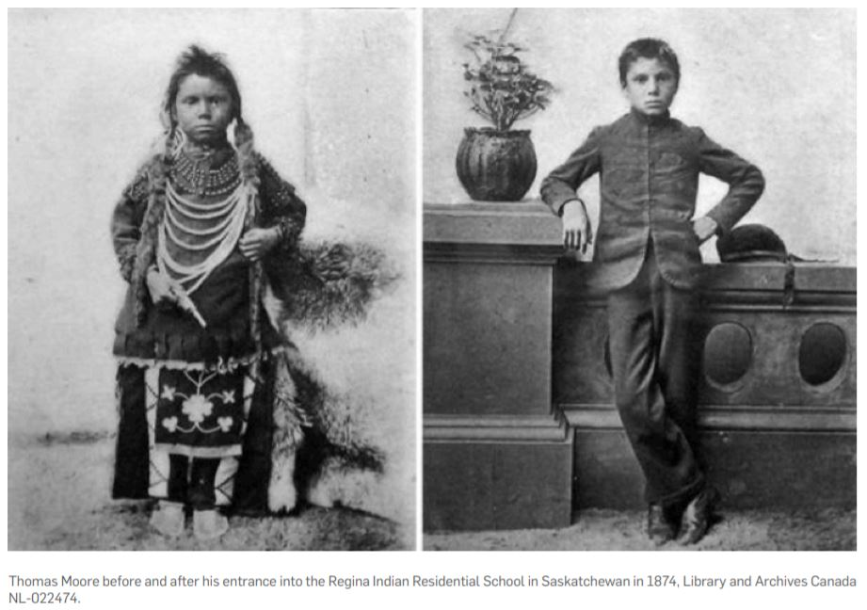
Source: https://cdn.we.org/wp-content/uploads/2016/07/WST-E47-Elementary_TheArts1.pdf
T-Chart (I Notice – I Wonder)
Task: Compare the two photographs of Thomas Moore Keesick. Use the T-Chart to record what
you notice in/about the photographs and what you wonder about them.
T-Chart
I notice… | I wonder…

APPENDIX D
The Residential School System: A Backgrounder
In your pairs/groups, find and record the answers to the following series of questions using the resources provided.
- Who set up the residential school system in Canada?
- What was the intended purpose of the residential schools?
- In total, about how many residential schools were there in Canada?
- Who operated/ran the residential schools?
- What were some of the long-lasting impacts of the residential schools for survivors, their families and their communities?
- What was the purpose of the Truth and Reconciliation Commission and why was/is it important?
APPENDIX E
Exit Card
Exit Card
Task: Think back over the last lesson or lessons focused on residential schools and answer the following two prompts. Please submit this to me when you’re done.
Your Name:
What is ONE new thing you learned about the residential school system or survivors of residential schools?
What is ONE thing you are still wondering or confused about related to the residential school system or survivors of residential schools?
---------------------------------------------------------------------------------------------------------------------------
Exit Card
Task: Think back over the last lesson or lessons focused on residential schools and answer the following two prompts. Please submit this to me when you’re done.
Your Name:
What is ONE new thing you learned about the residential school system or survivors of residential schools?
What is ONE thing you are still wondering or confused about related to the residential school system or survivors of residential schools?

APPENDIX F

