About this Lesson
Students will compare the social benefits and costs of buying versus renting a home and will describe the potential impacts of both choices on individuals and society.

Grade Level | Course(s)/subject(s) | Learning Goal(s) | Suggested  Timing
8 | Geography  Language | I will be able to describe the social costs and benefits of buying versus renting. I will be able to communicate my preference for buying versus renting using three-dimensional media. | 2 x  40–50 minutes =  80–100 minutes

Curriculum Links
Grade 8 Geography
B1:
- Application: Analyze some interrelationships among factors that contribute to global inequalities, with a focus on inequalities in quality of life, and assess various responses to these inequalities
- Analyze how various factors have affected the economies of specific developed and developing countries around the world
Grade 8 Media Literacy
2 Overall
Create a variety of media texts for different purposes and audiences, using appropriate forms, conventions and techniques
2.1 Specific
Explain how individual elements of various media forms combine to create, reinforce and/or enhance meaning

Inquiry Question
In what way(s) does the decision to rent or buy a home contribute to the quality of life, both for the individual and for society?

Materials List
- Markers
- Appendix A: The Cost of Buying a House
- Appendix B: The Cost of Renting a House
- Appendix C: Questions Cube Template
- Appendix D: Rubric
- Appendix E: Suggested Research Websites

Timing  (Mins.) | Lesson Sequence | Assessment for and as Learning Opportunities (self/peer/teacher)
MINDS ON
10–15 minutes | - Ask students if they have any idea of how much a house costs. Show some examples of house prices (sample site: www.realtor.ca)  - Ask the students whether they think that they would rather buy a home or rent.  - Discuss why. (Examples of reasons could be: Good  long-term investment, parents say it is a good idea, houses have made a lot of money in the past)  - Many of them may choose to buy a house. Emphasize that they might not be familiar with all the costs associated with buying a house.  - Ask them, “At what point would you rather buy and when it would be better to rent?”  - In two separate sides of the room, put up poster paper. One should be entitled “Costs and Benefits of Buying a Place to Live” and the other should say “Costs and Benefits of Renting a Place to Live.”  - Put markers out for the students by each of the signs. Have the students add their ideas to each chart. | Assessment for Learning – Observations & Anecdotal Notes: What do students conceptualize about housing prices? Do they understand how much a house truly costs?
ACTION
40–60 minutes | Compare Cost of Renting versus Buying  - Explain to the students that while many people want to buy a house, there are many factors to take into consideration. Depending on the circumstance, it may be better to rent a house, instead of buying. | Assessment for Learning – Observations & Anecdotal Notes:

Timing  (Mins.) |  | Lesson Sequence |  | Assessment for and as Learning Opportunities (self/peer/teacher)
ACTION (cont’d.)
40–60 minutes | - Considering debt and expenses, have the students determine the annual cost of owning and renting a house. Students can either find the information on their own or use the suggested research websites (Appendix E). Have them calculate costs on the Housing Cost Sheets (Appendices A & B) for both buying and renting, such as:  ○ Property taxes  ○ Land transfer taxes  ○ Mortgage  ○ Realtor fees (legal fees and disbursements)  ○ Utilities  ○ Home insurance  ○ Phone/cable/Internet  ○ Maintenance costs (furnace, plumbing)  ○ Home inspection  ○ Moving expenses  ○ Appraisals  ○ Condo fees  Buying  - Have students calculate the cost of buying a house on Appendix A  - Choose an area in which to live within your community (town, city, neighbourhood)  - Brainstorm costs (roofing, heating, energy and  other costs)  - List advantages of buying:  ○ Own the property, it is yours  ○ Make money when you sell the property  ○ Emotionally invested in the property  ○ Any others?  - List disadvantages of buying  ○ There are a lot of unknown costs  ○ You have little control over your neighbours  ○ Any others? |  | Assessment for Learning – Observations & Anecdotal Notes:

 | Timing  (Mins.) |  | Lesson Sequence |  |  | Assessment for and as Learning Opportunities (self/peer/teacher)
 | ACTION (cont’d.)
 |  | Renting  - Have students calculate the cost of renting a home on Appendix B  - Brainstorm costs associated with renting  - List advantages of renting:  ○ Costs are known  ○ Money that would be put into a house can be put into other investments  ○ There are very few unknown costs  ○ If you don’t like your neighbours, it is easy to move  ○ Any others?  - List disadvantages of renting:  ○ You do not get any capital gains (make money) from selling a house  ○ You do not own the house you are living in  ○ The landlord may or may not be any good  ○ You will probably not be as emotionally invested in the property as if you own  ○ Any others? Individually, use the information from the activity to answer the questions below:  - Title: Choose whether you would rather buy  or rent.  - What benefit(s) would there be for you to choose to rent or buy?  - Besides the dollar cost, what are some advantages of renting? Buying?  - After looking at the costs, both monetary and otherwise, which would you choose: to rent or  to buy?  - (Two reasons, two sides) Explain in detail, using numbers and examples from your research, why you would make your choice to rent or buy.  - Have students use information from the questions they answered to fill out the Cube Template (Appendix C).  - The students can then present their cubes to the class, giving their reasons and justification for their choice.  - Students can use the provided Cube Template (Appendix C) or they can make their own size and/or shape if they wish to be more creative or have more room. |  |  | Assessment for Learning- Observations & Anecdotal Notes:
CONSOLIDATION/DEBRIEF
10–20 minutes |  | Follow up:  - On one side of the room post the poster for Renting  - On the other side post the poster for Buying  - Have students take their cubes and stand on the side of the room that matches their choice  - Depending on how many students chose to stand on a particular side, ask students:  - Why they think more chose to buy (rent) rather than rent (buy)?  OR  - Why did the same number of students choose to buy  and rent?  OR  - What would the impact be to society if more people choose to buy than rent? |  | Assessment as Learning – Rubric (Appendix D)

The Cost of Buying a House
The Cost of Buying
Recurring Costs
Name of Cost | Costs | Times per Year | Total Cost
Potential One-Time Costs
Name of Cost | Costs | Times per Year | Total Cost

APPENDIX A
The Cost of Buying a House (cont’d.)
The Cost of Buying
Social/ Emotional Costs
Name of Cost | Costs | Times per Year | Total Cost

APPENDIX A
The Cost of Renting a House
The Cost of Renting
Recurring Costs
Name of Cost | Costs | Times per Year | Total Cost
Potential One-Time Costs
Name of Cost | Costs | Times per Year | Total Cost

APPENDIX B
The Cost of Renting a House (cont’d.)
The Cost of Renting
Social/Emotional Costs
Name of Cost | Costs | Times per Year | Total Cost

APPENDIX B
Questions Cube Template
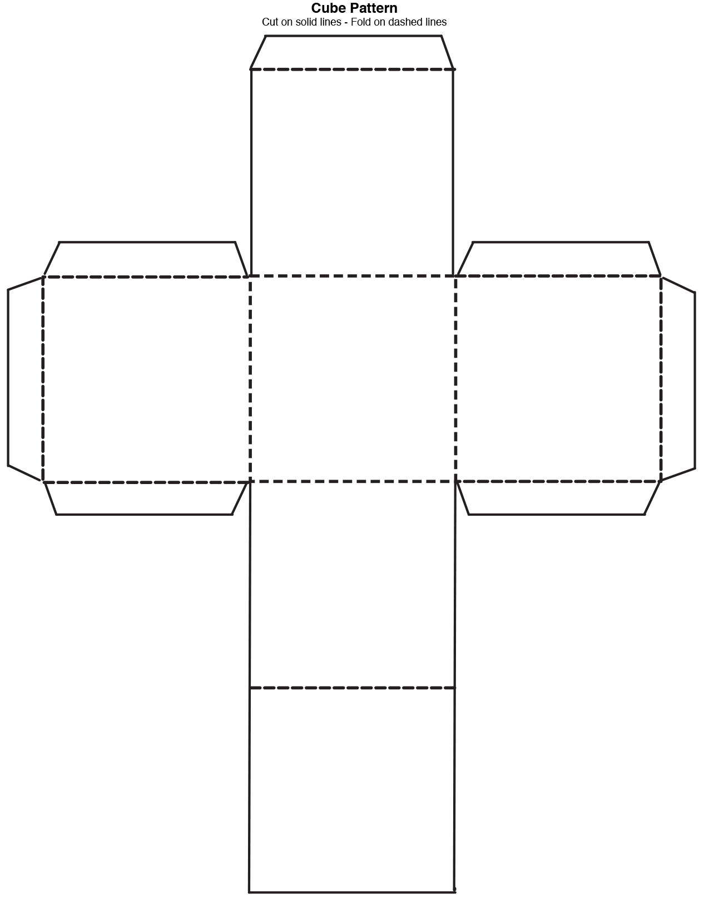
APPENDIX C
Rubric
GEOGRAPHY
 | 4 | 3 | 2 | 1
Student is able to analyze some interrelationships among factors that contribute to inequalities | Demonstrates limited understanding of interrelationships among factors that contribute to inequalities | Demonstrates some interrelationships among factors that contribute to inequalities | Demonstrates considerable understanding of interrelationships among factors that contribute to inequalities | Demonstrates thorough  understanding of interrelationships among factors that contribute to inequalities
Student is able to analyze how various factors have affected the economies of specific developed and developing countries around the world | Demonstrates limited ability to analyze how various factors have affected the economies of specific developed and developing countries around the world | Demonstrates some ability to analyze how various factors have affected the economies of specific developed and developing countries around the world | Demonstrates considerable ability to analyze how various factors have affected the economies of specific developed and developing countries around the world | Demonstrates thorough ability to analyze how various factors have affected the economies of specific developed and developing countries around the world
MEDIA
Create a variety of media texts for different purposes and audiences, using appropriate forms, conventions and techniques | Demonstrates limited ability to create a variety of media texts for different purposes and audiences, using appropriate forms, conventions and techniques | Demonstrates some ability to create a variety of media texts for different purposes and audiences, using appropriate forms, conventions and techniques | Demonstrates considerable ability to create a variety of media texts for different purposes and audiences, using appropriate forms, conventions and techniques | Demonstrates thorough ability to create a variety of media texts for different purposes and audiences, using appropriate forms, conventions and techniques
Explain how individual elements of various media forms combine to create, reinforce and/or enhance meaning | Demonstrates limited ability to explain how individual elements of various media forms combine to create, reinforce and/or enhance meaning | Demonstrates some ability to explain how individual elements of various media forms combine to create, reinforce and/or enhance meaning | Demonstrates considerable ability to explain how individual elements of various media forms combine to create, reinforce and/or enhance meaning | Demonstrates thorough ability to explain how individual elements of various media forms combine to create, reinforce and/or enhance meaning

APPENDIX D
Suggested Research Websites
https://www.greedyrates.ca/blog/know-when-to-rent-em-know-when-to-buy-em/

https://www.ratesupermarket.ca/blog/cost-of-buying-vs-renting-in-ontario-infographic/

https://www.incharge.org/housing/homebuyer-education/homeownership-guide/advantages-and-disadvantages-of-owning-a-home/

https://www.property24.com/property101/rent-vs-buy-guide/pros-and-cons-of-buying-and-renting/17510
APPENDIX E

