About this Lesson
In this lesson, students will learn how trade agreements between Canada and its economic partners work. Students will also learn how tariffs, customs duties and import taxes affect the price of consumer goods.

Grade Level | Course(s)/subject(s) | Learning Goal(s) | Suggested  Timing
9–10 | Grade 9  MFM1P – Foundations of Mathematics  Grade 10  CHC2D – Canadian History  since World War I  Grade 10  CHC2P – Canadian History  since World War I | By the end of this lesson, students will have an understanding of the key principles of the concept of free trade  By the end of this lesson, students will be able to assess the benefits and drawbacks of free trade as an economic model  Grade 9  MFM1P – Foundations of Mathematics  Grade 10  CHC2D – Canadian History  since World War I  Grade 10  CHC2P – Canadian History  since World War I | 75 minutes

Curriculum Links
CHC2D — Canadian History since World War I
Canadian and World Studies Curriculum
Strand: Canada, 1982 to the Present
Overall Expectation:
E1. Social, Economic, and Political Context: describe some key social, economic, and political events, trends, and developments in Canada from 1982 to the present, and assess their significance for different groups in Canada (FOCUS ON: Historical Significance; Continuity and Change)
Specific Expectation:
E1.3 Describe some key trends and/or developments in the Canadian economy since 1982 and compare them to earlier trends/developments.

Curriculum Links (cont’d.)
MFM1P — Foundations of Mathematics
Strand: Number Sense and Algebra
Expectation:
Demonstrate an understanding of the characteristics of an affine function.
Content for Learning:
Compare two affine functions, in a given situation, using their value table, graph and equation (e.g.,
a videotape rental company has a fixed monthly rate of $30 for rental, regardless of the number of cassettes rented; a second video cassette rental company has a fixed monthly rate of $9 plus $3 per cassette rented. Determine when one should be chosen over the other; compare, using non-algebraic methods, the rates of each company).

Inquiry Question
Why is Canada occasionally involved in so-called “tariff wars”?

Materials List
- Digital Devices
- Internet
- Calculator
- Multimedia Projector and a Board
- Appendix A: Canada-U.S. Trade Relations Timeline
- Appendix B: Key Terms Connected to Free Trade
- Appendix C: Calculating Tariffs and the Effects of Customs Duties

Timing  (Mins.) |  | Lesson Sequence |  | Assessment for and as Learning Opportunities (self/peer/teacher)
MINDS ON
10  minutes |  | Invite students to share their prior knowledge of or views on the most recent (2017) tariff war between Canada and the United States.  Ask students the following question to encourage thinking and discussion:  What prior knowledge do you have about this trade/tariff war?
Timing  (Mins.) |  | Lesson Sequence |  | Assessment for and as Learning Opportunities (self/peer/teacher)
MINDS ON (cont’d.)
Student responses can be recorded in pairs or small groups and pooled as a whole class or compiled as a teacher-led activity with the whole class.
Following the this initial activity, share Appendix A, which features a timeline of the history of trade relations between Canada and the United States over the past decades.
Assess students’ comprehension by asking a sequence of questions about the timeline:
- Do you understand why Canada and the United States became important trading partners following the Second World War?
- Can you explain how free trade is beneficial, in theory, for entrepreneurs, consumers and governments?
- Can you explain how free trade can have a negative impact on the economies of participating countries?
ACTION
Part 1 – 25 minutes | Arrange students in pairs or small groups.  Identity and display terms found at the bottom of Appendix A.  Ask each pair or group to compose a brief draft definition, of each term in their own words which draws on their collective prior knowledge.  Call on each pair or group – at least once – to provide one of the terms and its definition. Invite other pairs or groups to offer additional or alternative wording for definitions as appropriate.  Use the sample definitions in Appendix B to ensure that key aspects of each term are surfaced in the students’ definitions.

Timing  (Mins.) |  | Lesson Sequence |  | Assessment for and as Learning Opportunities (self/peer/teacher)
ACTION (cont’d.)
Part 2 – 20 minutes | Once students have a command of the key terms, refer students to the following websites which provide key facts and events that led to the tariff war(s) between Canada and the United States.  https://www.cbc.ca/canadaus/timeline.html  https://www.thecanadianencyclopedia.ca/en/article/economic-canadian-american-relations  Teacher’s Notes: 1) Be sure to point students to the relevant (more recent/modern) parts of the timeline of events on each website. 2) It may be necessary to substitute other websites to provide students with more recent or up-to-date summaries of Canada-U.S. trade agreements or tariff wars.  Share Appendix C which features a fleshed-out example (infographic) of a way to identify the economic impacts of a tariff war.  As a class, brainstorm other types of purchases that young people might typically make.  Then, assign pairs or small groups of students to design their own scenario/infographic, based on one of the common types of purchases by youth, to showcase the role and impact that tariffs have when it comes to the consumer habits of Canadians.

Timing  (Mins.) | Lesson Sequence | Assessment for and as Learning Opportunities (self/peer/teacher)
CONSOLIDATION/DEBRIEF
10 minutes | Lead a whole-class discussion, inviting students to answer the following question:  Who are the winners and losers in a tariff war?  Ensure that students consider and raise the following points during the whole-class debrief:  - Consumers often lose out during a tariff war. Whenever competition is reduced, and prices are artificially inflated (e.g., by imposing additional tariffs), consumers are the ones who pay the price.  - Many businesses suffer from a loss of access to a significant number of consumers in foreign markets who will avoid paying a surcharge on their purchases  - Some businesses will benefit because most of their products are sold on the domestic market and their consumers will not seek to go elsewhere  - Some politicians stand to gain from adopting protectionist practices if they can convince voters that they are protecting the national economy and have the best interests of the country in mind

Canada-U.S. Trade Relations Timeline
APPENDIX A
Timeline — Canada-U.S. Trade Relations
This timeline looks at five major events in the evolution of Canada’s trade relations with the
United States in recent decades.
Teacher’s Note: Teachers may need to define the terms below for students by direct instruction (See Appendix B for suggested definitions). Alternatively, teachers can have students work individually, in pairs or in small groups to create definitions for each term. Regardless of the instructional approach, students will require a firm understanding of these key terms.
1965 | Implementation of the Auto Pact, which virtually eliminates tariffs between the two countries on components in automotive manufacturing. The bilateral agreement also guarantees a higher percentage for Canadian-built vehicles to be sold in the North American market.
1988 | Implementation of the Canada-U.S. Free Trade Agreement. The agreement creates a free trade area on products and services by which both countries reduce or eliminate tariffs and customs duties to promote trade.
1993 | Implementation of NAFTA (North American Free Trade Agreement) that extends the free trade area into Mexico. All three countries experience a gradual increase in trade of goods and services as a result of this multilateral agreement.
1996 | The softwood lumber dispute is settled by an agreement that allows Canada to sell softwood lumber to the United States up to a limit of $14.7 billion US without tariffs. Beyond this limit, the United States would discourage American consumers from buying Canadian products by imposing tariffs. This is an example of protectionism.
2018 | The United States pursues protectionist trade practices and strategies by imposing tariffs on several Canadian products destined for the U.S. manufacturing sector (secondary). Canada retaliates by imposing tariffs on several U.S. products destined for the Canadian retail sector (tertiary).  This is the beginning of a new tariff war.
Key Terms:
Bilateral Agreement
Customs Duties
Free Trade
Manufacturing Sector (secondary sector of the economy)
Multilateral Agreement
Products and Services
Protectionism
Retail Sector (tertiary sector of the economy)
Tariff War
Tariffs
Key Terms Connected to Free Trade
Tariffs
Tariffs are taxes applied by a government on an imported product or service. The objective of a tariff is to increase the price of the product to make it less attractive to consumers. For example, if the Government of Canada imposes a tariff (an additional tax) on maple syrup imported from the United States and the price of American maple syrup is too high, Canadians will not buy it.
Bilateral Agreement
It is a treaty concluded between two countries and is legally binding under international law. For example, the 1940 Ogdensburg Treaty is a bilateral agreement between Canada and the United States that provides military defence for both countries in the event of an attack from a foreign country.
Free Trade
It is an economic concept that ensures that governments and private companies reduce or eliminate tariff barriers or other obstacles to the free movement of goods and services between countries participating in free trade. For example, in continental Europe there are no import duties or taxes on products traded between countries on the continent.
Products and Services
It is all that can be traded or sold in a given market. For example, buying an automobile (product) from a dealer requires the intervention of a salesperson (service).
Customs Duties
A type of tax that is levied on imported products once they cross the border. Customs duties may be imposed directly on consumers who return to Canada after a trip abroad. For example, an individual who buys more than $200 worth of products in the United States while spending more than 24 hours in that country, but less than
48 hours, will have to pay customs duties.
Multilateral Agreement
A treaty concluded between more than two countries and is legally binding under international law. For example, the 1949 North Atlantic Treaty Organization (NATO) agreement is a multilateral agreement between countries of this region that provides military defence in the event of an attack from a foreign country.
Protectionism
An economic practice by which a government limits imports or imposes excessive tariffs and duties on imported products in order to promote the consumption of goods and services produced and sold within the country’s borders. For example, Canada imposes high tariffs on American maple syrup, encouraging Canadian consumers to buy Canadian maple syrup.
Manufacturing Sector (secondary sector of the economy)
The sector of the economy that transforms natural resources into consumer goods. For example, workers in the automotive sector transform aluminum into car chassis.
Retail Sector (tertiary sector of the economy)
The sector of the economy that represents the service provided to consumers. For example, car salespeople in dealerships work in the tertiary sector of the economy.
Tariff War
A situation in which two countries implement protectionist practices to restrict the free movement of goods and services between them. For example, the United States restricts the importation of softwood lumber from Canada, while Canada imposes tariffs on American maple syrup.
APPENDIX B
Calculating Tariffs and the Effects of Customs Duties
CHC2D, CDC2P, MFM1P
Name:
This activity will help to develop a better understanding of the impacts of a tariff war.
The Smartphone Purchase
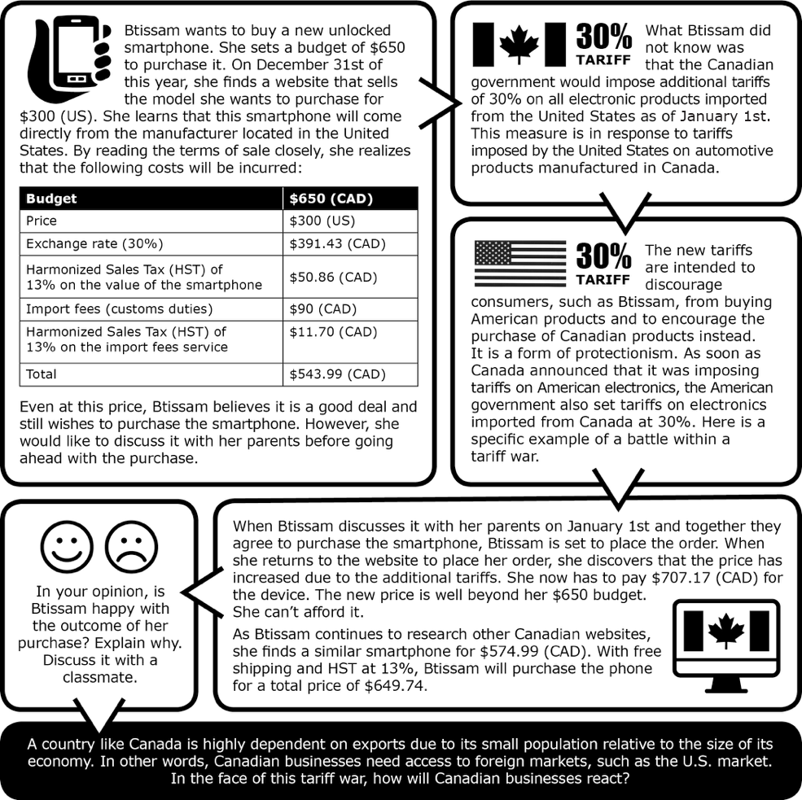
APPENDIX C

