About this Lesson
In this lesson, students will learn how the concept of fair trade can sometimes lead to inequities that comparable to those associated with traditional trade.

Grade Level | Course(s)/subject(s) | Learning Goal(s) | Suggested  Timing
6 | Introduction to Business (BBI1O/BBI2O)  Exploring Family Studies (HIF1O/2O)  Personal Life Management (HIP40) | B2. Explain the importance of international co-operation in addressing global issues and evaluate the effectiveness of selected actions by Canada and Canadian citizens in the international arena. (ACCENT ON: Interrelationships; Perspective) | 150 minutes

Curriculum Links
http://www.edu.gov.on.ca/eng/curriculum/elementary/sshg18curr2013.pdf
Social Studies (Grade 6)
Overall Expectation:
B2: Inquiry: use the social studies inquiry process to investigate some global issues of political, social, economic, and/or environmental importance, their impact on the global community, and responses to the issues (FOCUS ON: Cause and Consequence)

Specific Expectations:
B2.1 Formulate questions to guide investigations into global issues of political, social, economic, and/or environmental importance and their impact on the global community, and responses to the issues
B2.2 Gather and organize information on global issues of political, social, economic, and/or environmental importance, including their impact and responses to them, using a variety of resources and various technologies
B2.3 Analyse and construct different types of maps, both print and digital, as part of their investigations into global issues, their impact, and responses to them
B2.4 Interpret and analyse information and data relevant to their investigations, using a variety of tools
B2.5 Evaluate evidence and draw conclusions about global issues of political, social, economic, and/or environmental importance, their impact on the global community, and responses to the issues
B2.6 Communicate the results of their inquiries, using appropriate vocabulary

Inquiry Question
How can ethical stances affect economic choices?

Materials List
- Digital Devices
- Internet
- Calculator
- Appendix A: Word and Term Bank
- Appendix B: Word Find
- Appendix C: Answers to Word Find
- Appendix D: Venn Diagram: Comparing Conventional and Fair Trade Chocolate
- Appendix E: Sample Answers to Worksheet: Chocolate Chip Cookies
- Appendix F: Worksheet Sample Answers - Chocolate Chip Cookies

Timing  (Mins.) |  | Lesson Sequence |  | Assessment for and as Learning Opportunities (self/peer/teacher)
MINDS ON
10 minutes |  | Invite students to consider the reasons why the prices of regular-size chocolate bars can vary quite dramatically.  Student responses may vary widely. It is recommended to make connections between what students are proposing and the principles underpinning the workings of our economic system (e.g., availability and price of ingredients, trade, scarcity, etc.).  If the responses provided by students do not accurately  or loosely address the concept of production cost, it is important to add this term to the board and discuss it  with students.  Recording sample responses will be beneficial for the steps that follow.  During the guided discussion on the cost of production,  the following ideas need to be raised:  - Availability and prices of the ingredients used to prepare the chocolate bar (e.g., cocoa, sugar, milk, etc.)  - Wages of workers who are involved in the production, transportation and sale of the chocolate bar  - Revenues and profits to be generated by the businesses in question  Ensure that students understand that the cost and value of consumer goods, such as a chocolate bar, are not the result of chance, but rather the result of several variables that influence how much consumer goods cost in a grocery store, convenience store or supermarket.  Of these variables, the value of the labour will be the subject of this lesson on fair trade.
ACTION
120 minutes  Part 1 – 50 minutes | Students are expected to learn the relevant terminology about fair trade in order to discuss it intelligently and intelligibly among themselves. To this end, have students create a word search, a word scramble or a word find using the word and term bank provided in Appendix A.

Timing  (Mins.) |  | Lesson Sequence |  | Assessment for and as Learning Opportunities (self/peer/teacher)
ACTION (cont’d.)
Students can refer to one of the following pages to create a word search or a word scramble:
http://tice.avion.free.fr/fswordfind/fswordfinder.php
https://www.educol.net/wordsearch/eng/
https://wordsearchlabs.com/

It is up to you to decide how many words and terms you will ask students to use to create their word games. Though there are 18 in total, working with all of these words may be a lengthy process.
Please note that it may be necessary to review the words, terms and definitions with students to provide additional clarification or specific examples to help ensure that students have a good grasp of the concepts.
Once the students have created their word game, have them present it to a classmate in pairs. Students can adjust their game as necessary.
An example is provided in Appendix B.
Part 2 – 30 minutes | To illustrate how fair trade can have a significant impact on the quality of life for those who depend on this business practice, together with the students, watch the following brief video by Equal Exchange: https://www.youtube.com/watch?v=lnpsFRcsnE0  One or more of the videos below can either replace the video noted above or complement it:  https://www.youtube.com/watch?v=6RmBKaQA6qI  https://www.fairtrade.org.uk/What-is-Fairtrade/Fairtrade-and-sustainability  Organize students into pairs or small groups and provide them with Appendix D.  Invite students to complete the Venn Diagram using content from one or more short films (see above links).  A discussion with the students will be necessary  to ensure that they understand the terminology and issues connected to fair trade.

Timing  (Mins.) |  | Lesson Sequence |  | Assessment for and as Learning Opportunities (self/peer/teacher)
ACTION (cont’d.)
It is suggested to divide the guided discussion into three parts:
1. Trade History
Review with the students the elements of the video that explain that since the period of major European explorers and discoveries in the 16th century, the wealthy countries of Europe have often taken advantage of their military and economic strengths and exploited the natural resources and inhabitants of countries they had conquered. Since then, this model has also been adopted by major commercial corporations. Encourage students to ask questions to ensure that they understand the information.
2. Inequities Caused by Modern Business Practices
Over the past several decades, major commercial corporations (e.g., multinational corporations) have become so powerful that they are able to manipulate the value and price of consumer goods in order to maximize their profits. In the video, the example demonstrates how these major corporations can control the supply and demand for chocolate and therefore influence its price. Modern practices are aimed at maximizing income and profits for owners and shareholders of major corporations. Their practices do not often improve the lives of farmers and producers. Encourage students to ask questions to ensure that they understand the information.
3. Fair Trade
Starting in the 1980s, a significant number of consumers began to take an interest in and were concerned about the way in which large companies appeared to take advantage of and exploit small producers in developing countries. With the advent of the Internet in the 1990s, information on the practices of major corporations became more available and circulated more freely throughout the world. Small producers, small farmers and their families in developing countries revealed the extent to which trade practices were unfair and threatened their livelihoods. A new movement was born: fair trade. Encourage students to ask questions to ensure that they understand the information.

Timing  (Mins.) |  | Lesson Sequence |  | Assessment for and as Learning Opportunities (self/peer/teacher)
ACTION (cont’d.)
Part 3 – 40 minutes | Implementing fair trade  In this section of the lesson, students can put into practice the way fair trade works. In pairs, students will make two virtual recipes for chocolate chip cookies: one recipe by choosing traditional ingredients, and a second recipe by choosing ingredients derived from fair trade.  To do this, students will refer to the worksheet in Appendix E of the lesson. In order to find online businesses where you can buy fair trade goods, students can refer to the following web page:  http://www.fairtrade.ca/en-CA/Buying-Fairtrade  Please refer to Appendix F for an example of the completed task.
CONSOLIDATION/DEBRIEF
10 minutes | As a class, invite students to participate in a discussion about the price difference between fair trade products. Can they understand why the price of these products, such as chocolate, is almost twice as expensive as ordinary chocolate traded internationally? An important task for students would be to reflect on the true cost of consumer goods and how the choices that are made by consumers affect the quality of life of the workers who produce the goods we consume.  Finally, ask students if the lesson might make a difference in their economic choices and whether they will be inclined to think about these workers when making their purchases.

Word and Term Bank
APPENDIX A
Using the following word and term bank, create a game for a classmate to confirm the correct use of vocabulary related to the subject of fair trade.
Your teacher will guide you to a web page that you can use to create a word find, word search, crossword puzzle, etc.
Word and Term Bank  Trade: The commercial activities (e.g., purchases, commercial exchanges) between consumers and entrepreneurs.  In a sentence: I am taking part in trade when  I purchase a pair of shoes in a store.  Fair: The capacity to act in a way that protects and promotes justice.  In a sentence: I shared my chocolate bar with my classmate who didn’t have one because it’s a fair way of doing things.  Fair Trade: The commercial activity that promotes profits on the part of the workers who produce consumer goods.  In a sentence: Fair trade allows farmers in developing countries to benefit as much as possible from the sale of their agricultural products.  Consumers: The individuals who purchase  consumer products.  In a sentence: In a pharmacy, consumers can buy beauty products.  Ethics: The capacity to think and act according to moral principles that promote a sense of good.  In a sentence: By making a charitable donation,  I am acting ethically.  Worker: Individuals who are paid to perform tasks assigned to them by their employer.  In a sentence: This morning I saw a municipal worker repairing a pothole on my street.  Workforce: All workers in a particular field  or industry.  In a sentence: Each and every worker represents the workforce at this airport.  Justice: A moral principle based on the recognition of other people’s rights.  In a sentence: It is justice that ensures that there are laws that help protect children.  Profits: The objective of business owners in order to accumulate wealth.  In a sentence: If this company’s profits are declining, it may have to close. | Income: The salary that workers receive, or the salary that entrepreneurs give themselves.  In a sentence: My uncle’s employment contract provides him with an annual income of $60,000.  Exports: These are consumer goods that leave Canada for a foreign country.  In a sentence: Maple syrup is a typical Canadian export product.  Imports: These are consumer goods that arrive in Canada from a foreign country.  In a sentence: Importing bananas and oranges is the only way to obtain them in Canada.  Poverty: As an economic and social reality, it describes the state of living on little or no income.  In a sentence: There is more poverty in developing countries than in developed countries.  Supply and Demand: It is the idea that consumers want goods (demand) and that producers try to meet this need (supply).  In a sentence: The law of supply and demand is such that DVD players now have very little value.  Capitalism: The concept by which entrepreneurs try to maximize their profits.  In a sentence: One effect of capitalism is that  the divide between rich and poor is widening more  and more.  Consumer Society: The economic system in which we are living where we must make purchases in order to ensure income for all workers.  In a sentence: It is almost impossible to live completely outside the consumer society.  Entrepreneur: The individual who takes the risk of investing his time and money in a business in order to generate income.  In a sentence: This entrepreneur has just opened a shoe shop on the main street of the village.  Bargain: The name given to an inexpensive purchase made by a consumer.  In a sentence: I bought this chocolate bar on sale for $1.25 when it usually costs $1.75. What a bargain!

Example of a Word Find
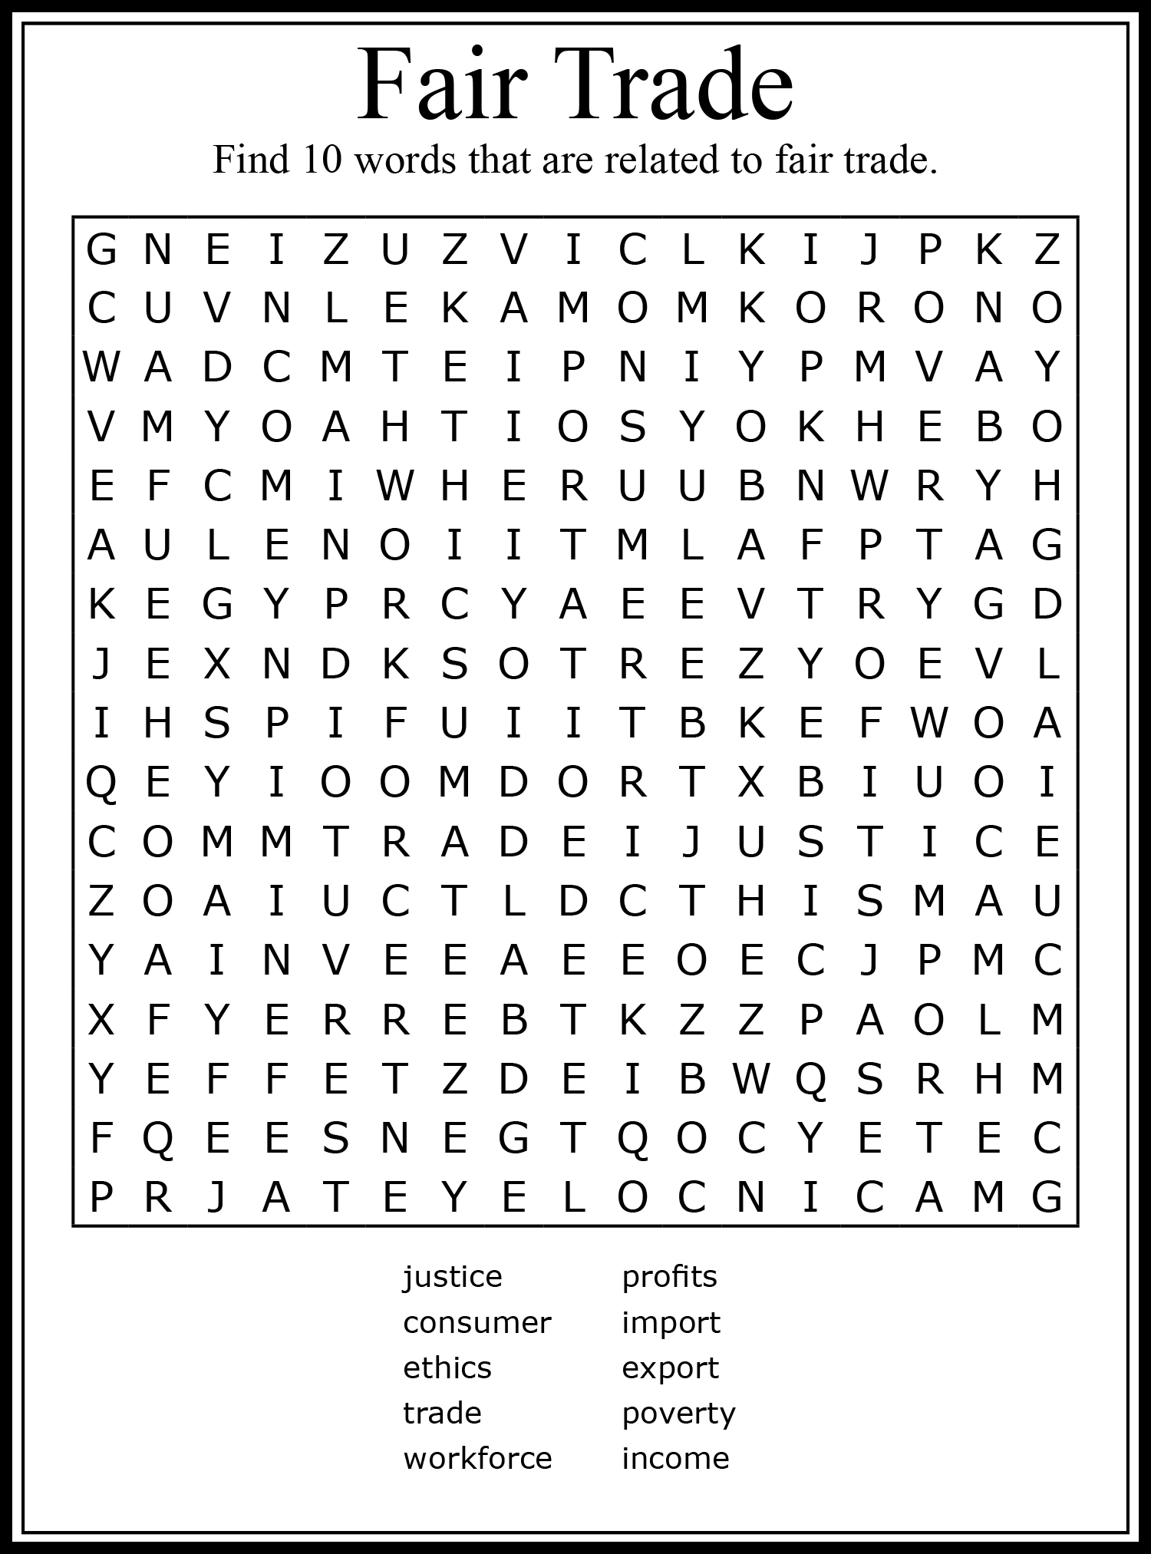
APPENDIX B
Answers to the Word Find
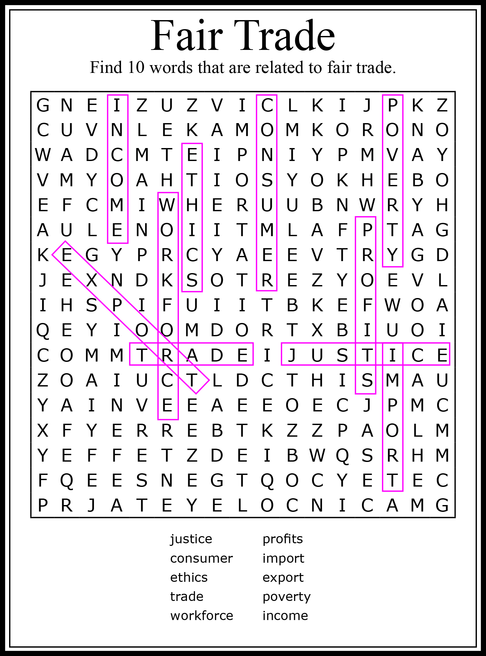
APPENDIX C
Venn Diagram: Comparing Conventional and
Fair Trade Chocolate
Task instructions:
While you watch the video “Why fair Trade Chocolate Matters” (https://www.youtube.com/watch?v=lnpsFRcsnE0), in pairs or small groups use the Venn Diagram below to compare and contrast conventional and fair trade cacao (chocolate).
Conventional Cacao BOTH Fair Trade Cacao

APPENDIX D
Worksheet: Chocolate Chip Cookies
Task: In pairs, search the Internet to find and compare the value of cookies made with traditional supermarket ingredients and cookies made with fair trade ingredients.
This recipe will make 36 cookies.

INGREDIENTS | SUPERMARKET PRICES | FAIR TRADE PRICES
2.5 grams of baking soda
145 grams of sugar
145 grams of chocolate chips
250 grams of flour
90 grams of butter
1 egg
30 millilitres of milk
Total price per cookie

What is the difference in price per cookie between the recipe made from conventional (traditional)ingredients found in the supermarket and the ones created with fair trade ingredients?
APPENDIX E
Sample Answers to Worksheet: Chocolate Chip Cookies
Task: In pairs, search the Internet to find and compare the value of cookies made with traditional supermarket ingredients and cookies made with fair trade ingredients.
This recipe will make 36 cookies
INGREDIENTS | SUPERMARKET PRICES | FAIR TRADE PRICES
2.5 grams of baking soda | $5.99/2 kg = $0.07/2.5 g | $5.99/2 kg = $0.07/2.5 g
145 grams of sugar | $2.99/2 kg = $0.21/145 g | $6.56/454 g = $2.09/145 g
145 grams of chocolate chips | $3.99/250 g = $2.31/145 g | $7.49/225 g = $4.83/145 g
250 grams of flour | $3.69/1 kg = $0.92/250 g | $3.69/1 kg = $0.92/250 g
90 grams of butter | $4.19/250 g = $1.50/90 g | $4.19/250 g = $1.50/90 g
1 egg | $2.27/1 dozen = $0.19/unit | $2.27/1 dozen = $0.19/unit
30 millilitres of milk | $2.79/1 litre = $0.08/30 ml | $2.79/1 litre = $0.08/30 ml
Total price per cookie | $5.28 ÷ 36 = $0.15 | $9.61 ÷ 36 = $0.27

What is the difference in price per cookie between the recipe made from ingredients found in the supermarket and the ones derived from fair trade* ingredients?
ANSWER: The price is almost double; from 15¢ to 27¢ per cookie.

Sources: (Prices as of July 2018)
https://www.loblaws.ca/Food/Pantry/Baking-Ingredients/Flour-%26-Baking-Aides/Baking-Soda/p/20018429_EA
https://well.ca/products/wholesome-sweeteners-organic-fair_19722.html
https://www.healthyplanetcanada.com/camino-chocolate-chips-semi-sweet-56-225g.html

*Note: Some fair trade ingredients were not available at the time this lesson was developed.
APPENDIX F

